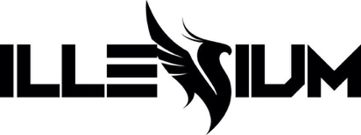

GRAMMY® AWARD NOMINATED DJ/PRODUCER ILLENIUM LINKS WITH SPIRITBOX FOR HEAVY METAL BASS HYBRID SINGLE “SHIVERING” – LISTEN HERE

ANNOUNCES FALLEN EMBERS (REMIXES) DUE MAY 27

FALLEN EMBERS NOMINATED FOR TOP DANCE/ELECTRONIC ALBUM AT BILLBOARD MUSIC AWARDS THIS SUNDAY, MAY 15

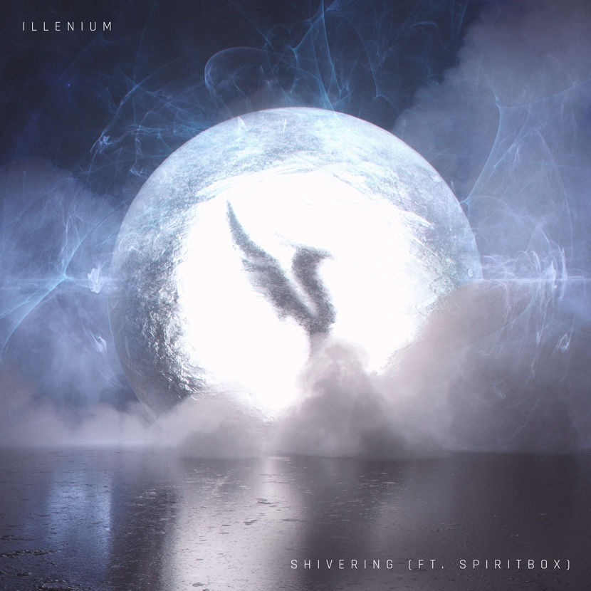

May 13, 2022 (Los Angeles, CA) – Today, GRAMMY® Award-nominated artist ILLENIUM returns with “Shivering,” a roaring new single featuring Canadian heavy metal band Spiritbox. Listen HERE via Warner Records. Alongside the genre-blurring track, ILLENIUM also announces a forthcoming remix album, FALLEN EMBERS (Remixes), out on May 27. Pre-order the club-ready project HERE.

Heartbreak gets a heavy metal bass twist on “Shivering,” a floorfiller that the multiplatinum cross-genre phenomenon previewed during his blistering set at Ultra Music Festival in March. Over ILLENIUM’s production – a storm of aggressive drums, wailing guitars, and engulfing drops – Spiritbox vocalist Courtney LaPlante sings with raging sorrow to a former flame: “All this time I burned alive till you found someone else / So everytime you think of me, can you feel me shivering?”

On collaborating with Spiritbox, ILLENIUM shared, “Spiritbox has been one of my favorite bands for a minute and being able to work with them has been a dream. They’re incredibly talented and Courtney has a voice unlike anyone. Definitely one of my favorite songs I’ve been a part of.”

“Watching ILLENIUM work and create on the spot was such an amazing thing to witness and be a part of.” Spiritbox’s Courtney LaPlante and Mike Stringer shared. “It was an honor working with him, and we appreciate his willingness to push boundaries, and use his influence to bring metal to the masses.”

“Shivering” follows ILLENIUM’s previous singles “Story of My Life” with Sueco and Trippie Redd and “Wouldn’t Change A Thing” featuring Thirty Seconds To Mars – which marked the first new music from the band in three years. The latter track was featured on ILLENIUM’s deluxe edition of his 2021 full-length FALLEN EMBERS. The original LP earned a GRAMMY® nomination earlier this year for Best Dance/Electronic Album and is currently up for Top Dance/Electronic Album at the Billboard Music Awards – which takes place this Sunday, May 15.

All the while, ILLENIUM’s stock continues to skyrocket. Last month, he put his own melodic-bass spin on Nirvana’s iconic “Something in the Way,” marking his first remix in over two years. The remix was inspired by the release of The Batman and his collaboration with DC Comics. The DC X ILLENIUM Batman Collection featured an array of merchandise including a Batman-themed jersey, T-shirt, hoodie, and crewneck, as well as a limited edition ILLENIUM x Batman comic book cover in partnership with Electric Family.

Looking to the stage, ILLENIUM has a packed schedule ahead with festival dates at Hangout Music Festival, Bonnaroo, Escapade, Lollapalooza Paris, EDC Las Vegas, Sunset Music Festival, and more; plus two nights at The Gorge Amphitheatre and his ongoing Vegas residency at OMNIA Nightclub and Tao Beach Dayclub. This December, ILLENIUM will bring his Ember Shores festival back to Cancun, Mexico, where among a specially curated lineup he’ll perform three unique sets – buy tickets HERE. More tour dates listed below.

Impressively, ILLENIUM’s total career streams have now eclipsed 5 billion and counting. With “Shivering,” along with his forthcoming remix album and DC collaboration, ILLENIUM cements his status as one of dance music’s most innovative and audacious producers.

TOUR DATES:

May 14 – We Are One Music and Arts Festival – Houston, TX
May 20 – Hangout Music Festival – Gulf Shores, AL
May 22 – EDC Las Vegas – Las Vegas, NV
May 27 – Sunset Music Festival – Tampa, FL
May 28 – Gorge Amphitheatre – George, WA
May 29 – Gorge Amphitheatre – George, WA
Jun 25 – Forest Hills Stadium – Forest Hill, NY
Aug 5 – 6 – Breakaway Music Festival – Bonner Springs, KS
Aug 5 – 7 – Outside Lands – San Francisco, CA
Sep 3 – North Coast Music Festival – Bridgeview, IL
Dec 2 – 4 – Ember Shores Festival – Cancun, Mexico

ABOUT SPIRITBOX:
SPIRITBOX arguably *the* hottest new band in heavy music over the past 12 months, dropped their long awaited debut album, ‘Eternal Blue’ in September of last year. The release rolled in on a global tsunami of critical acclaim, from perfect score reviews and features everywhere including Spin, Forbes, Billboard and Alternative Press, to multiple front covers including Kerrang!, MetalHammer, Rock Sound, Distorted Sound, Pollstar, and Revolver. It spawned a string of hit singles including "Holy Roller", "Constance", “Circle With Me”, "Secret Garden" and most recently, "Hurt You". With several incendiary US festival performances and a full US tour with Underoath under their belts, SPIRITBOX will be heading to Europe this summer for a run of festivals and a handful of sold-out headline shows. SPIRITBOX have accumulated over 185 million streams across platforms. They are nominated for 2 Juno Awards this year for Breakthrough Group Of The Year and Metal/Hard Music Album of The Year.

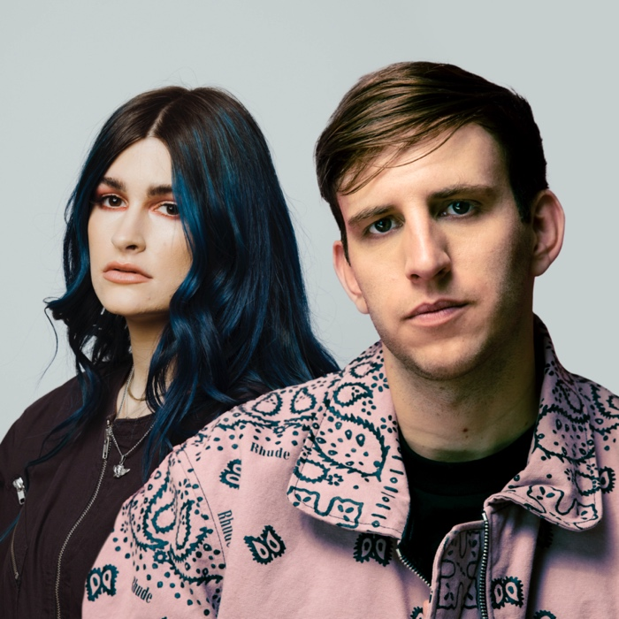
Courtney LaPlante of SPIRITBOX & ILLENIUM

Follow ILLENIUM:
Official | Instagram | Twitter | TikTok | YouTube | Press Materials

Follow SPIRITBOX:
Official | Instagram | Twitter | TikTok | YouTube

ILLENIUM Contacts:
Darren Baber | Warner Records
Darren.Baber@warnerrecords.com

Regional: Jenny Huynh | Warner Records
Jenny.Huynh@warnerrecords.com

SPIRITBOX Contact:
Charley Bezer | Cosa Nostra PR
charley@cosanostrapr.com

