RISING POP STAR JENNA RAINE CLAIMS HER INDEPENDENCE ON EMPOWERING NEW SINGLE “NOT AGAIN”

WATCH VIDEO HERE

MORE NEW MUSIC COMING SOON

May 27, 2022 (Los Angeles, CA) – Gearing up for what promises to be an unforgettable summer, Texas-born pop phenomenon Jenna Raine unveils a new single and music video entitled “NOT AGAIN” via Warner Records. Listen HERE and watch the video for “NOT AGAIN” HERE.

About the song, Jenna explains, “’NOT AGAIN’ is a little reminder for all of those who have given their ex too many second chances. This song is meant to empower those to stop going back to that familiar person and grow on their own.”

On the track, handclaps and acoustic guitar brush up against breezy production. She details an ex’s half-hearted attempts to rekindle their relationship in vivid verses before delivering the instantly irresistible hook, “You want me back? Oh not again!” With the accompanying video, she relives her transformation post-breakup. In a split-screen, she sings to the camera as series of TikTok videos of Jenna and friends play along her that all tell stories of their new independence.
Through and through, it reflects her clever and candid approach as a songstress and dynamic personality as a performer.

Jenna has truly cemented herself as an artist-to-watch this year. In February, she signed with Warner Records and released her major-label debut EP, see you later, which featured a new version of the viral breakout song “see you later (ten years)” with hit singer-songwriter and GRAMMY® nominated producer JVKE. The song has nearly 1 billion views on TikTok and 285,000 creates. Jenna has already generated over 50 million streams and has earned widespread acclaim. Right out of the gate, Variety predicted, “Raine’s future looks bright,” and she received plugs from Entertainment Tonight, J-14, and more. Sweety High summed up the EP best as “stunning.” Jenna is steadily building a devoted fanbase with 1.5 million followers on TikTok, 1.9 million monthly listeners on Spotify and 254,000 followers on Instagram.

It’s been a busy start to summer as Jenna just enjoyed her high school graduation and shut down prom!

Raine has been working toward this moment since she entered a talent show at 8 years old. Encouraged by the rapturous response, she asked for singing lessons for her 10th birthday and joined Septien Entertainment Group, whose alumni include Beyoncé, Selena Gomez, and Demi Lovato. A four-year stint in a girl group called L2M followed as well as multiple world tours and two self-released solo EPs. She even found the time to act in Hulu’s California Dreaming which premiered on Nickelodeon in December 2021. With her see you later EP, Raine takes another step toward superstardom, sharing more of herself with the world with each song she releases.

Raine is currently working with some of today’s top songwriters and producers, including GRAMMY-winning producer Ryan Tedder (Adele, Ed Sheeran) as well as Nathan Chapman (Taylor Swift) who produced “see you later (ten years).” With much more music in store for 2022, you’ll want to keep your eye on Jenna Raine!

###

FOLLOW JENNA RAINE:
TikTok | Instagram | Twitter | Facebook | YouTube

For more information on Jenna Raine, please contact:
Darren Baber | Warner Records
Darren.Baber@warnerrecords.com

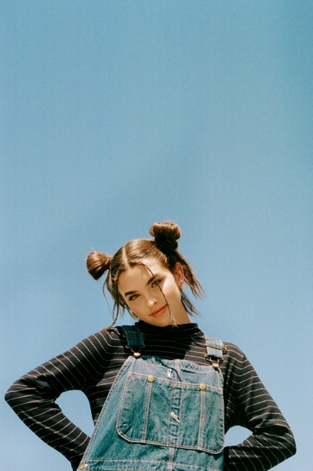
Photo credit: Caity Krone

