RISING POP STAR JENNA RAINE CELEBRATES WARNER RECORDS SIGNING WITH SEE YOU LATER EP – LISTEN HERE

WATCH THE VIDEO FOR BRAND NEW VERSION OF BREAKTHROUGH HIT “see you later (ten years)” FEATURING JVKE HERE

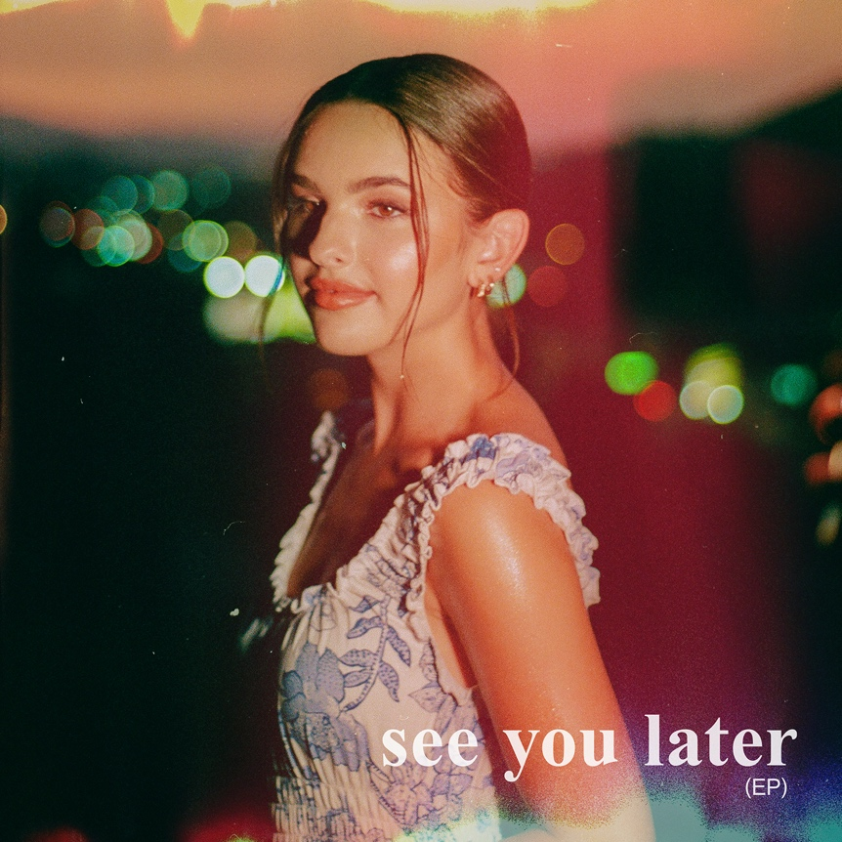

February 11, 2022 (Los Angeles, CA) – Today, Texas-born pop phenomenon Jenna Raine releases her major-label debut EP, see you later, via Warner Records. Listen HERE and watch the video for “see you later (ten years)” featuring JVKE HERE.

The three-song set contains her breakthrough “see you later (ten years),” which has amassed more than 36 million global streams since its release in 2021. Upon release, the single quickly shot to #1 on Spotify’s Global and US Viral Charts and earned early radio support, debuting on Billboard’s Adult Top 40 Chart. The EP also includes a new version of that romantic ballad featuring JVKE and the equally emotional, introspective, “2%” — a song fans have been aching for since the 17-year-old artist first teased it to her 1.5 million followers and counting on TikTok.

All three songs on the EP are deeply personal and intimately relatable. “see you later (ten years)” captures the anguish of dating the right person at the wrong time. “It’s heartbreaking when the timing is all wrong,” says the singer/songwriter/multi-instrumentalist. “But now I'm dating the person that used to be my Right Person, Wrong Time.” That happy ending inspired the song. She always envisioned a feature on it and found the right collaborator in viral hit singer-songwriter and GRAMMY® nominated producer JVKE – best known for his breakout hit “this is what falling in love feels like,” JVKE has over 5.4M monthly listeners on Spotify and amassed over 300 million global streams.

“His lyrics are just perfect,” Raine says. “It's so insane how talented he is and I'm so happy that he's the one doing it.” She’s equally excited about the possibility of releasing the finished version of “2%” after going viral on TikTok with a snippet. “It’s about the statistic that only 2% of people marry their high school sweetheart,” the talented teen says. “I want to give young couples hope. There are no love songs for the teens anymore.”

Raine has been working toward this moment since she entered a talent show at 8 years old. Encouraged by the rapturous response, she asked for singing lessons for her 10th birthday and joined Septien Entertainment Group, whose alumni include Beyoncé, Selena Gomez, and Demi Lovato. A four-year stint in a girl group called L2M followed as well as multiple world tours and two self-released solo EPs. She even found the time to act in Hulu’s California Dreaming which premiered on Nickelodeon in December 2021. With her see you later EP, Raine takes another step toward superstardom, sharing more of herself with the world with each song she releases.

Raine is currently working with some of today’s top songwriters and producers, including GRAMMY-winning producer Ryan Tedder (Adele, Ed Sheeran) as well as Nathan Chapman (Taylor Swift) who produced “see you later (ten years).” With much more music in store for 2022, you’ll want to keep your eye on Jenna Raine!

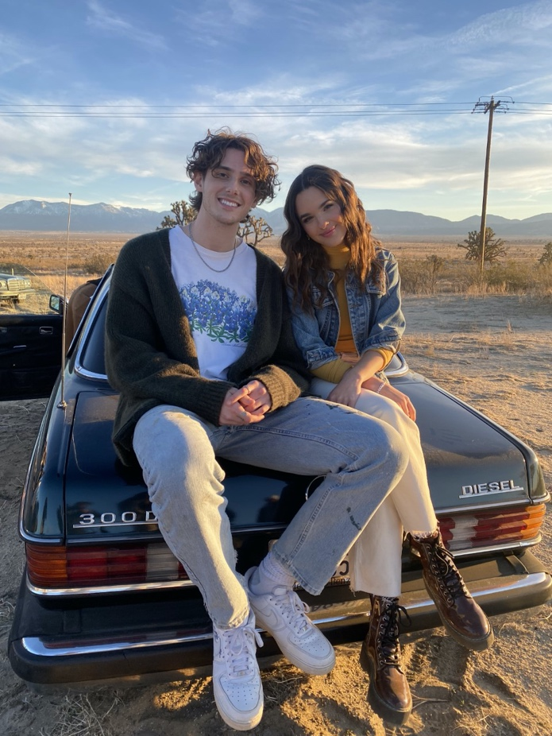
Jenna Raine & JVKE | Photo credit: Kathleen Tagarao

###

FOLLOW JENNA RAINE:
TikTok | Instagram | Twitter | Facebook | YouTube

FOLLOW JVKE:
TikTok | Instagram | YouTube

For more information on Jenna Raine, please contact:
Darren Baber | Warner Records
Darren.Baber@warnerrecords.com

For more information on JVKE, please contact:
Dvora Englefield | The Lede Company
Dvora.Englefield@ledecompany.com

Christopher Iacullo | The Lede Company
chris.iacullo@ledecompany.com

