RISING TROUBADOUR JOHN-ROBERT RELEASES ADELINE EP TODAY

WATCH THE VIDEO FOR NEW VERSION OF “ADELINE” FEATURING
SINGER-SONGWRITER KATHLEEN DIRECTED BY SPENCER FORD HERE

APPEARS ON RICKY REED’S UPCOMING ALBUM THE ROOM ALONGSIDE
ALESSIA CARA ON “FAV BOY” OUT AUGUST 28TH

“…small-town teen poised to become the next big singer-songwriter.” – Ones To Watch

“The young singer-songwriter John-Robert has taken the music industry by storm with his heartfelt lyricism, passionate vocal delivery, and catchy melodies.” – Earmilk
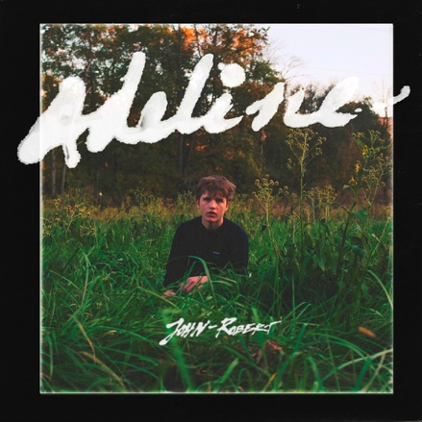
August 21, 2020 (Los Angeles, CA) - Rising artist and producer John-Robert unveils his new Adeline EP today via Nice Life Recording Company and Warner Records. Listen HERE.

The 20-year-old troubadour re-envisioned and reimagined his debut release for the three new interpretations of “Adeline” on the EP. He invited acclaimed Rocky Mountain-raised and Los Angeles-based singer and songwriter Kathleen to accompany him on a heartfelt and hypnotic duet highlighted by delicately picked acoustic guitar and powerful harmonies. Watch the Spencer Ford (Brockhamton) directed video HERE. Showing yet another side of this breakthrough song, he included a cinematic version comprising lush orchestration with a string quartet and lilting vocals arranged by Rob Moose (Bon Iver, Perfume Genius). Additionally, he recruited his friend Joey Pecoraro to remix the song. All three versions appear on the EP alongside the original. Full tracklisting below.

"I fell for someone way too hard in a relationship, and she broke my heart. At the time I thought, maybe this is all part of fate and we can circle back and have a meal together 30 years down the line with hindsight and perspective. ‘Adeline’ is a song about what that conversation might look like” explains John-Robert.

Kathleen added, "When John-Robert and Ricky asked me to be a part of the song, I was already a fan. In thinking of my own role in the story of 'Adeline,' I definitely related to that idea that it brings forth—that love can exist in many forms, and just because it’s over or not mutual in the way you might’ve originally hoped - doesn’t have to mean you stop caring for them. You can still love that person, you both can still love each other regardless of the shape that it takes."

John-Robert originally released “Adeline” independently in April, 2019, prior to signing to Nice Life Recording Company in partnership with Warner Records. The track has since amassed over 1.75 million streams. “Adeline” is featured on John-Robert’s much-praised debut EP Bailey Barely Knew Me which was released in May and features other stand-out tracks “Urs,” “Friends,” “Pelican” and “Love Won’t You Stay.”

Keeping especially busy this summer, he recently contributed “Fav Boy” with GRAMMY®-winning superstar Alessia Cara to Ricky Reed’s forthcoming album The Room, out August 28th. Additionally, he continues to uncover performances from his last show pre-quarantine at the Echo in Los Angeles on March 4th as part of his “Live at The Echo” series. Check out the latest two performances: “Love Won’t You Stay” and “Urs.”

Earlier this year, John-Robert teamed up with the Recording Academy® to perform his rendition of Fiona Apple’s GRAMMY®- winning breakthrough “Criminal” as part of the Recording Academy’s ‘ReImagined’ video series where artists bring a fresh take on classic GRAMMY-winning/nominated songs by their favorite artists. Watch his performance of “Criminal” HERE. He performed “Adeline” for the Recording Academy’s ‘Press Play’ series – watch HERE.

Adeline EP Tracklisting:
- Adeline (featuring Kathleen)
- Adeline (featuring Kathleen) [for String Quartet and Vocal]
- Adeline (Joey Pecoraro Remix)
- Adeline

Photo Credit: Spencer Ford

###

For further information, contact Warner Records Publicity:
National: Darren Baber | Darren.Baber@warnerrecords.com

Regional: Bre Flores | Breanne.Flores@warnerrecords.com

Follow John-Robert
Official | Instagram | Twitter | Facebook | Press Materials

