

**RISING SINGER-SONGWRITER AND ACTOR JOSHUA BASSETT RELEASES NEW SONG & VIDEO “ANYONE ELSE” – WATCH** [**HERE**](https://joshuatbassett.lnk.to/anyoneelsevideo)

**DEBUT EP COMING SOON**

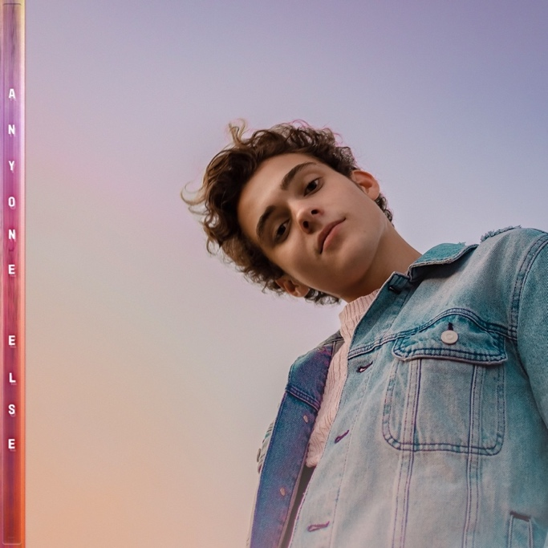

**July 16, 2020 (Los Angeles, CA) –**After making his Warner Records debut in April and attracting acclaim from *E! News*, *Idolator*, *Pop Sugar*, and more, **Joshua Bassett** unveils a brand-new song with accompanying music video entitled **“Anyone Else.”** Not only did Joshua pen the song, he also played guitar, bass, cajón and drums on the track and notably makes his video directorial debut.

Listen to it[**HERE**](https://joshuatbassett.lnk.to/anyoneelse).

Watch it [**HERE**](https://joshuatbassett.lnk.to/anyoneelsevideo).

The rising singer-songwriter, multi-instrumentalist, and star of the breakthrough Disney+ original series *High School Musical: The Musical: The Series* showcases yet another side of his dynamic style. On the track, delicate acoustic guitar gives way to glistening piano as his impressive vocals take hold. “Anyone Else” culminates on the hypnotic hook, *“I promise if you would, I’d love you better than he ever could...”*

Joshua explains, “‘Anyone Else’ came about after the sudden realization that I was hopelessly falling in love with a close friend…who was in a relationship with someone else. ‘How am I supposed to think about anything else’ was the first lyric I wrote and then kinda back-pocketed the idea. After weeks of denial, in hopes that I’d move on and/or my feelings would subside, I had to finish the song and face the reality, ‘I am done pretending I want anyone else.’”

“Anyone Else” arrives on the heels of his very first original release, “Common Sense.” Watch the “Common Sense” video [**HERE**](https://www.youtube.com/watch?v=b7SnbKS4YAQ). Amidst a bevy of praise upon its release, *Idolator* put it best, *“Joshua Bassett is a name you want to familiar yourselves with.”*

Right now, he’s putting the finishing touches debut EP —due out this year.

Joshua Bassett may sing, write, act, and play multiple instruments, but he humbly identifies himself as *“just a kid from San Diego who loves music*.*”* Long before starring in the Disney+ original series *High School Musical: The Musical: The Series*, generating millions of streams, and garnering widespread acclaim, he grew up surrounded by music in the suburb of Oceanside, CA. Described by many as an “old soul,” he played drums in church, taught himself ukulele, guitar, and piano, and wrote his first song for his homecoming date at 15. In addition to being homeschooled alongside his five sisters, he was able to strengthen his voice as a singer and actor in local theater productions. After various television parts on *Dirty John, Grey’s Anatomy* and more, he landed the lead role of Ricky in *High School Musical: The Musical: The Series* which premiered in November 2019. Simultaneously, he feverishly wrote music. Inking a deal with Warner Records, he unveiled his solo debut “Common Sense” in 2020. Within a month, it tallied 5 million total streams and received praise from *Idolator*, *Pop Sugar*, and *E! News* who called it *“a home run on his very first at bat*.*”* On its heels, the single “Anyone Else” illuminates his vocal and instrumental range and hints it even bigger things on the horizon.

###

For further information, please contact:

Darren Baber | Warner Records | 818-953-3751

[Darren.Baber@warnerrecords.com](mailto:Darren.Baber@warnerrecords.com)

Samantha Hill | Viewpoint PR | 310-461-8216

[Samantha.hill@viewpointla.com](mailto:Samantha.hill@viewpointla.com)

Follow Joshua Bassett:

[**Official**](https://www.joshuabassettofficial.com/) **|**[**Instagram**](https://www.instagram.com/joshuatbassett/?hl=en)**|**[**Twitter**](https://twitter.com/joshuatbassett?ref_src=twsrc%5Egoogle%7Ctwcamp%5Eserp%7Ctwgr%5Eauthor)**|**[**Facebook**](https://www.facebook.com/joshuatbassett/)**|** [**Press Materials**](https://press.warnerrecords.com/joshua-bassett/)

