JOSHUA BASSETT SPEAKS HIS TRUTH ON THREE EMOTIONAL NEW SINGLES
“CRISIS / SECRET / SET ME FREE”

ALL EARNINGS FROM “CRISIS” TO BE DONATED TO MENTAL HEALTH ORGANIZATIONS

LISTEN TO “CRISIS / SECRET / SET ME FREE” HERE
WATCH THE VIDEOS HERE

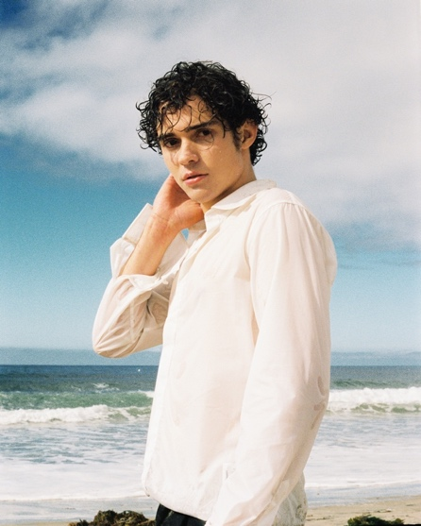
photo credit: Luke Rogers

December 3, 2021 (Los Angeles, CA) – Today, Joshua Bassett documents his tumultuous 2021 with a trio of raw, highly emotional singles complete with their own stunning visuals: “Crisis / Secret / Set Me Free.” Get them HERE via Warner Records. In a bid to help others, the singer, songwriter, and High School Musical: The Musical: The Series actor shares his journey from the depths of grief and emotional trauma to the early stages of healing.

“As stated in ‘Set Me Free,’ ‘It’s been a fucking year,’” the 20-year-old begins an unflinchingly honest statement about the three-song package. “While it’s been one of the most challenging periods in my lifetime by far; it has ultimately led to immense growth.” This is reflected in his new music. “I’ve been up, down, and everywhere in between,” he says. “Each of these songs pinpoint a different moment in time, in my processing.”

“If you get to tell your truth then so do I,” Bassett sings over acoustic guitar on “Crisis,” before setting the record straight: “Half the shit you’re saying is only half true, messing with my life as a career move.” He hopes his story will help others get through their lowest moments. “100% of the earnings for my new single ‘Crisis’ will be donated to mental health organizations in perpetuity,” the multi-talented artist revealed. In honor of Giving Tuesday, he donated a further $1 for every new pre-save/pre-add to Bring Change to Mind, Jack.org, Beyond Blue and Mind UK.

The other tracks pick up where “Crisis” left off—with pure vulnerability. “Secret” finds the budding hitmaker ruing his decisions. “My friends all warned me I should run for the hills, but I defended you still,” he laments over upbeat retro-pop production. The trio of tracks ends with the powerful “Set Me Free,” a beautiful ballad about moving on. “Releasing these vulnerable snippets of my life is equally terrifying and beautifully liberating,” Bassett says.

Bassett’s goal is ultimately to inspire others. “My hope is that those going through similar things feel heard and seen and can step closer to healing. While it’s important to express my truth in art, I do not wish ill will on anyone, nor do I endorse using art as fuel for negativity,” the Oceanside, CA native says. “I truly hope the peace I’ve found amidst this challenging year encourages others to keep going and know that there really is light at the end of the tunnel.” With “Crisis / Secret / Set Me Free,” Bassett not only speaks his truth, but also showcases his growth as a singer, songwriter and musician.

All three songs come with suitably emotional one-take music videos that form an overarching narrative. Bassett strums his guitar at a sunset photoshoot in the intimate “Crisis” visual before standing up and delivering his lyrics straight to the camera. He is then catapulted through a dream sequence and makes a startling discovery in “Secret,” while serenity is the theme of “Set Me Free.” It finds the artist playing the piano on a pristine beach. Watch the visuals HERE.

“Crisis / Secret / Set Me Free” are Bassett’s first releases since “Feel Something,” which helped bring his total global streams to more than 170 million. That track coincided with the budding hitmaker announcing that he was a member of the LGBTQ+ community that he candidly spoke about in profiles in Attitude magazine and GQ. This glowing press followed the arrival of a critically acclaimed, self-titled debut EP at the top of 2021. In October, he was also named to Billboard’s esteemed 21 Under 21 list.

ABOUT JOSHUA BASSETT:
Joshua Bassett may sing, write, act, and play multiple instruments, but he humbly identifies himself as “just a kid from San Diego who loves music.” Long before starring in the Disney+ original series High School Musical: The Musical: The Series, generating millions of streams, and garnering widespread acclaim, he grew up surrounded by music in the suburb of Oceanside, CA. He played drums in church, taught himself ukulele, guitar, and piano, and wrote his first song for his homecoming date at 15. In addition to being homeschooled alongside his five sisters, he was able to strengthen his voice as a singer and actor in local theater productions. After various television parts on Dirty John, Grey’s Anatomy and more, he landed the lead role of Ricky in High School Musical: The Musical: The Series which premiered in November 2019. Simultaneously, he feverishly wrote music. Inking a deal with Warner Records, he unveiled his solo debut “Common Sense” and follow-up “Anyone Else” in 2020, laying the foundation for his 2021 self-titled debut EP in March and critically-lauded single called “Feel Something” in May, racking up over 170 million streams along the way.

FOLLOW JOSHUA BASSETT:
Twitter | Instagram | Website | Facebook | TikTok | Press Materials

For more information, please contact:
Darren Baber | Warner Records | 818-953-3751
Darren.Baber@warnerrecords.com

Samantha Hill | Viewpoint PR | 310-461-8216
Samantha.hill@viewpointla.com

