JOSHUA BASSETT BEGINS A NEW CHAPTER WITH SOUL-BARING SINGLE “DOPPELGÄNGER”

BASSETT CO-DIRECTS COMING OF AGE MUSIC VIDEO WITH YOUTUBER, FILMMAKER & TWITCH STREAMER ELLE MILLS

LISTEN HERE – WATCH THE TOUCHING VIDEO HERE

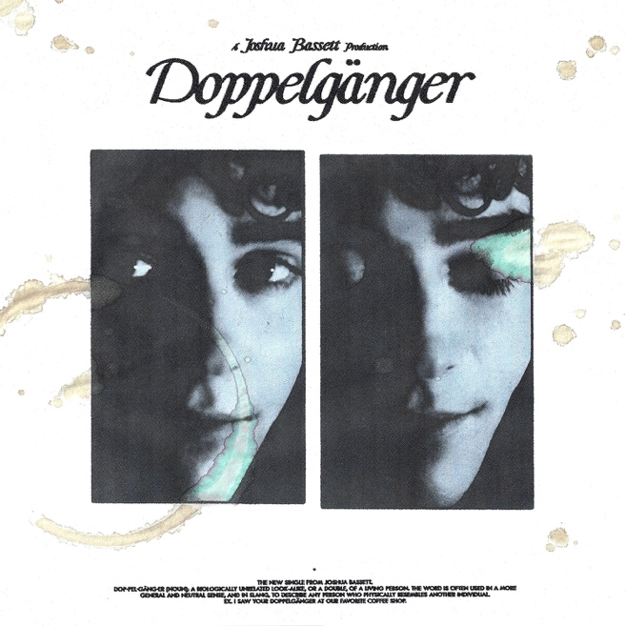

February 25, 2022 (Los Angeles, CA) – Multi-talented singer, songwriter, and actor Joshua Bassett is back today with an emotional new single called “Doppelgänger.” Listen HERE via Warner Records. The 21-year-old’s first new track of 2022 finds him in a contemplative mood, laying his heart bare as he did on last year's raw, vulnerable anthems “Crisis / Secret / Set Me Free.” The track’s reflective tone is perfectly captured by the music video, which was co-directed by Bassett and YouTuber, filmmaker and Twitch Streamer Elle Mills. Watch it HERE.

It turns out "Doppelgänger" was inspired by a real-life event. “The song poured out of me immediately after seeing someone who I thought was my ex at a coffee shop,” the rising hitmaker says. “Sucker punched in the heart, I realized I'm not quite as over them as I thought, and that no one, not even a look-alike, could ever take their place.” That gut-wrenching realization comes through in Bassett's lyrics.

Crooning gently over fingerpicked guitars, the breakout artist reveals his innermost feelings on a melancholy chorus. “I guess I’m not as over you as I thought that I was,” he sings. “I saw someone who looked like you at our favorite coffee shop.” Instead of avoiding his ex, Bassett ultimately comes to the realization that he would welcome a reunion: “Part of me was hoping we would get the chance to talk, guess I’m not as over you as I thought.” It’s another strikingly intimate addition to his discography.

Bassett is beginning a new chapter in 2022. After speaking his truth on “Crisis / Secret / Set Me Free,” the Oceanside, CA, native is ready to move forward. He is currently filming the third season of hit TV show High School Musical: The Musical: The Series and has a few exciting projects in the works including lots more new music on the horizon.

“Crisis / Secret / Set Me Free” were greeted with widespread critical acclaim upon their release in December 2021. The three songs amassed more than 49 million streams and raised money for mental health organizations including a $20K donation from Bassett himself. Those songs, along with last year’s “Feel Something” and his critically acclaimed self-titled debut EP helped bring Bassett’s total global streams to more than 255 million. In October, he was also named to Billboard’s esteemed 21 Under 21 list. With songs like “Doppelgänger,” Bassett is only building on these successes, using sensitive lyrics and gentle instrumentals to establish himself as one of the most exciting—and introspective—songwriters working today.

Photo credit: Callum Hutchinson

###

FOLLOW JOSHUA BASSETT:
TikTok | Instagram | Twitter | Facebook | YouTube | Press Materials

For more information, please contact:
Darren Baber | Warner Records | 818-953-3751
Darren.Baber@warnerrecords.com

