JOSHUA BASSETT WANTS YOU TO “FEEL SOMETHING” ON NEW SINGLE OUT TODAY
WATCH THE SELF-DIRECTED MUSIC VIDEO HERE
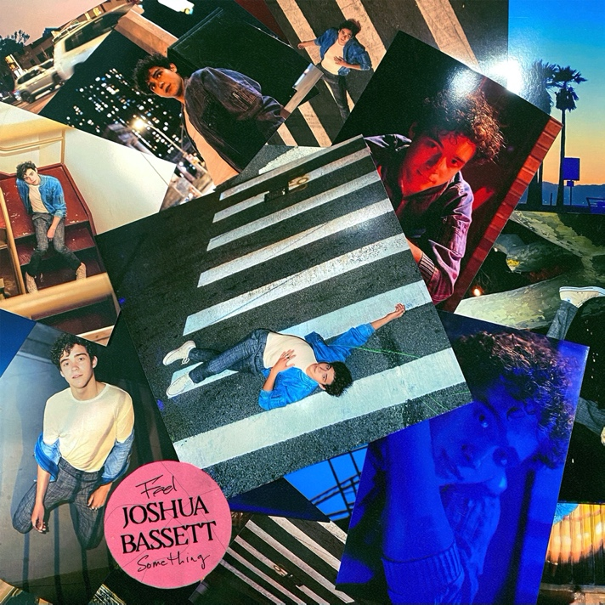
(Click HERE for hi-res image)
May 7, 2021 (Los Angeles, CA) – Continuing his undeniable momentum this year, singer-songwriter, multi-instrumentalist, and actor Joshua Bassett unveils a new single and music video entitled “Feel Something” today. Listen to “Feel Something”—available HERE. Watch the music video for “Feel Something” HERE.
About the song, Joshua shared, “‘Feel Something is a middle-of-the-night, windows down, running-around-the-city-with-your-friends type of song. After a year of lockdown, everyone can relate to ‘doing anything we can just to feel something.’ I’m writing and recording more than I ever have in my life, and I can’t remember the last time I had this much fun making music. I wrote this very recently and was so excited that I just had to put it out as soon as possible! Hope you enjoy!”
The upbeat anthem glides along on shimmering synths as Joshua’s voice fluctuates between intimate verses and a hypnotic high-register refrain. Meanwhile, the accompanying music video plays out like your favorite idyllic John Hughes coming-of-age flick. Co-directed by Joshua and his creative director Sarah Carpenter, it follows our star and three friends on a carefree suburban night complete with a self-service carwash trip gone wild, shopping cart shenanigans, and cinematic moments under the stars.
Joshua keeps making headlines. He recently teamed up with co-star Olivia Rodrigo for the blockbuster duet “Best Part/Even When” from High School Musical: The Musical The Series—out now. Meanwhile, Season 2 of High School Musical: The Musical The Series premieres on May 14.
Earlier this year, Joshua unveiled his self-titled debut EP. Boasting singles such as “Lie Lie Lie” and “Telling Myself,” it has already amassed over 30 million-plus streams and garnered rave reviews from Teen Vogue, Elite Daily, Billboard, Pop Sugar, The New York Times, and more. Additionally, he garnered a nod in the category of “Favorite Male TV Star” at the 2021 Nickelodeon Kids’ Choice Awards, delivered a standout performance on The Ellen DeGeneres Show, and performed his first-ever virtual show, “A Night With Joshua Bassett: A One Night Only Virtual Concert Experience.”
With more music coming soon, Joshua Bassett will continue to make you feel something in 2021!
Joshua Bassett may sing, write, act, and play multiple instruments, but he humbly identifies himself as “just a kid from San Diego who loves music.” Long before starring in the Disney+ original series High School Musical: The Musical: The Series, generating millions of streams, and garnering widespread acclaim, he grew up surrounded by music in the suburb of Oceanside, CA. Described by many as an “old soul,” he played drums in church, taught himself ukulele, guitar, and piano, and wrote his first song for his homecoming date at 15. In addition to being homeschooled alongside his five sisters, he was able to strengthen his voice as a singer and actor in local theater productions. After various television parts on Dirty John, Grey’s Anatomy and more, he landed the lead role of Ricky in High School Musical: The Musical: The Series which premiered in November 2019. Simultaneously, he feverishly wrote music. Inking a deal with Warner Records, he unveiled his solo debut the “Common Sense” and follow-up “Anyone Else” in 2020, laying the foundation for his 2021 self-titled debut EP out now. The 6-song set includes stand out tracks “Lie Lie Lie,” “Telling Myself”, “Only A Matter of Time,” “Heaven Is You” and more.
###
For further information, please contact:
Darren Baber | Warner Records | 818-953-3751
Darren.Baber@warnerrecords.com
Samantha Hill | Viewpoint PR | 310-461-8216
Samantha.hill@viewpointla.com
Follow Joshua Bassett:
Website | Instagram | Twitter | Facebook | Tik Tok | Press Materials

