EMERGING SINGER-SONGWRITER AND ACTOR JOSHUA BASSETT RETURNS WITH NEW SINGLE & VIDEO “LIE LIE LIE” – WATCH HERE

PRE-ORDER JOSHUA’S DEBUT EP HERE
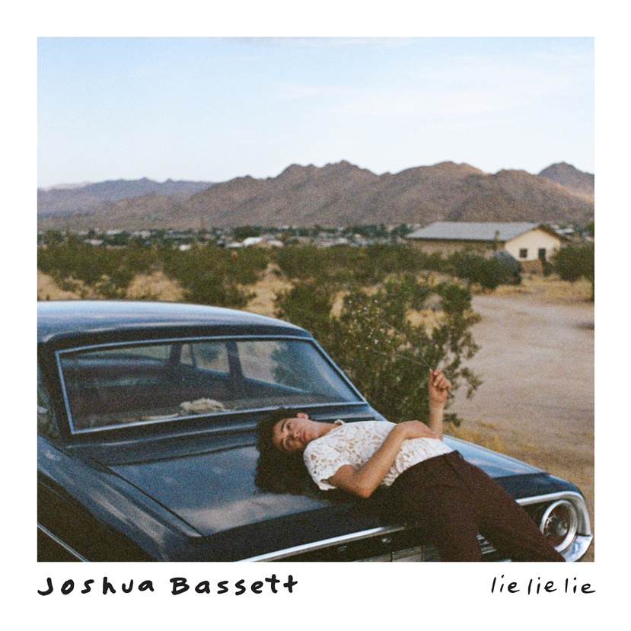
January 14, 2021 (Los Angeles, CA) – Affirming himself as the triple-threat to watch in 2021, singer-songwriter, multi-instrumentalist, and actor Joshua Bassett shares a new song and video “Lie Lie Lie” today. “Lie Lie Lie” is the first release from the rising star’s debut body of work, coming soon on Warner Records. Listen to “Lie Lie Lie” HERE and watch the video which made its broadcast premiere today on MTV Live, MTVU and on the Viacom Times Square billboard HERE. Fans can pre-order Joshua’s self-titled debut EP HERE.
On the track, upbeat acoustic guitar shuffles along to a bold beat as his vocals stretch from slick verses into a falsetto-spiked hook as he promises a duplicitous friend, “It won’t work this time.” Joshua’s uncontainable energy and presence practically jumps off the screen in the accompanying visual, shot in Joshua Tree where he quarantined for much of 2020 while recording the upcoming EP.
About the single, he commented, “I wrote ‘Lie, Lie, Lie' after I found out someone close to me had been lying about me behind my back for a long time. It always sucks to hear that someone you thought you could trust would throw you under the bus when it benefits them. It happens to all of us, and I think all you can do is seek out people that build you up rather than tear you down.”

The song follows last year’s “Anyone Else” and his 2020 Warner Records debut “Common Sense” which was declared “a homerun on his very first at bat” by E! News. POPSUGAR proclaimed, “Prepare to get lost in Joshua Bassett’s vocals…,” while Idolator stated “Joshua Bassett is a name you want to familiarize yourselves with.”

Beyond racking up nearly 100 million total career streams, Joshua has consistently attracted widespread critical applause from the likes of Billboard, Flaunt, Elite Daily, POPSUGAR, E! News, Idolator, and more. He also continues to captivate audiences as the star of the breakthrough Disney+ original series High School Musical: The Musical: The Series. Last month, Joshua appeared on Good Morning America’s “GMA3” and performed his original holiday song “The Perfect Gift” from The High School Musical: The Musical: The Holiday Special soundtrack. Watch his performance and interview HERE.

Stay tuned for the arrival of his debut EP very soon!

Joshua Bassett may sing, write, act, and play multiple instruments, but he humbly identifies himself as “just a kid from San Diego who loves music.” Long before starring in the Disney+ original series High School Musical: The Musical: The Series, generating millions of streams, and garnering widespread acclaim, he grew up surrounded by music in the suburb of Oceanside, CA. Described by many as an “old soul,” he played drums in church, taught himself ukulele, guitar, and piano, and wrote his first song for his homecoming date at 15. In addition to being homeschooled alongside his five sisters, he was able to strengthen his voice as a singer and actor in local theater productions. After various television parts on Dirty John, Grey’s Anatomy and more, he landed the lead role of Ricky in High School Musical: The Musical: The Series which premiered in November 2019. Simultaneously, he feverishly wrote music. Inking a deal with Warner Records, he unveiled his solo debut “Common Sense” and follow-up “Anyone Else” in 2020, paving the way for his self-titled debut EP to arrive this year.

###

For further information, please contact:
Darren Baber | Warner Records | 818-953-3751
Darren.Baber@warnerrecords.com

Samantha Hill | Viewpoint PR | 310-461-8216
Samantha.hill@viewpointla.com

Follow Joshua Bassett:
Official | Instagram | Twitter | Facebook | Tik Tok | Press Materials

