JOSHUA BASSETT DELIVERS HEARTFELT ANTHEM WITH NEW SONG & VIDEO “ONLY A MATTER OF TIME” – WATCH HERE

“LIE LIE LIE” SOARS WITH UNANIMOUS ACCLAIM FROM BILLBOARD, POP SUGAR, TEEN VOGUE, & MORE

PRE-ORDER JOSHUA’S SELF-TITLED DEBUT EP HERE
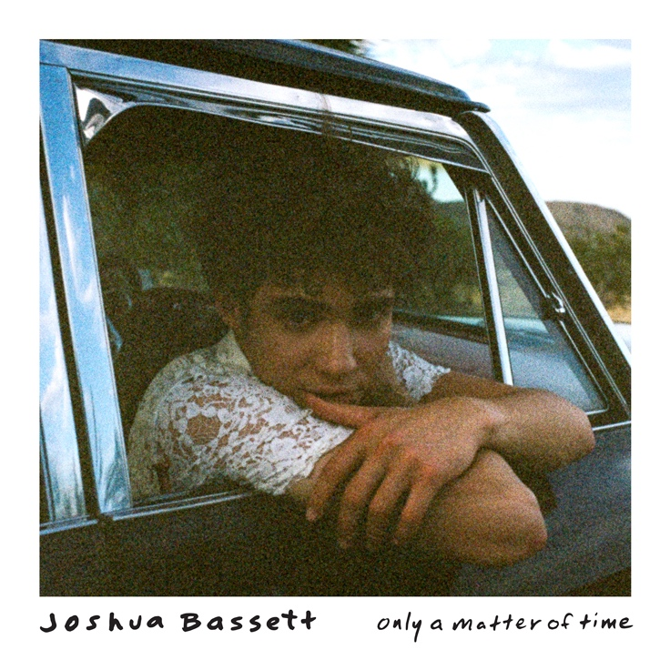
January 28, 2021 (Los Angeles, CA) – Skyrocketing to the forefront of popular culture as the year’s ultimate triple-threat, singer-songwriter, multi-instrumentalist, and actor Joshua Bassett unveils a new song and video “Only A Matter of Time” out now on Warner Records. Listen to “Only A Matter of Time” HERE and watch the video HERE. It stands out as the second track to be revealed from his anxiously awaited self-titled debut EP available for pre-order HERE.

The track pairs his vulnerable vocals with warm piano and delicately plucked acoustic guitar. His impressive high-register takes hold on the hook as he promises, “Well darling I’ll be fine. It’s only a matter of time.” It unfolds as an intimate goodbye letter sealed with raw feelings as he urges kindness in the face of indiscriminate social media noise. The one-shot visual focuses on a close-up of Joshua as he sings on a train track. The tight angle only augments the song’s emotional intensity before he walks away one last time.

About the track, Joshua shared, "I wrote this song in the summer of 2020 in a moment in time where social media was bringing a lot of darkness to my life. It was healing to put my phone down, turn off the noise and just write. There’s good that comes from social media, but it’s also become a place where people can say anything about anyone, no matter how false or damaging with no accountability. We’ve gotta be much kinder to each other and recognize there are real people behind the screens!”

“Only A Matter Of Time” follows the staggering recent success of “Lie Lie Lie,” which garnered universal acclaim. Teen Vogue raved, “‘Lie Lie Lie’ has a 2000s boy band feel in the best way – fun, acoustic, guitar-driven pop,” and ET described it as “a fiery, guitar-driven rebuke of a former lover twisting the truth.” Elite Daily dubbed it “a total #mood,” and Billboard praised his “pop-rock talent, and ability not to mince words in his music.” The New York Times touted it on “The Playlist,” and Pop Sugar captured the excitement best with the admission, “I can’t wait to hear what other pop hits he has in store for his upcoming EP.” Additionally, UPROXX included Joshua on their 2021 Rising Popstars To Watch list.

Taking a moment to give back in a big way, Joshua recently pledged 100% of the proceeds from his merch store to the charity of the buyer’s choosing. Fans who pick up merchandise may pick one of five charities for their money to go to, all of which focus on youth-led movements or organizations led by next generation leaders, including A Long Walk Home, Jack, Teen Line, The Sunrise Movement, and The Young Feminist.

Beyond racking up nearly 100 million total career streams, Joshua has consistently attracted widespread critical applause from the likes of Billboard, Flaunt, Elite Daily, POPSUGAR, E! News, Idolator, and more. He also continues to captivate audiences as the star of the breakthrough Disney+ original series High School Musical: The Musical: The Series.

Joshua Bassett may sing, write, act, and play multiple instruments, but he humbly identifies himself as “just a kid from San Diego who loves music.” Long before starring in the Disney+ original series High School Musical: The Musical: The Series, generating millions of streams, and garnering widespread acclaim, he grew up surrounded by music in the suburb of Oceanside, CA. Described by many as an “old soul,” he played drums in church, taught himself ukulele, guitar, and piano, and wrote his first song for his homecoming date at 15. In addition to being homeschooled alongside his five sisters, he was able to strengthen his voice as a singer and actor in local theater productions. After various television parts on Dirty John, Grey’s Anatomy and more, he landed the lead role of Ricky in High School Musical: The Musical: The Series which premiered in November 2019. Simultaneously, he feverishly wrote music. Inking a deal with Warner Records, he unveiled his solo debut “Common Sense” and follow-up “Anyone Else” in 2020, paving the way for his self-titled debut EP to arrive this year.

###

For further information, please contact:
Darren Baber | Warner Records | 818-953-3751
Darren.Baber@warnerrecords.com

Samantha Hill | Viewpoint PR | 310-461-8216
Samantha.hill@viewpointla.com

Follow Joshua Bassett:
Official | Instagram | Twitter | Facebook | Tik Tok | Press Materials

