LINDSEY LOMIS FINDS BEAUTY IN THE MADNESS ON ALTADENA/WARNER RECORDS DEBUT EP

IN THE MADNESS - LISTEN HERE

LINDSEY TO PERFORM A HOMETOWN LIVESTREAM RELEASE SHOW
TODAY AT 2PM PT
https://app.loopedlive.com/events/2189/live / code LindseyLomis1023

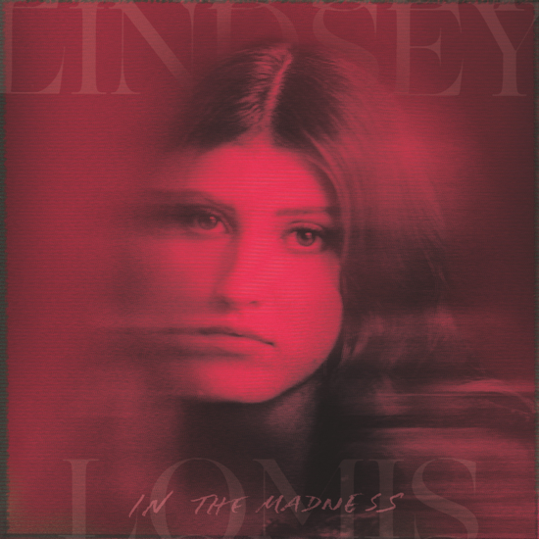

October 23, 2020 (Los Angeles, CA) – Amid a year of constant upheaval, Lindsey Lomis is shining a light on the beauty that can hide within chaos. On her Altadena/Warner Records debut EP, In the Madness, the 17-year-old Nashville powerhouse shares songs that are equal parts mantras and rallying cries for everyone trying to find their footing in 2020. Listen HERE.

Lindsey will celebrate the release with a special livestream performance today, performing all
songs from the EP live from The 5 Spot in Nashville at 2pm PT. Fans can get free virtual ticket
at https://app.loopedlive.com/events/2189/live with code LindseyLomis1023.

Lindsey says she often views her soulful, slow-burning pop anthems as escapes from the worries of the world, but on In The Madness, she was aiming to capture the strange energy of now. “Music is the one thing that really helps me process the chaos and connect with other people,” she says. “I hope this EP allows my audience to simultaneously acknowledge the craziness of the world while also finding the joy within it. These songs will make you feel something; they are the hopeful light—the magic in the madness—that we all need right now.”

On the sultry “Slow Motion” featuring Pop/R&B superstar JoJo which was released last week, Lindsey offers sage advice: Listen to your heart, take a breath, and pause. And the gorgeous new track “Magic in the Madness”—the inspiration for the EP’s title—marries muted keys, atmospheric effects, and lush strings that bring both sparkle and stillness. In the track’s center, Lindsey’s smoky vocals call out with a relatable plea: “All that I want is a little magic in the madness / All that I’m looking for is a little beauty in the sadness.”

In the Madness also includes this summer’s cross-genre and cutting edge “Feel” and the bluesy stomp “Bones,” along with two new tracks “Into You” and “Do You See Me.” A Gen Z powerhouse with an old-soul heart, Lindsey has quickly made it clear she’s an unstoppable force. In 2018, Brandi Carlile hand-picked Lindsey to join her onstage after being wowed by the teen’s stunning cover of “That Wasn’t Me,” and tastemakers like Ones to Watch have compared Lomis’ emotive songwriting to that of Amy Winehouse. At a time when so many of us are struggling to make sense of a wild world, this 17-year-old is using her music to highlight the beauty that still surrounds us.

IN THE MADNESS EP TRACKLIST:
1. Magic In The Madness
2. Feel
3. Slow Motion (Lindsey Lomis + JoJo)
4. Bones
5. Into You
6. Do You See Me?

# # #

FOLLOW LINDSEY LOMIS
Official | Instagram | Twitter | Facebook | YouTube | Press Materials

For more information, contact Warner Records Publicity:
National: Darren Baber | Darren.Baber@warnerrecords.com
Regional: Bre Flores | Breanne.Flores@warnerrecords.com

