LAUNDRY DAY MAKE WARNER RECORDS DEBUT WITH “CONNECT 5”
LISTEN HERE

PREMIERED EXCLUSIVELY ON APPLE MUSIC 1 WITH ZANE LOWE

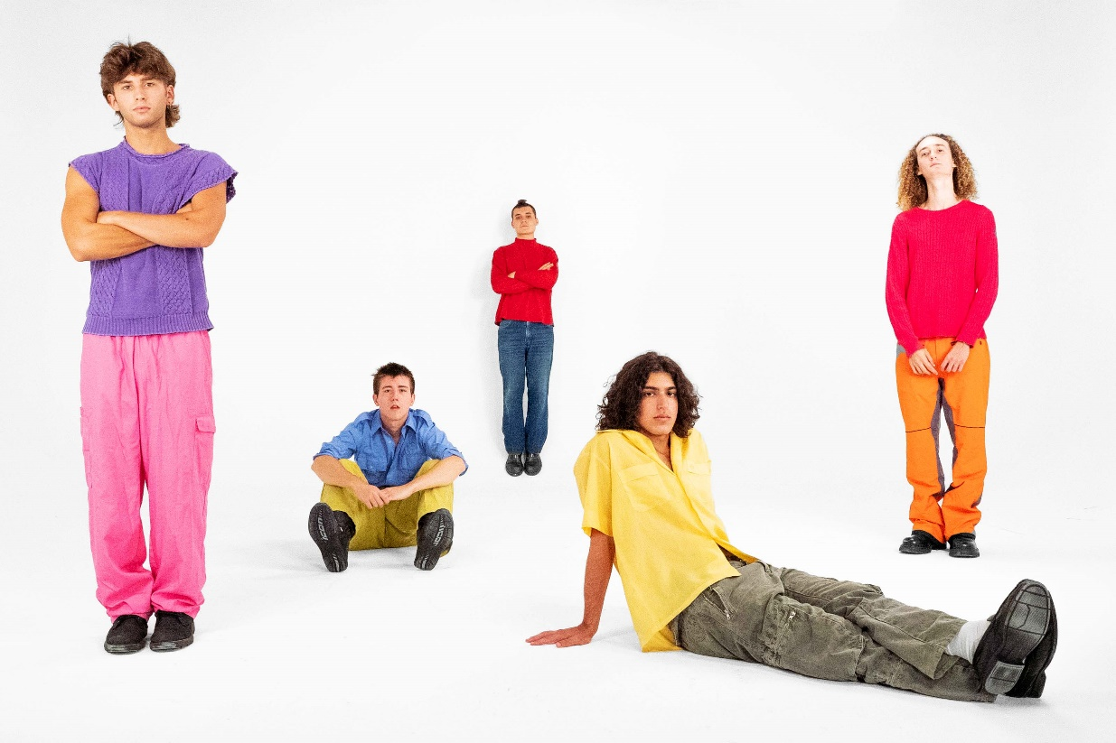

October 13, 2021 (Los Angeles, CA) – New York City's LAUNDRY DAY release brand new single “Connect 5.” Arriving just one year after the band’s high school graduation and following standout festival performances at Lollapalooza, Governors Ball, and Firefly Music Festival this past summer, the new track marks their official debut on Warner Records. Listen to “Connect 5” HERE, which just premiered on Apple Music 1 with Zane Lowe.

About the single, the band commented, "‘Connect 5’ was a song that kind of came right in the middle of the album writing process. This had been the longest time we’d ever spent making an album, and we still had a long way to go. It came at a time where we needed to be reminded to rely on each other and support one another. I think this is reflected in the lyrics and production work throughout the song. It feels like every member gave a piece of themselves to the track in order to ‘make this work’.”

All before even graduating from Beacon High School in Manhattan during June 2020, LAUNDRY DAY sold out shows at iconic venues such as The Bowery Ballroom and The Roxy, canvassed the U.S. and Europe on tour – including runs with The 1975 and Clairo – and earned support from the likes of The FADER, NME, Pigeons & Planes, and i-D who raved, “LAUNDRY DAY is reinventing the teen boy band,” as well as HYPEBEAST who named them among “Best Music Artists on the Come Up.” They recorded their 2019 album HOMESICK with producer Romil Hemnani [BROCKHAMPTON] at Rick Rubin’s Shangri-La Studios in Malibu. Of the latter, Lyrical Lemonade attested, “HOMESICK illustrates the galvanizing energy of a young group with the prowess and skill, both technical and intuitively, of a bunch of veterans, all without skipping a beat.” In 2021, they reteamed with Romil and BROCKHAMPTON’s Kevin Abstract, the production duo Video Store, to cultivate their next evolution in the studio. Additionally, they welcomed legendary producer Brendan O’Brien [Pearl Jam, Red Hot Chili Peppers] into the fold to truly shock their vision to life.

Follow LAUNDRY DAY:
Website | Twitter | Instagram | TikTok

For more information, please contact:
Ceri Roberts | Warner Records
Ceri.Roberts@warnerrecords.com

Patrice Compere | Warner Records
Patrice.Compere@warnerrecords.com

Duncan Will | Orienteer
duncan@orienteer.us

Bradley Bledsoe | Orienteer
bradley@orienteer.us

