LAUNDRY DAY SHARES NEW SONG AND VIDEO
“WORRY BOUT YOURSELF”
LISTEN HERE – WATCH HERE

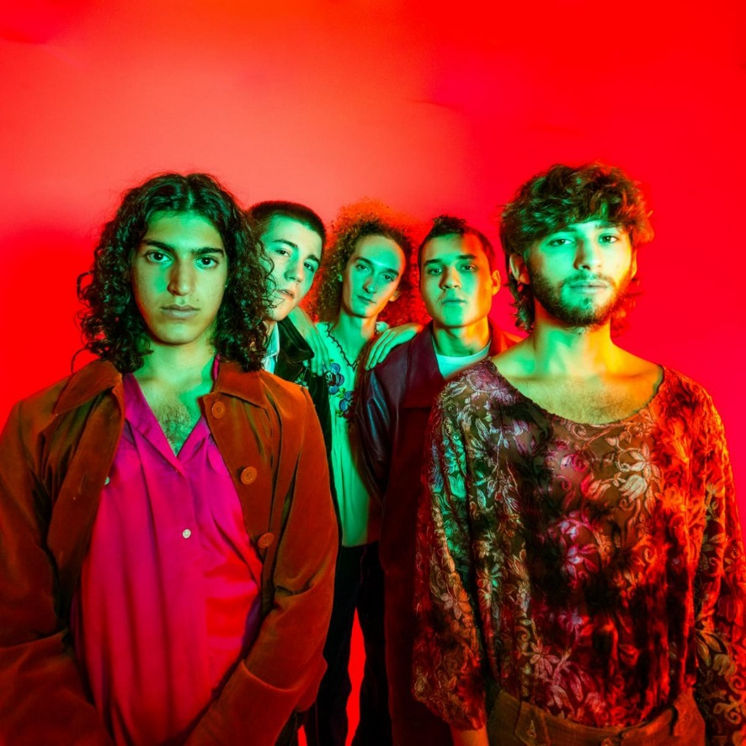

December 3, 2021 (Los Angeles, CA) – New York City's LAUNDRY DAY shares its brand new single “Worry Bout Yourself.” The new song combines outsider r&b with doses of psych pop as it continuously morphs from beginning to end all while being anchored by an upbeat, hand clap-type of rhythm and arrives alongside an accompanying visual that sees the group alternate from superhero costumes to dance floor kings to an Ed Sullivan-esque B&W performance. Arriving after standout festival performances at Lollapalooza, Governors Ball, and Firefly Music Festival this past summer, the new single closely follows "Connect 5" and its accompanying visual released last month, marking the band's first official offering on Warner Records. Watch “Worry Bout Yourself” HERE.

About the single, the band commented, "The song is quite literally about 'worrying about yourself' and how anxiety can leave you with lots of people telling you to relax, and to take a breath, but at the end of the day, you gotta learn to do it ON YOUR OWN. As a band, we were all going through the trials and tribulations of the pandemic in our own ways, but this became a prevalent feeling for all of us. How can I let go?

Despite the song being about handling things on your own, it was as much of a full team effort as you can get. Etai made the main instrumental, Sawyer laid down some scratch

vocal ideas, then Jude recycled some verses from another song and he and Sawyer turned one of Sawyer’s ideas into the chorus. Next thing you know, Henry created the instrumental that led us to the bridge, HP threw his bass magic over everything, and we had the record."

All before even graduating from Beacon High School in Manhattan during June
2020, LAUNDRY DAY sold out shows at iconic venues such as The Bowery Ballroom and The Roxy, canvassed the U.S. and Europe on tour – including runs with The 1975 and Clairo – and earned support from the likes of The FADER, NME, Pigeons & Planes, and i-
D who raved, “LAUNDRY DAY is reinventing the teen boy band,” as well
as HYPEBEAST who named them among “Best Music Artists on the Come Up.” They recorded their 2019 album HOMESICK with producer Romil
Hemnani [BROCKHAMPTON] at Rick Rubin’s Shangri-La Studios in Malibu. Of the latter, Lyrical Lemonade attested, “HOMESICK illustrates the galvanizing energy of a young group with the prowess and skill, both technical and intuitively, of a bunch of veterans, all without skipping a beat.” In 2021, they reteamed with Romil
and BROCKHAMPTON’s Kevin Abstract, the production duo Video Store, to cultivate their next evolution in the studio. Additionally, they welcomed legendary producer Brendan O’Brien [Pearl Jam, Red Hot Chili Peppers] into the fold to truly shock their vision to life.

Watch the video for "Worry Bout Yourself" above and stay tuned for more from LAUNDRY DAY coming soon.

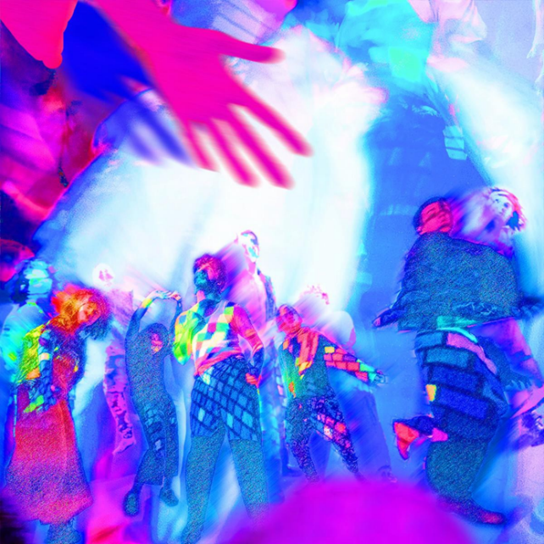

Follow LAUNDRY DAY:
Website | Twitter | Instagram | TikTok

For more information, please contact:
Ceri Roberts | Warner Records
Ceri.Roberts@warnerrecords.com

Patrice Compere | Warner Records
Patrice.Compere@warnerrecords.com

Duncan Will | Orienteer
duncan@orienteer.us

Bradley Bledsoe | Orienteer
bradley@orienteer.us

