LILYISTHATYOU UNLEASHES FEROCIOUS NEW SINGLE “ALL ABOUT ME”

LISTEN HERE

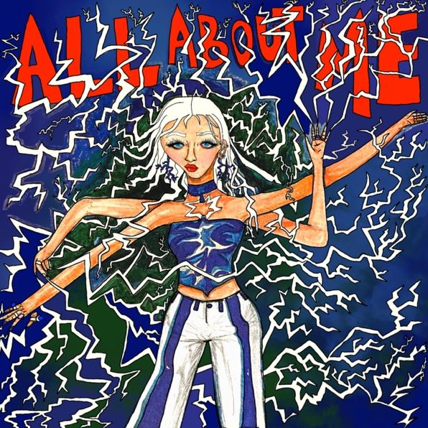

“Lilyisthatyou… knows precisely what she’s doing today, and she’s calling all the shots” – Consequence

April 1, 2022 (Los Angeles, CA) – Today, rising pop star Lilyisthatyou unleashes another brazen party anthem, called “ALL ABOUT ME.” Destined to turn heads and invade eardrums, it’s an irreverent call-to-arms for fun-seekers everywhere with a highly relevant message about self-love. Listen HERE via Warner Records.

The singer, born Lily Davies, comes out of her corner swinging on the rock-infused track, proudly showcasing her penchant for getting wild and reckless over thrumming electric guitars. “Everywhere I go, I bring the chaos,” Lily sings. “Just a little extra, lots of payoffs.” The track then careens into a chorus that is equal parts sweet and savage. Although on the face of it, the track seemingly exudes brash self-indulgence, it’s clear the singer has a lot more on her mind. Namely, sometimes self-interest is about survival.

"This song is about how it is important to be selfish, how if you do not put yourself first, the world will eat you alive,” Lily explains. “But, wow, it is so hard, so hard to believe you deserve good things, good people, healthy communication, boundaries… but you do, and so do I.” Ultimately, it’s the kind of brashly empowering pop that is becoming her trademark.

The catchy single follows quickly on the heels of “Moderation,” another audacious track showcasing the Canadian’s ability to be effortlessly provocative and profound while staking out her own territory in the music landscape. Previously, Lily also dropped the ’80s-soaked single “Purity” in January. Her debut for Warner, “Party 22,” arrived in December, just four months after her first-ever release “FMRN” set the internet on fire to the tune of TikTok virality and 34 million Spotify streams. As “ALL ABOUT ME” proudly displays, Lilyisthatyou isn’t taking prisoners on her path to pop domination.

Photo credit: Justin Abernethy

ABOUT LILYISTHATYOU:
Through her raw and vulnerable take on pop, Lilyisthatyou wants to be the role model she never had. Thanks to defiant, vibrant anthems like “FMRN” (a.k.a. “Fuck Me Right Now”) the 21-year-old has already established herself as a pop singer without parallel, tackling topics others won't—sex, addiction, shame—without preaching or posturing, in order to reach listeners where they are. While she employs all sorts of sounds across her diverse pop songs, she’s committed to making dynamic female-first party anthems. And on her new single, “Party 22,” the freshly minted hitmaker takes a moment to let her hair down. “Party 22” follows the breakout “FMRN,” which has amassed more than 29 million global streams so far. The sex-positive, synth-heavy hit made headlines when it took off on TikTok, then was promptly removed from the platform in July, which only helped spread the song further. Lily’s frankness and confidence—which date back to a childhood of talent shows and home recording—connected with listeners, which strengthened her resolve to be completely transparent. She continues the discourse on upcoming singles like anti-slut-shaming anthem “Purity,” and the addiction-tackling “Moderation.” Her attitude and magnetic personality ensure a common thread runs through her songs, no matter the sound. “There’s an empowered and confident woman singing to you on every track,” Lily says. “I couldn’t identify with any pop star as a teen. I'm still fighting for 15-year-old me.” With much more music on the way, 2022 is shaping up to be Lily’s year!

FOLLOW LILYISTHATYOU:
Twitter | Instagram | Spotify | YouTube | TikTok

For more information, please contact:
Darren Baber | Darren.Baber@warnerrecords.com
Ceri Roberts | Ceri.Roberts@warnerrecords.com

