LILYISTHATYOU ADVOCATES FOR “MODERATION” ON POWERFUL NEW SINGLE

LISTEN HERE – WATCH THE STRIKING VIDEO HERE

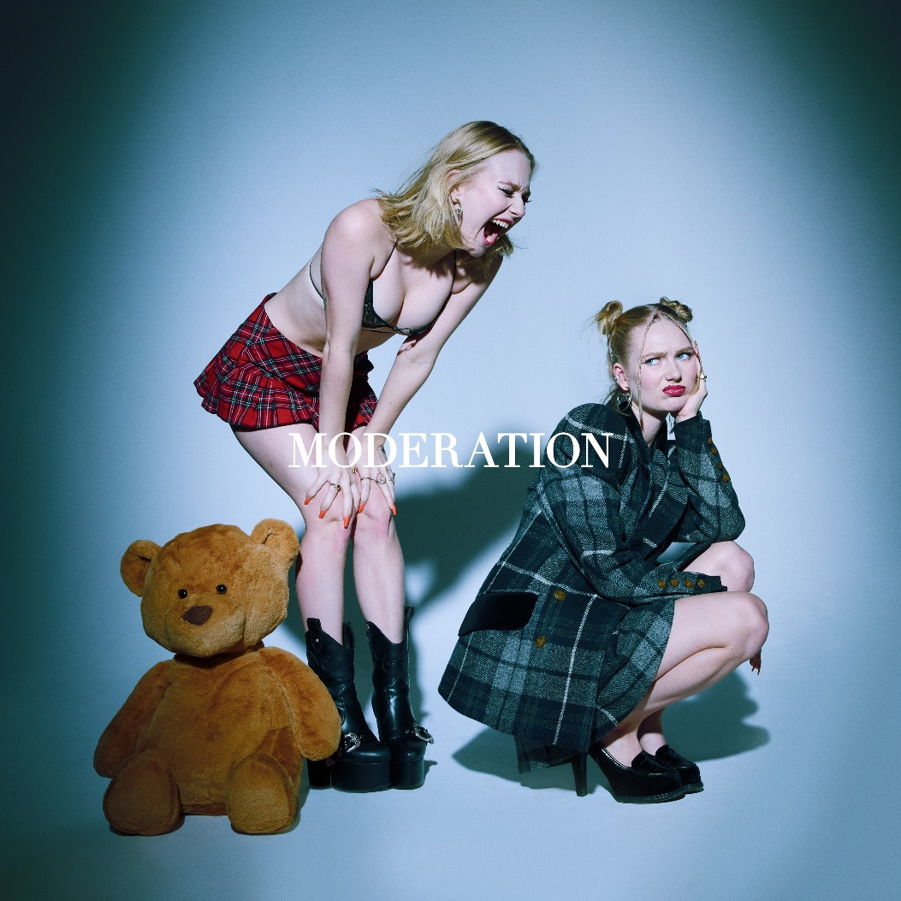

February 25, 2022 (Los Angeles, CA) – Today, Lilyisthatyou continues her run of bold pop singles with “Moderation” via Warner Records. Listen to the vulnerable, rock-tinged track HERE and watch the striking video, which finds the breakout pop star serving fierce looks and serious attitude, HERE.

The artist born Lily Davies puts it all on the line with her distinct, hypnotic vocals underpinned by equally transfixing production. Lilyisthatyou begins the song by admitting she has a tendency to “keep my vices on rotation.” However, after failing to find answers in excess and “chasing meaning, chasing feeling” in all the wrong places, she has concocted a new mantra: “Everything in moderation.”

“I feel a responsibility to be honest with my fan base about my own struggles with substance abuse,” Lilyisthatyou says of the track’s inspiration. “Constantly high, losing touch with reality, losing friendships, jobs, and losing my sense of self, I went into psychotherapy for addiction.” Happily, she is in recovery. “I have come so far and I am still healing but I am so proud to say I no longer feel a dependency on any substance.”

The Toronto native adds: “I don’t condone substance use, nor do I encourage isolating yourself and never going out. In my experience, I have had the most fun as I’ve learned to balance both.” In the accompanying visual, Lily showcases her duality—the “too good” and “downright dirty” versions of herself. Good Lily is prim and pristine, encased in a corset as she peeks into the free, raunchy domain of Bad Lily.

“They look into each other's worlds with jealousy, but both seem to deteriorate in their decisions,” Lilyisthatyou says of the video. “Neither the good nor the bad versions of myself are sustainable ways to be human. It is the balance of these values that makes me feel best.”

“Moderation” follows Lily’s liberating, ’80s-inspired “Purity” single from January, premiered with Rolling Stone who praised how she “channeled evil, sexy cheerleader realness.” Her debut for Warner Records, “Party 22,” arrived in December, roughly four months after her first-ever release “FMRN” set the internet on fire to the tune of TikTok virality and 32 million Spotify streams. Together, they set the stage for pop’s next great provocateur to take flight.

ABOUT LILYISTHATYOU:

Through her raw and vulnerable take on pop, Lilyisthatyou wants to be the role model she never had. Thanks to defiant, vibrant anthems like “FMRN” (a.k.a. “Fuck Me Right Now”), her Warner Records debut “Party 22,” and latest singles “Purity” and “Moderation,” the 21-year-old has already established herself as a pop singer without parallel, tackling topics others won't—sex, addiction, shame—without preaching or posturing, in order to reach listeners where they are. While she employs all sorts of sounds across her diverse pop songs, she’s committed to making dynamic female-first party anthems. Her breakout “FMRN,” for example, has amassed more than 50 million global streams so far. The sex-positive, synth-heavy hit made headlines when it took off on TikTok, then was promptly removed from the platform 24 hours later, which only helped spread the song further. Lily’s frankness and confidence—which date back to a childhood of talent shows and home recording—connected with listeners, which strengthened her resolve to be completely transparent. She continues the discourse with the anti-slut-shaming anthem “Purity,” and the addiction-tackling “Moderation.” Her attitude and magnetic personality ensure a common thread runs through her songs, no matter the sound. “There’s an empowered and confident woman singing to you on every track,” Lily says. “I couldn’t identify with any pop star as a teen. I'm still fighting for 15-year-old me.” With much more music on the way, 2022 is shaping up to be Lily’s year!

Follow LilyIsThatYou:
Twitter | Instagram | Spotify | YouTube | TikTok

For more information, please contact:
Darren Baber | Darren.Baber@warnerrecords.com
Ceri Roberts | Ceri.Roberts@warnerrecords.com

