LILYISTHATYOU REJECTS “PURITY” ON EMPOWERING NEW SINGLE

WATCH THE VIDEO HERE

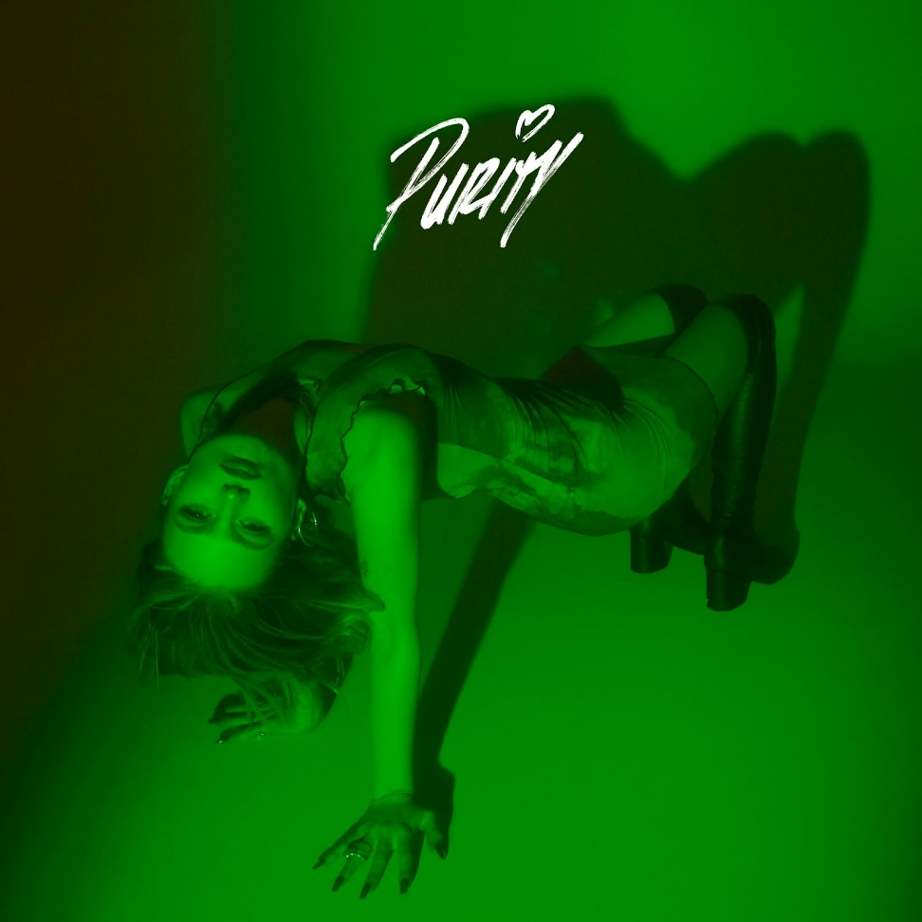

January 21, 2022 (Los Angeles, CA) – Today, breakout pop star Lilyisthatyou returns with a defiant new single and video called “Purity.” The Toronto newcomer rails against misogyny on the catchy, sex-positive anthem. “Call me a slut, call me a whore,” she declares. “It’s obvious you’re insecure, there’s no such thing as purity anymore.” Listen HERE and watch the accompanying retro, cheerleader-themed video HERE.

With “Purity,” the artist born Lily Davies uses vibrant ‘80s-inspired synth as a canvas for her message about reclaiming her autonomy as a woman moving through the world. It’s infectious, but purposeful too. “The purpose of this song is to reshape the language we use around young women’s bodies,” she says. “Sex has always been something others used to define me. Purity is not how many people you have slept with, sex should not make you feel weak or less than. I’ve realized words like ‘slut’ and ‘whore’ only have as much power as I allow them to.”

With its outspoken message, “Purity” picks up where Lilyisthatyou’s first hit “FMRN” left off. An acronym for “Fuck Me Right Now,” Lily’s unapologetic debut single became a sensation on TikTok and then went on to amass more than 30 million Spotify streams. She then followed up with “Party 22,” a feel-good celebration of the possibilities of a new year. “I want to create anthems people will remember from the year the world really came back to life,” Lily says. With “Purity” out now via Warner Records, the pop provocateur is well on her way to achieving that.

photo credit: Brian Ziff

ABOUT LILYISTHATYOU:

Through her raw and vulnerable take on pop, Lilyisthatyou wants to be the role model she never had. Thanks to defiant, vibrant anthems like “FMRN” (a.k.a. “Fuck Me Right Now”) the 21-year-old has already established herself as a pop singer without parallel, tackling topics others won't—sex, addiction, shame—without preaching or posturing, in order to reach listeners where they are. While she employs all sorts of sounds across her diverse pop songs, she’s committed to making dynamic female-first party anthems. And on her new single, “Party 22,” the freshly minted hitmaker takes a moment to let her hair down. “Party 22” follows the breakout “FMRN,” which has amassed more than 29 million global streams so far. The sex-positive, synth-heavy hit made headlines when it took off on TikTok, then was promptly removed from the platform in July, which only helped spread the song further. Lily’s frankness and confidence—which date back to a childhood of talent shows and home recording—connected with listeners, which strengthened her resolve to be completely transparent. She continues the discourse on upcoming singles like anti-slut-shaming anthem “Purity,” and the addiction-tackling “Moderation.” Her attitude and magnetic personality ensure a common thread runs through her songs, no matter the sound. “There’s an empowered and confident woman singing to you on every track,” Lily says. “I couldn’t identify with any pop star as a teen. I'm still fighting for 15-year-old me.” With much more music on the way, 2022 is shaping up to be Lily’s year!

FOLLOW LILYISTHATYOU:
Twitter | Instagram | Spotify | YouTube | TikTok

For more information, please contact:
Darren Baber | Darren.Baber@warnerrecords.com
Ceri Roberts | Ceri.Roberts@warnerrecords.com

