

**ACCLAIMED NASHVILLE SINGER & SONGWRITER LINDSEY LOMIS SHARES NEW SINGLE & MUSIC VIDEO “BONES”**

**WATCH**[**HERE**](https://lindseylomis.lnk.to/bonesvideo)

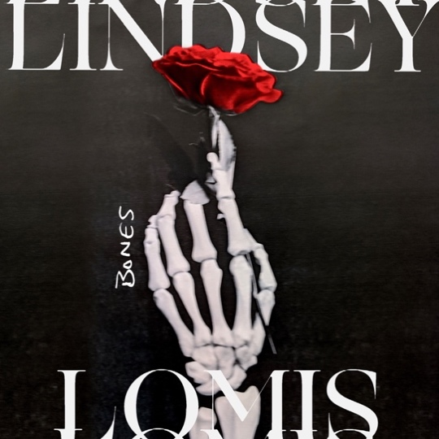

**August 21,2020 (Los Angeles, CA) –**Continuing to turn heads with critical acclaim from *Idolator*, *American Songwriter*, and more, rising 17-year-old Nashville singer, songwriter and multi-instrumentalist **Lindsey Lomis**shares a new song and music video entitled **“Bones”**today. Get it [**HERE**](https://lindseylomis.lnk.to/bones) via **Altadena**/**Warner Records**.

*"It has an upbeat mood despite a dark story,”* said Lindsey about the song. *“I’m calling someone out for trying to manipulate me through their lies. In the end, they’ve dug their own grave, where they ‘lie’ alone. I hope people feel empowered from this song. Sometimes even when you want to help someone, you can tell they’re taking advantage of you. To me, it’s sassy and about standing up for yourself. From the lyrics to the whole vibe of the song, it just makes me feel like a badass."*

Co-written and produced by Ryan Daly, “Bones” has a bluesy bass line that snakes just beneath soulful verses as the percussion builds towards a spunky and spirited send-off, *“I ain’t tryna love you when you lie like bones*.*”* The track highlights Lindsey’s robust vocals and uncanny attitude. Meanwhile, this energy also carries over to the accompanying music video. Watch it [**HERE**](https://lindseylomis.lnk.to/bonesvideo).

The track arrives on the heels of her debut major label release **“Feel**.**”**Gathering tastemaker praise, *[Idolator](https://nam04.safelinks.protection.outlook.com/?url=https%3A%2F%2Fwww.idolator.com%2F7911457%2Flindsey-lomis-makes-major-label-debut-with-feel%3Fsafari%3D1&data=02%7C01%7CBreanne.Flores%40warnerrecords.com%7C6c0accf29bcb46616df408d842ea33ef%7C8367939002ec4ba1ad3d69da3fdd637e%7C0%7C0%7C637332921112243795&sdata=PaBgPCkzDkzVnAPtNSQscm8vjUvvgwH4IJYWODvKu8M%3D&reserved=0)* described it as *“a hook-filled, instantly catchy pop song with enough edge and attitude to set her apart from the crowd*,*”* and [*American Songwriter*](https://nam04.safelinks.protection.outlook.com/?url=https%3A%2F%2Famericansongwriter.com%2Ffeel-by-lindsey-lomis%2F&data=02%7C01%7CBreanne.Flores%40warnerrecords.com%7C6c0accf29bcb46616df408d842ea33ef%7C8367939002ec4ba1ad3d69da3fdd637e%7C0%7C0%7C637332921112243795&sdata=TOCLRPHpJ0b164VuS0O9x2TItaXRJTQByZYf%2FFFNMYw%3D&reserved=0) said, *“a catchy tune with a fantastically driving beat,****‘Feel’****demonstrates the young artist’s innate ability to craft pop songs*.*”* She also unveiled the [music video](https://nam04.safelinks.protection.outlook.com/?url=https%3A%2F%2Fwww.youtube.com%2Fwatch%3Fv%3Dv9Hn4SkNXSA&data=02%7C01%7CBreanne.Flores%40warnerrecords.com%7C6c0accf29bcb46616df408d842ea33ef%7C8367939002ec4ba1ad3d69da3fdd637e%7C0%7C0%7C637332921112253794&sdata=Kixmx8c1OkSoIypyBRldq5Ymyimbz4pagwIk5msh2Dc%3D&reserved=0) and the accompanying stripped-down version [**“Feel (Acoustic)**.**”**](https://nam04.safelinks.protection.outlook.com/?url=https%3A%2F%2Fwww.youtube.com%2Fwatch%3Fv%3D1EL3tqI7FYc&data=02%7C01%7CBreanne.Flores%40warnerrecords.com%7C6c0accf29bcb46616df408d842ea33ef%7C8367939002ec4ba1ad3d69da3fdd637e%7C0%7C0%7C637332921112253794&sdata=7p1uVpwaaVLWNzOmFgB7gL7KIkQMSoFxNlAglncUTJQ%3D&reserved=0)

In less than two years, **Lindsey** has attracted praise from A-list talent and built a growing fan base with her soulful voice and eloquent songcraft. In 2018, Lindsey was personally invited by GRAMMY® Award winner **Brandi Carlile** to join her on stage at her *Girls Just Wanna Weekend*after Lindsey submitted a video to her *Brandi-oke*Contest. In 2019, another live-performance dream came true when Lindsey was offered an opening slot for another one of her favorite musicians, **Bruno Major**, in New York City.  During a recent episode of his *“Live From The Lodge”* YouTube series, **Allen Stone**, who happens to be one of Lindsey’s biggest musical influences, raved about her as an *“effortless singer*.*”*On Instagram Live, **Justin Bieber**and **Corey Harper** notably touted her cover of **Billie Eilish**’s **“Ocean Eyes”** with **Eddie Benjamin**.  The clip which was posted on both Lindsey’s and Eddie’s [Instagram](https://nam04.safelinks.protection.outlook.com/?url=https%3A%2F%2Fwww.instagram.com%2Fp%2FBqDYHgaB8VX%2F&data=02%7C01%7CBreanne.Flores%40warnerrecords.com%7C6c0accf29bcb46616df408d842ea33ef%7C8367939002ec4ba1ad3d69da3fdd637e%7C0%7C0%7C637332921112263783&sdata=0tja3MIw3r0cqNd3MKrnH6YTIdRnQsb%2FGjrLGkhRbY0%3D&reserved=0) has racked up over 1.3 million views. Moreover, her followers on social media are a cadre of superstars, including **Alessia Cara**, **Meghan Trainor**, **Lennon Stella**, **Joe Jonas**, **Shawn Mendes**, **AJ Mitchell, Sophie Turner,** **Ryan Tedder**, and more.

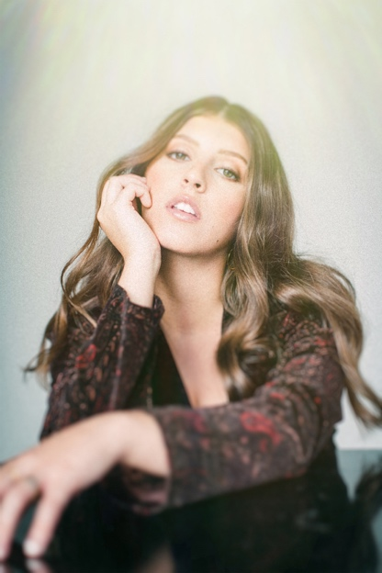

###

For further information, contact **Warner Records Publicity**:

National: Darren Baber | [Darren.Baber@warnerrecords.com](mailto:Darren.Baber@warnerrecords.com)

Regional: Bre Flores | [Breanne.Flores@warnerrecords.com](mailto:Breanne.Flores@warnerrecords.com)

Follow Lindsey Lomis

[Official](https://www.lindseylomis.com/) | [Instagram](https://www.instagram.com/lindseylomis/?hl=en) | [Twitter](https://twitter.com/lindseylomis?lang=en) | [Facebook](https://www.facebook.com/lindseylomis/) | [YouTube](https://www.youtube.com/channel/UCHqJ_3oP2HTTmCHt9rmLhZw) | [Press Materials](https://press.warnerrecords.com/lindsey-lomis/)

