RISING 17-YEAR OLD NASHVILLE SONGSTRESS LINDSEY LOMIS MAKES
ALTADENA/WARNER RECORDS DEBUT WITH “FEEL” – WATCH HERE

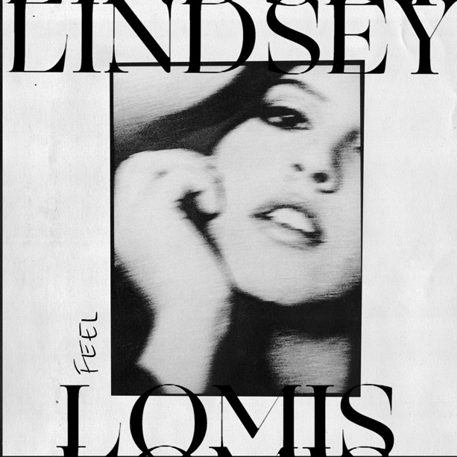

June 12, 2020 (Los Angeles, CA) – After generating millions of streams independently, rising 17-year-old Nashville singer, songwriter and multi-instrumentalist Lindsey Lomis makes her Altadena/Warner Records debut with brand new song and music video “Feel.”

Listen HERE.
Watch it HERE.

From the very first line, Lindsey raises eyebrows with an intense observation, “Did you just call to say you hate me.” As handclaps and bass carry a funky groove, her voice stretches from intimate verses into a fluttering and fiery hook, “I like the way you make me feel. And every time it hurts, at least it’s real.” The track highlights her showstopping range, bluesy timbre, and powerhouse delivery. Lindsey shot the accompanying video during quarantine. Through ruddy vintage filters, the video features her singing in an empty parking lot illuminated by streetlights. The nocturnal vignette ultimately reflects the tune’s raw emotion.

“Feel” sets the stage for Lindsey’s upcoming EP produced by Ryan Daly (Adam Lambert, Fitz & The Tantrums, James Arthur, We The Kings). The cross-genre and cutting-edge song is Lindsey’s first release since 2018’s independently released EP Chapter 1, which was led by breakthrough track “Simple Love.”

In less than two years, Lindsey has attracted praise from A-list talent and built a growing fan base with her soulful voice and eloquent songcraft. In 2018, Lindsey was personally invited by GRAMMY® Award winner Brandi Carlile to join her on stage at her Girls Just Wanna Weekend after Lindsey submitted a video to her Brandi-oke Contest. In 2019, another live-performance dream came true when Lindsey was offered an opening slot for another one of her favorite musicians, Bruno Major, in New York City. During a recent episode of his “Live From The Lodge” YouTube series, Allen Stone, who happens to be one of Lindsey’s biggest musical influences, raved about her as an “effortless singer.” On Instagram Live, Justin Bieber and Corey Harper notably touted her cover of Billie Eilish’s “Ocean Eyes” with Eddie Benjamin. The clip which was posted on both Lindsey’s and Eddie’s Instagram has racked up over 1.3 million views. Moreover, her followers on social media are a cadre of superstars, including Alessia Cara, Meghan Trainor, Lennon Stella, Joe Jonas, Shawn Mendes, AJ Mitchell, Sophie Turner, Ryan Tedder, and more.

With an arsenal of new music on the horizon, 2020 is poised to be an exciting new chapter in Lindsey’s burgeoning career.

###

For further information, contact Warner Records Publicity:
National: Darren Baber | Darren.Baber@warnerrecords.com

Regional: Bre Flores | Breanne.Flores@warnerrecords.com

Follow Lindsey Lomis
Official | Instagram | Twitter | Facebook | YouTube | Press Materials

