LINDSEY LOMIS RETURNS WITH SENTIMENTAL SINGLE “DIE WITH MY FRIENDS”

LISTEN TO “DIE WITH MY FRIENDS” HERE

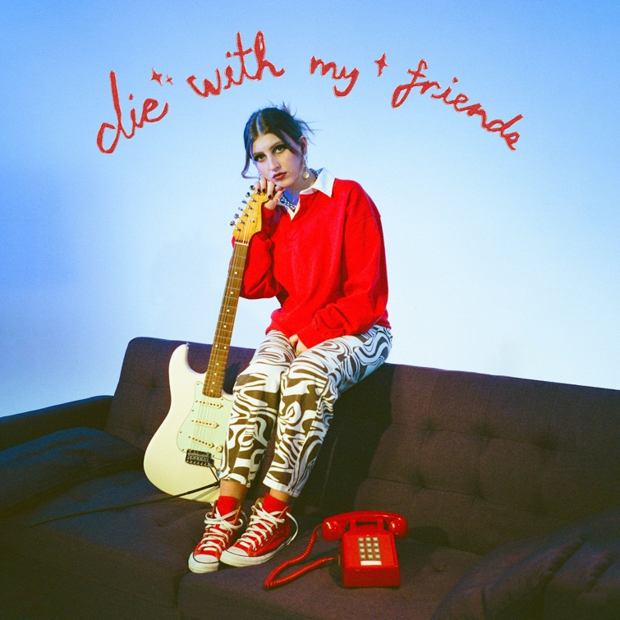

April 22, 2022 (Los Angeles, CA) – Pop-soul powerhouse Lindsey Lomis returns with the sentimental new single “die with my friends” on Altadena/Warner Records. It’s her first new recording since the release of her major-label debut EP, In the Madness, in 2020. Listen HERE.

A bittersweet ode to high school endings and new beginnings, the song began to take shape as Lomis’ friends were leaving for college. “‘die with my friends’ is about the naïve idea that we could all live our separate lives and come back together for the end of them,” she explains. “It’s not about wanting to die, but wanting to spend your life with the people you’re closest to.”

Bursting with that teenage optimism, the track shines with a shimmering guitar lick as Lomis’ soulful vocals evoke a touch of melancholy. “If we’re all gonna die, I might as well die with my friends,” she declares. It’s the kind of heart-tugging, relatable anthem that will be played at proms and high school parties for years to come.

While tastemakers like Ones to Watch have compared her emotive songwriting to that of Amy Winehouse, Lomis continues to define her own voice as she steps into adulthood. Following the release of In the Madness, she spent the last year honing her performance chops, supporting Wild Rivers, The Brook & The Bluff, Lawrence, and now JoJo, her “Slow Motion” collaborator, who she’ll be joining again next month on the European leg of her tour. Stay tuned for more to come from Lomis later this year!
Photo credit: Kirsten Barnett

ABOUT LINDSEY LOMIS:
Lindsey Lomis may be a singer, songwriter, performer, and dog-mom, but she most endeavors to be a friend. The 19-year-old Nashville artist relates with a familial intimacy as she unpacks her experiences through eloquent lyricism and artful instrumentation rooted in jazz-y delivery and uplifted by pop palatability. Such honesty has enabled her to build an unshakable bond with a growing and devoted fan base. At nine-years-old, she embraced music and never let go. After honing her craft for years, she caught the attention of Brandi Carlile with a cover of “That Wasn’t Me,” resulting in a duet on stage with the GRAMMY® Award-winning star. As her independent EP Chapter I gathered millions of streams powered by “Simple Love” and “String of Lights,” she earned the endorsement of high-profile supporters such as Meghan Trainor, Alessia Cara, Allen Stone, Ryan Tedder, Lennon Stella, AJ Mitchell, Shawn Mendes, Sophie Turner, Joe Jonas, and Justin Bieber who touted her on Instagram Live. Signing to Altadena Records and Warner Records, her 2020 EP In The Madness boasted highlights such as “Feel” and “Slow Motion” [feat. JoJo]. After amassing millions of streams and earning acclaim from OnesToWatch, American Songwriter, and Idolator, to name a few, she connects more than ever on her Daydreaming EP [Altadena Records/Warner Records] introduced by the single “die with my friends.”

# # #

FOLLOW LINDSEY LOMIS:
Official | Instagram | Twitter | Facebook | YouTube | Press Materials

For more information, contact Warner Records Publicity:

Darren Baber | Darren.Baber@warnerrecords.com
Regional: Jenny Huynh | Jenny.Huynh@warnerrecords.com

