LINDSEY LOMIS SHARES “CHEEKY” SINGLE “SAVE YOUR BREATH” – LISTEN HERE

FROM HER FORTHCOMING DAYDREAMING EP OUT AUGUST 19

SUPPORTING JOSHUA BASSETT ON TOUR THIS FALL

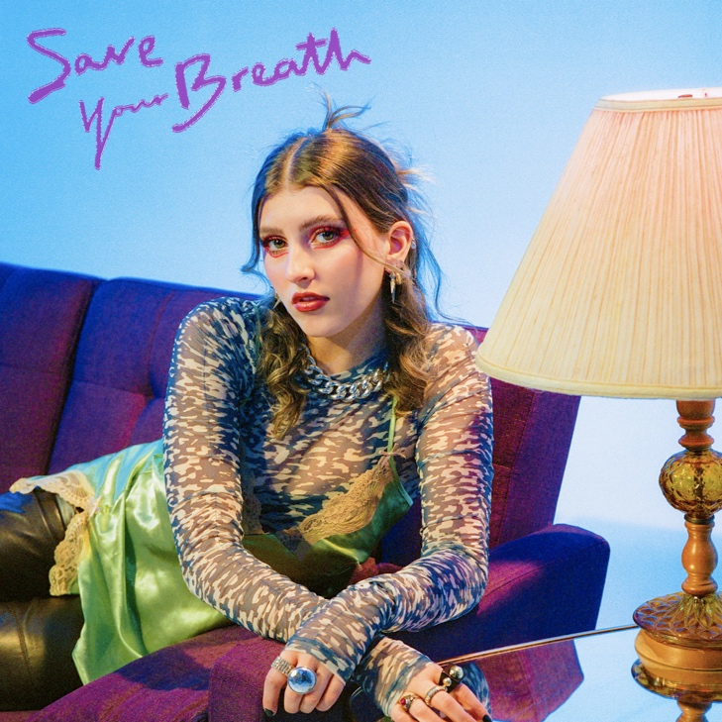

June 3, 2022 (Los Angeles, CA) – Today, pop-soul powerhouse Lindsey Lomis releases her new single “save your breath” via Altadena/Warner Records. Listen HERE. The punchy dance-pop cut will be featured on Lomis’ new EP Daydreaming, set to release on August 19. Pre-save/order HERE.

On “save your breath,” Lomis details a familiar scenario: working up the courage to talk to the cutest person in the room, then regretting it as soon as they open their mouth. “I don’t need to hear your take on morality,” she sings. “I think your opinion might ruin you for me, so keep that easy-on-the-eyes personality.” Her brush-off is fiery yet flirty, her voice strong and intoxicating as she rides a syrupy, funky groove worthy of an uninhibited night out.

“‘save your breath’ is about someone who looks good but doesn’t have much going on in their head,” the 19-year-old Lomis explains. “It’s a fun, cheeky way of saying ‘We don’t need to talk. Let’s just enjoy the night before we part ways.’”

The new track highlights Lomis’ powerful range, both as a singer and songwriter. It follows the sentimental “die with my friends,” which will also appear on her upcoming Daydreaming EP. While tastemakers like Ones to Watch have compared her emotive songwriting to that of Amy Winehouse, she continues to define her own voice as she steps into adulthood.

Following the release of her 2020 EP In the Madness, Lomis has spent the last year honing her performance chops, supporting Wild Rivers, The Brook & The Bluff, and most recently JoJo, her “Slow Motion” collaborator, whom she joined on both the US and European legs of her tour. Come fall, Lomis will be back on the road supporting Joshua Bassett. See tour dates below. No doubt, the intoxicating “save your breath” will be a highlight as she continues to connect with even more new fans, in person.

TOUR DATES WITH JOSHUA BASSETT:
September 9 - Toronto, ON - Axis Lounge
September 12 - New York, NY - Bowery Ballroom
September 13 - New York, NY - Bowery Ballroom
September 14 - Boston, MA - Brighton Music Hall
September 16 - Washington, D.C. - Union Stage
September 17 - Philadelphia, PA - Foundry
September 19 - Chicago, IL - Lincoln Hall
September 22 - Los Angeles, CA - Troubadour
September 23 - Los Angeles, CA - Troubadour
September 24 - San Francisco, CA - Great American Music Hall
September 26 - San Diego, CA - Music Box
September 27 - San Diego, CA - Music Box

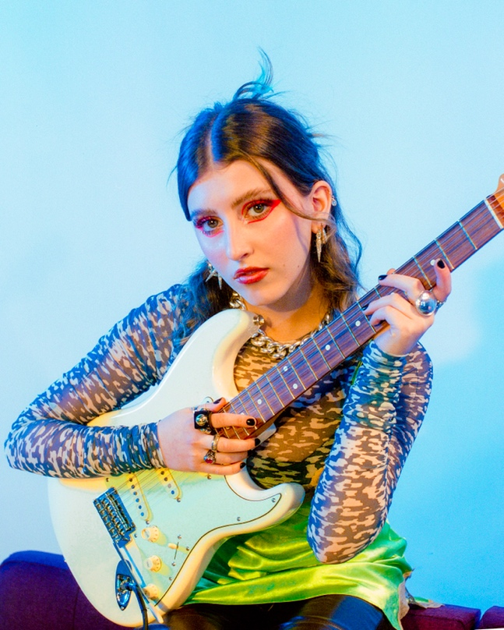
Photo credits: Kirsten Barnett

ABOUT LINDSEY LOMIS:
Lindsey Lomis may be a singer, songwriter, performer, and dog-mom, but she most endeavors to be a friend. The 19-year-old Nashville artist relates with a familial intimacy as she unpacks her experiences through eloquent lyricism and artful instrumentation rooted in jazz-y delivery and uplifted by pop palatability. Such honesty has enabled her to build an unshakable bond with a growing and devoted fan base. At nine-years-old, she embraced music and never let go. After honing her craft for years, she caught the attention of Brandi Carlile with a cover of “That Wasn’t Me,” resulting in a duet on stage with the GRAMMY® Award-winning star. As her independent EP Chapter I gathered millions of streams powered by “Simple Love” and “String of Lights,” she earned the endorsement of high-profile supporters such as Meghan Trainor, Alessia Cara, Allen Stone, Ryan Tedder, Lennon Stella, AJ Mitchell, Shawn Mendes, Sophie Turner, Joe Jonas, and Justin Bieber who touted her on Instagram Live. Signing to Altadena Records and Warner Records, her 2020 EP In The Madness boasted highlights such as “Feel” and “Slow Motion” [feat. JoJo]. After amassing millions of streams and earning acclaim from OnesToWatch, American Songwriter, and Idolator, to name a few, she connects more than ever on her Daydreaming EP [Altadena Records/Warner Records] introduced by the single “die with my friends.”

# # #

FOLLOW LINDSEY LOMIS:
Official | Instagram | Twitter | Facebook | YouTube | Press Materials

For more information, contact Warner Records Publicity:
Darren Baber | Darren.Baber@warnerrecords.com
Regional: Jenny Huynh | Jenny.Huynh@warnerrecords.com

