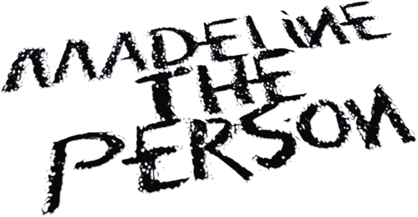

MADELINE THE PERSON EMBRACES THE “GROWING PAINS” WITH NEW EP CHAPTER 2: THE SHEDDING

“UNRECOGNIZABLE” VIDEO OUT NOW – WATCH HERE

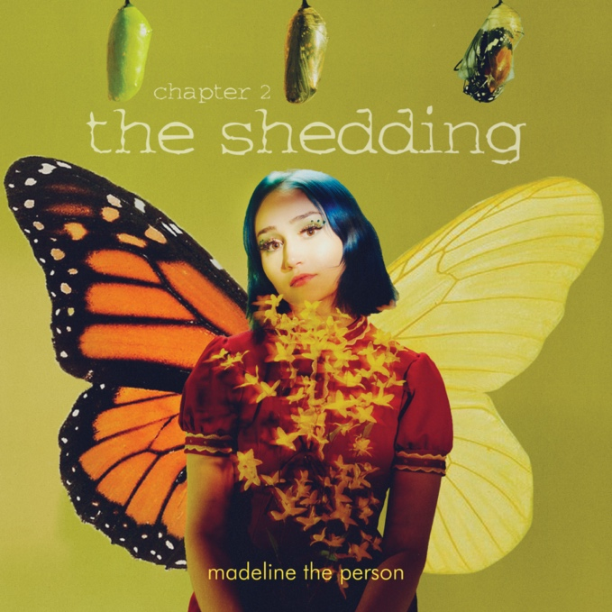

September 17, 2021 (Los Angeles, CA) – Rising alt-pop wunderkind Madeline The Person continues to share her transformative story through her new EP, Chapter 2: The Shedding, out today via Warner Records. To celebrate the release, Madeline unveils a reflective video for “Unrecognizable.” Listen to Chapter 2: The Shedding HERE and watch the video for “Unrecognizable” HERE.
The accompanying video for “Unrecognizable” finds Madeline in a deeply introspective state of mind. Reconnecting with her inner child reminds herself of a time that was simpler and more carefree. She dances freely through a hall of mirrors and draws with her childhood self, making amends with the idea of growing. The video closes as Madeline greets a younger version of herself that seems more accurate to the reality of her past. With dirty blonde hair and a simple outfit, her childhood self gazes back at her in the mirror as she accepts that she has changed.

Of the song, she recalls, “I wrote “Unrecognizable” in a deep depression in which I felt like I had strayed so far from my true identity. I couldn’t recognize the person that my sadness turned me into, and it scared me. The idea of my younger self was something that got me through this time and reminded me of my purpose. I remembered my passion and pure joy as a kid, and I worked hard to get that back. It’s still hard sometimes, but it is now a goal of mine to make decisions daily that contribute to my love for the person I am.”

Chapter 2: The Shedding picks up right where Madeline left off on Chapter 1: The Longing. Once again, she plunges down a rabbit hole of raw emotion with enough vibrancy to make everything better. The four-track collection contains the previously released singles “August” featuring Adam Melchor and “Haunted,” with new vulnerable additions “Unrecognizable” and “Growing Pains.”
Receiving widespread critical acclaim, Billboard described “Haunted” as “a song where Madeline openly sings of the pain that comes with losing someone you love too soon, especially at an early age.” People also featured Madeline on their Emerging Artists list earlier this year.
Regarding Chapter 2: The Shedding, she says, “Chapter 2: The Shedding” is about my identity and its shaping. Sometimes, it’s a painful process of elimination to figure out who you are. Much like “The Longing,” I wanted to highlight the struggle of growth, but in the lens of my younger self, pining to find a way to live life that felt exciting and authentic after feeling death so closely. Accepting the version of myself that came out of my cocoon has been the most wonderful experience of my life thus far. I want these songs to reach the people who are changing right now. The ones who consistently evolve, create, destroy, and start all over again.”
Madeline the Person feels everything at once. Bright and colorful on the outside, the Houston, Texas native uses her music to express the more painful aspects of her world. Having built a substantial following on TikTok (732k followers) with covers of Frank Ocean, Phoebe Bridgers, Harry Styles, Lizzo, Joni Mitchell, Queen and more, the 20-year-old made her first foray into original music with the release of her EP, ‘Chapter 1: The Longing,’ which includes the somber & evocative "As A Child,” as well as “I Talk to the Sky,” both deep reflections on grief & the loss of her father. With several more heartfelt releases in store for 2021, Madeline the Person is already shining as bright as the future that lies ahead.

Chapter 2: The Shedding Tracklisting:
- August (feat. Adam Melchor)
- Growing Pains
- Unrecognizable
- Haunted

# # #
For further information, please contact:
Darren Baber | Warner Records | 818-953-3751
Darren.Baber@warnerrecords.com
Follow Madeline the Person:
TikTok |Instagram |Twitter | YouTube |Press Materials

