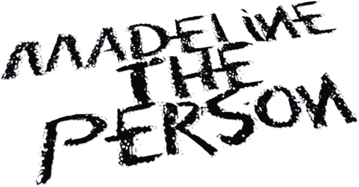
MADELINE THE PERSON IS STUCK IN “AUGUST” ON NEW SINGLE FEATURING ADAM MELCHOR
August 13, 2021 (Los Angeles, CA) — Attempting to the close the gap between star-crossed lovers, alt-pop wunderkind Madeline The Person dreams out loud on her new single “August” featuring Adam Melchor. Listen to “August” HERE. Watch the music video for “August” HERE.
On the track, her delicate delivery cracks with longing over soft piano as she confesses, “I just miss my dog, and I miss you all the more.” Madeline’s chorus gives way to Melchor’s response carried by a slow beat wrapped in acoustic guitar. As their voices entwine, the track arrives at a moment of relief as she admits “And suddenly, I don’t feel so alone.”
About the song, Madeline shared, “I wrote “August” at a time of my life that was full of lovesickness and missing someone I had just begun a relationship with. The song is an expression of how much of a mess I was when my biggest crush ever had to live across the country. I felt silly for missing someone so much and falling apart about it. The line about gluing my fingers together actually happened. I was making jewelry to get my mind off of the longing in my heart and the metal adhesive got all over my hands and I truly panicked trying to pull my hands apart. I looked around my room and realized it was the messiest it has ever been and I thought, “Okay, this is a song,” and I wrote it as soon as I got my fingers unstuck.”

In the accompanying video directed by Angela Kohler [Liz Phair, The Maine], lonely mornings and restless days blend together as Madeline and Melchor yearn to connect before finally breaking through. It seamlessly translates all of the song’s feels to the screen!
On working with Adam on the video, Madeline commented, “I wanted the music video to show Adam and I occupying the same space at different times. I wanted to bring light to the parallels in our separate ways of going through the motions and how much it makes your heart ache to witness. Adam was incredible to work with. I can’t imagine someone being more eager to do the silly things I suggested for the video. I had so much fun styling him and doing his makeup. He really wanted to bring my vision to life, and I’m so grateful for that.”
Madeline the Person feels everything at once. Bright and colorful on the outside, the Houston, Texas native uses her music to express the more painful aspects of her world. Having built a substantial following on TikTok (nearly 500k followers) with covers of Frank Ocean, Phoebe Bridgers, Harry Styles, Lizzo, Joni Mitchell, Queen and more, the 19-year-old made her first foray into original music with the release of her EP, ‘CHAPTER 1: The Longing,’ which includes the somber & evocative "As A Child,” as well as “I Talk to the Sky,” both deep reflections on grief & the loss of her father. With several more heartfelt releases in store for 2021, Madeline the Person is already shining as bright as the future that lies ahead.
# # #
For further information, please contact:
Darren Baber | Warner Records | 818-953-3751
Darren.Baber@warnerrecords.com
Follow Madeline the Person:
TikTok | Instagram | Twitter | YouTube | Press Materials

