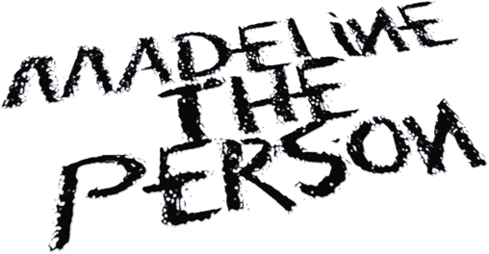
MADELINE THE PERSON INVITES EVERYONE INTO PERSONVILLE ON HER
DEBUT EP CHAPTER 1: THE LONGING
SHARES MUSIC VIDEO FOR NEW SINGLE “I TALK TO THE SKY” - WATCH THE VIDEO HERE

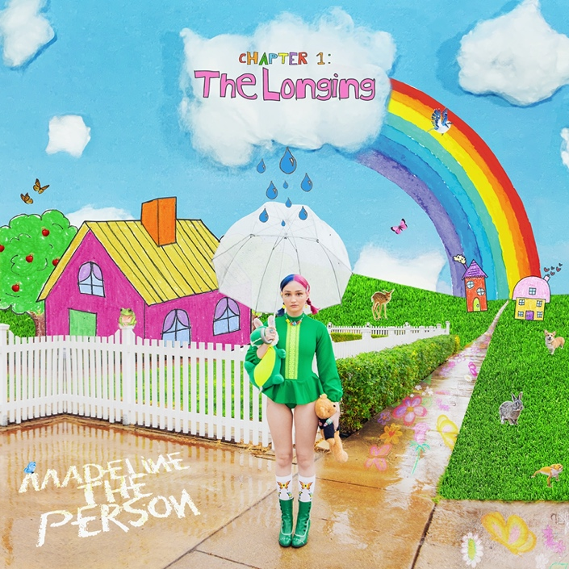
April 30, 2021 (Los Angeles, CA) – Imagine a world where pain dissolves into pops of color and trauma transforms into art meant to be passed along like a smile. Alt-Pop wunderkind Madeline the Person unlocks that world on her debut EP, CHAPTER 1: The Longing, out today on Warner Records. Listen to CHAPTER 1: The Longing HERE and watch the video for her new single “I Talk To The Sky” HERE.
Sonically and visually, “I Talk To The Sky” brings listeners right into the heart of Personville—her rainbow-colored art emporium where all humans and all feelings are welcome to express themselves. In the clip, she bounces on a trampoline against a clear cloud-less blue sky. The video jumps from her in a valley ensconced by mountains to sitting on a bed in the middle of a field, clutching her teddy bear as she sings. The earthy beat underscores an emotionally charged elegy as she confesses, “I write down the things I wish I could say to you. I talk to the sky.”
Of the song, she recalls, “I wrote ‘I Talk To The Sky’ a couple of weeks after my dad passed away when I was 15. It felt really weird to want to talk to him about the fact that he had died, but he was the only person I actually couldn’t talk to. So, at night, I told the sky everything I wanted to tell him, and I imagined the sky as the perfect messenger. The sky became my really good friend. Talking to the sky got me through the hardest point in my life, so I hope this song encourages others to try their own version of it. Talk to anything or anyone about your feelings, and you will be set free.”
She set the stage for CHAPTER 1: The Longing with “As A Child” which was released last month and is nearing 2 million audio and music video streams. Receiving widespread critical acclaim, Billboard described it as “a song where Madeline openly sings of the pain that comes with losing someone you love too soon, especially at an early age.” Meanwhile, Melodic Magazine christened her “an angelic voice that can’t be matched,” and TheHoneyPop promised, “You’ll fall in love with the melancholic and amazingly melodic folk-pop.”
Elsewhere on the EP, soft acoustic guitar wraps around her warm delivery on “Going Home.” The project concludes with the standout “Gladly.” As strings uphold delicate piano, she reveals, “So I’ll tell you the secrets to survive, you just laugh and cry harder and scream to survive.”
Regarding CHAPTER 1: The Longing, she says, “CHAPTER 1: The Longing is about the first half of my life that happened to be full of loss. I chose to tell my story in CHAPTERS, because it helps me to process the real things that have happened to me if I imagine that it’s all in a storybook. It reminds me that there’s so much more to write and experience. From childhood to now, I have become so familiar with the feeling of longing for something I cannot have, because it no longer exists in the physical world. I cannot think of growing without remembering the pain of longing. I hope this collection of songs lands in the laps of the people that need to hear it most—the people who endlessly long for things that are harder to reach.”

Madeline the Person feels everything at once. Bright and colorful on the outside, the Houston, Texas native uses her music to express the more painful aspects of her world. Having built a substantial following on TikTok (nearly 500k followers) with covers of Frank Ocean, Phoebe Bridgers, Harry Styles, Lizzo, Joni Mitchell, Queen and more, the 19-year-old makes her first foray into original music with the release of her EP, ‘CHAPTER 1: The Longing,’ which includes the somber & evocative "As a Child,” as well as “I Talk to the Sky,” both deep reflections on grief & the loss of her father. With several more heartfelt releases in store for 2021, Madeline the Person is already shining as bright as the future that lies ahead.
Now, Madeline The Person speaks for countless fans with CHAPTER 1 and much more to come…

# # #
For further information, please contact:
Darren Baber | Warner Records | 818-953-3751
Darren.Baber@warnerrecords.com
Follow Madeline the Person:
TikTok |Instagram |Twitter | YouTube |Press Materials

