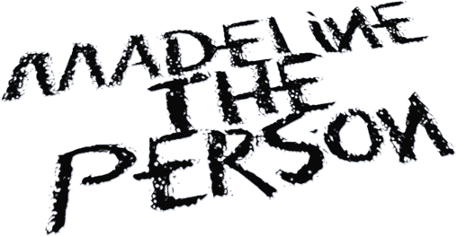
MADELINE THE PERSON UNWRAPS HER TRUTH ON NEW SINGLE “HAUNTED”
ANNOUNCES NEW EP CHAPTER 2: THE SHEDDING OUT SOON
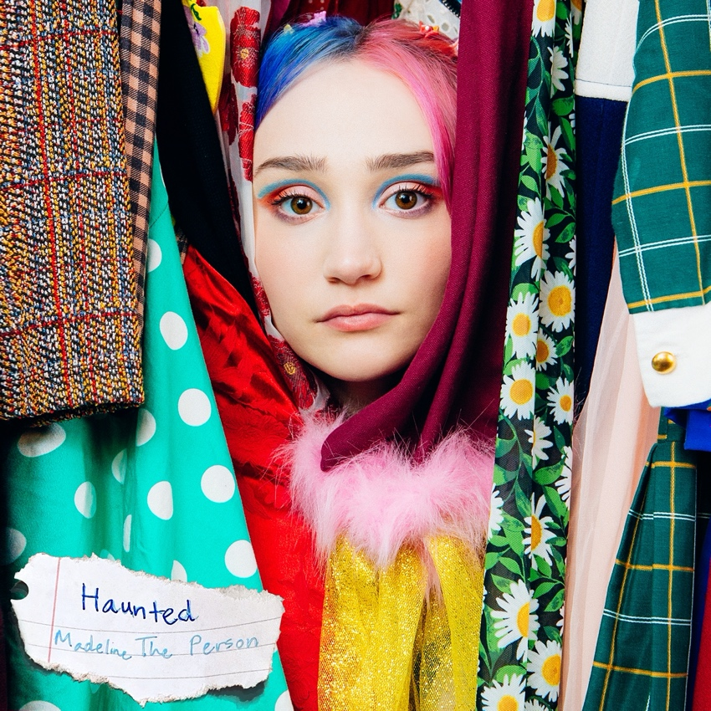
May 29, 2021 (Los Angeles, CA) — Making her most personal statement yet, Alt-Pop wunderkind Madeline The Person gets real on her heartbreaking new single “Haunted.” Listen to “Haunted” HERE. Watch the music video filmed in Madeline’s actual closet HERE.
About the single, she shared, “‘Haunted’ is a song for all of the hidden love that wants to be set free. I remember so badly needing to exclaim my love for the first time ever. It was hard to realize that coming out has to happen on your time. Be patient with the people close to you. They will tell the world who they are eventually. When they do, it will be so beautifully joyous. ‘Haunted’ is the story of my first love and its painful but beautiful secrecy. I want this song to be a reminder that love carries no shame and is meant to be celebrated instead of hidden.”
Over softly stark acoustic guitar, she bravely details her coming out and paints a vivid picture of her first relationship with a girl. Right from the jump, she intones, “You were the first girl that I wanted…every day felt like a movie, like one that’s sweet and slightly gloomy.” This balance of joy and sadness elevates the hook as she pleads, “Why’d you go back in the closet? All the heavy things are in it.”
She confronts the pain of society’s stigmatization head-on with her head held up high, nonetheless. Even in the midst of darkness, Madeline The Person always shines hope without compromise or apology.
The song paves the path for the arrival of her forthcoming EP, CHAPTER 2: The Shedding, coming very soon. It picks up right where she left off on CHAPTER 1: The Longing.
Inciting widespread praise as of late, Houston Press proclaimed, “Madeline The Person represents a new generation of breakthrough artists,” while American Songwriter sat down with her for an exclusive interview.
She initially set the stage for the first EP with “As A Child,” which was released last month and is nearing 2 million audio and music video streams. Receiving widespread critical acclaim, Billboard described it as “a song where Madeline openly sings of the pain that comes with losing someone you love too soon, especially at an early age.” Meanwhile, Melodic Magazine christened her “an angelic voice that can’t be matched,” and TheHoneyPop promised, “You’ll fall in love with the melancholic and amazingly melodic folk-pop.”
Madeline the Person feels everything at once. Bright and colorful on the outside, the Houston, Texas native uses her music to express the more painful aspects of her world. Having built a substantial following on TikTok (nearly 500k followers) with covers of Frank Ocean, Phoebe Bridgers, Harry Styles, Lizzo, Joni Mitchell, Queen and more, the 19-year-old makes her first foray into original music with the release of her EP, ‘CHAPTER 1: The Longing,’ which includes the somber & evocative "As A Child,” as well as “I Talk to the Sky,” both deep reflections on grief & the loss of her father. With several more heartfelt releases in store for 2021, Madeline the Person is already shining as bright as the future that lies ahead.
Now, Madeline The Person speaks for countless fans with much more to come…

# # #
For further information, please contact:
Darren Baber | Warner Records | 818-953-3751
Darren.Baber@warnerrecords.com
Follow Madeline the Person:
TikTok |Instagram |Twitter | YouTube |Press Materials

