BUZZING D.I.Y. SINGER/SONGWRITER MYKEY
UNVEILS NEW SONG “PLEASE DON’T GO”

Shares Self-Directed iPhone Music Video
Watch HERE

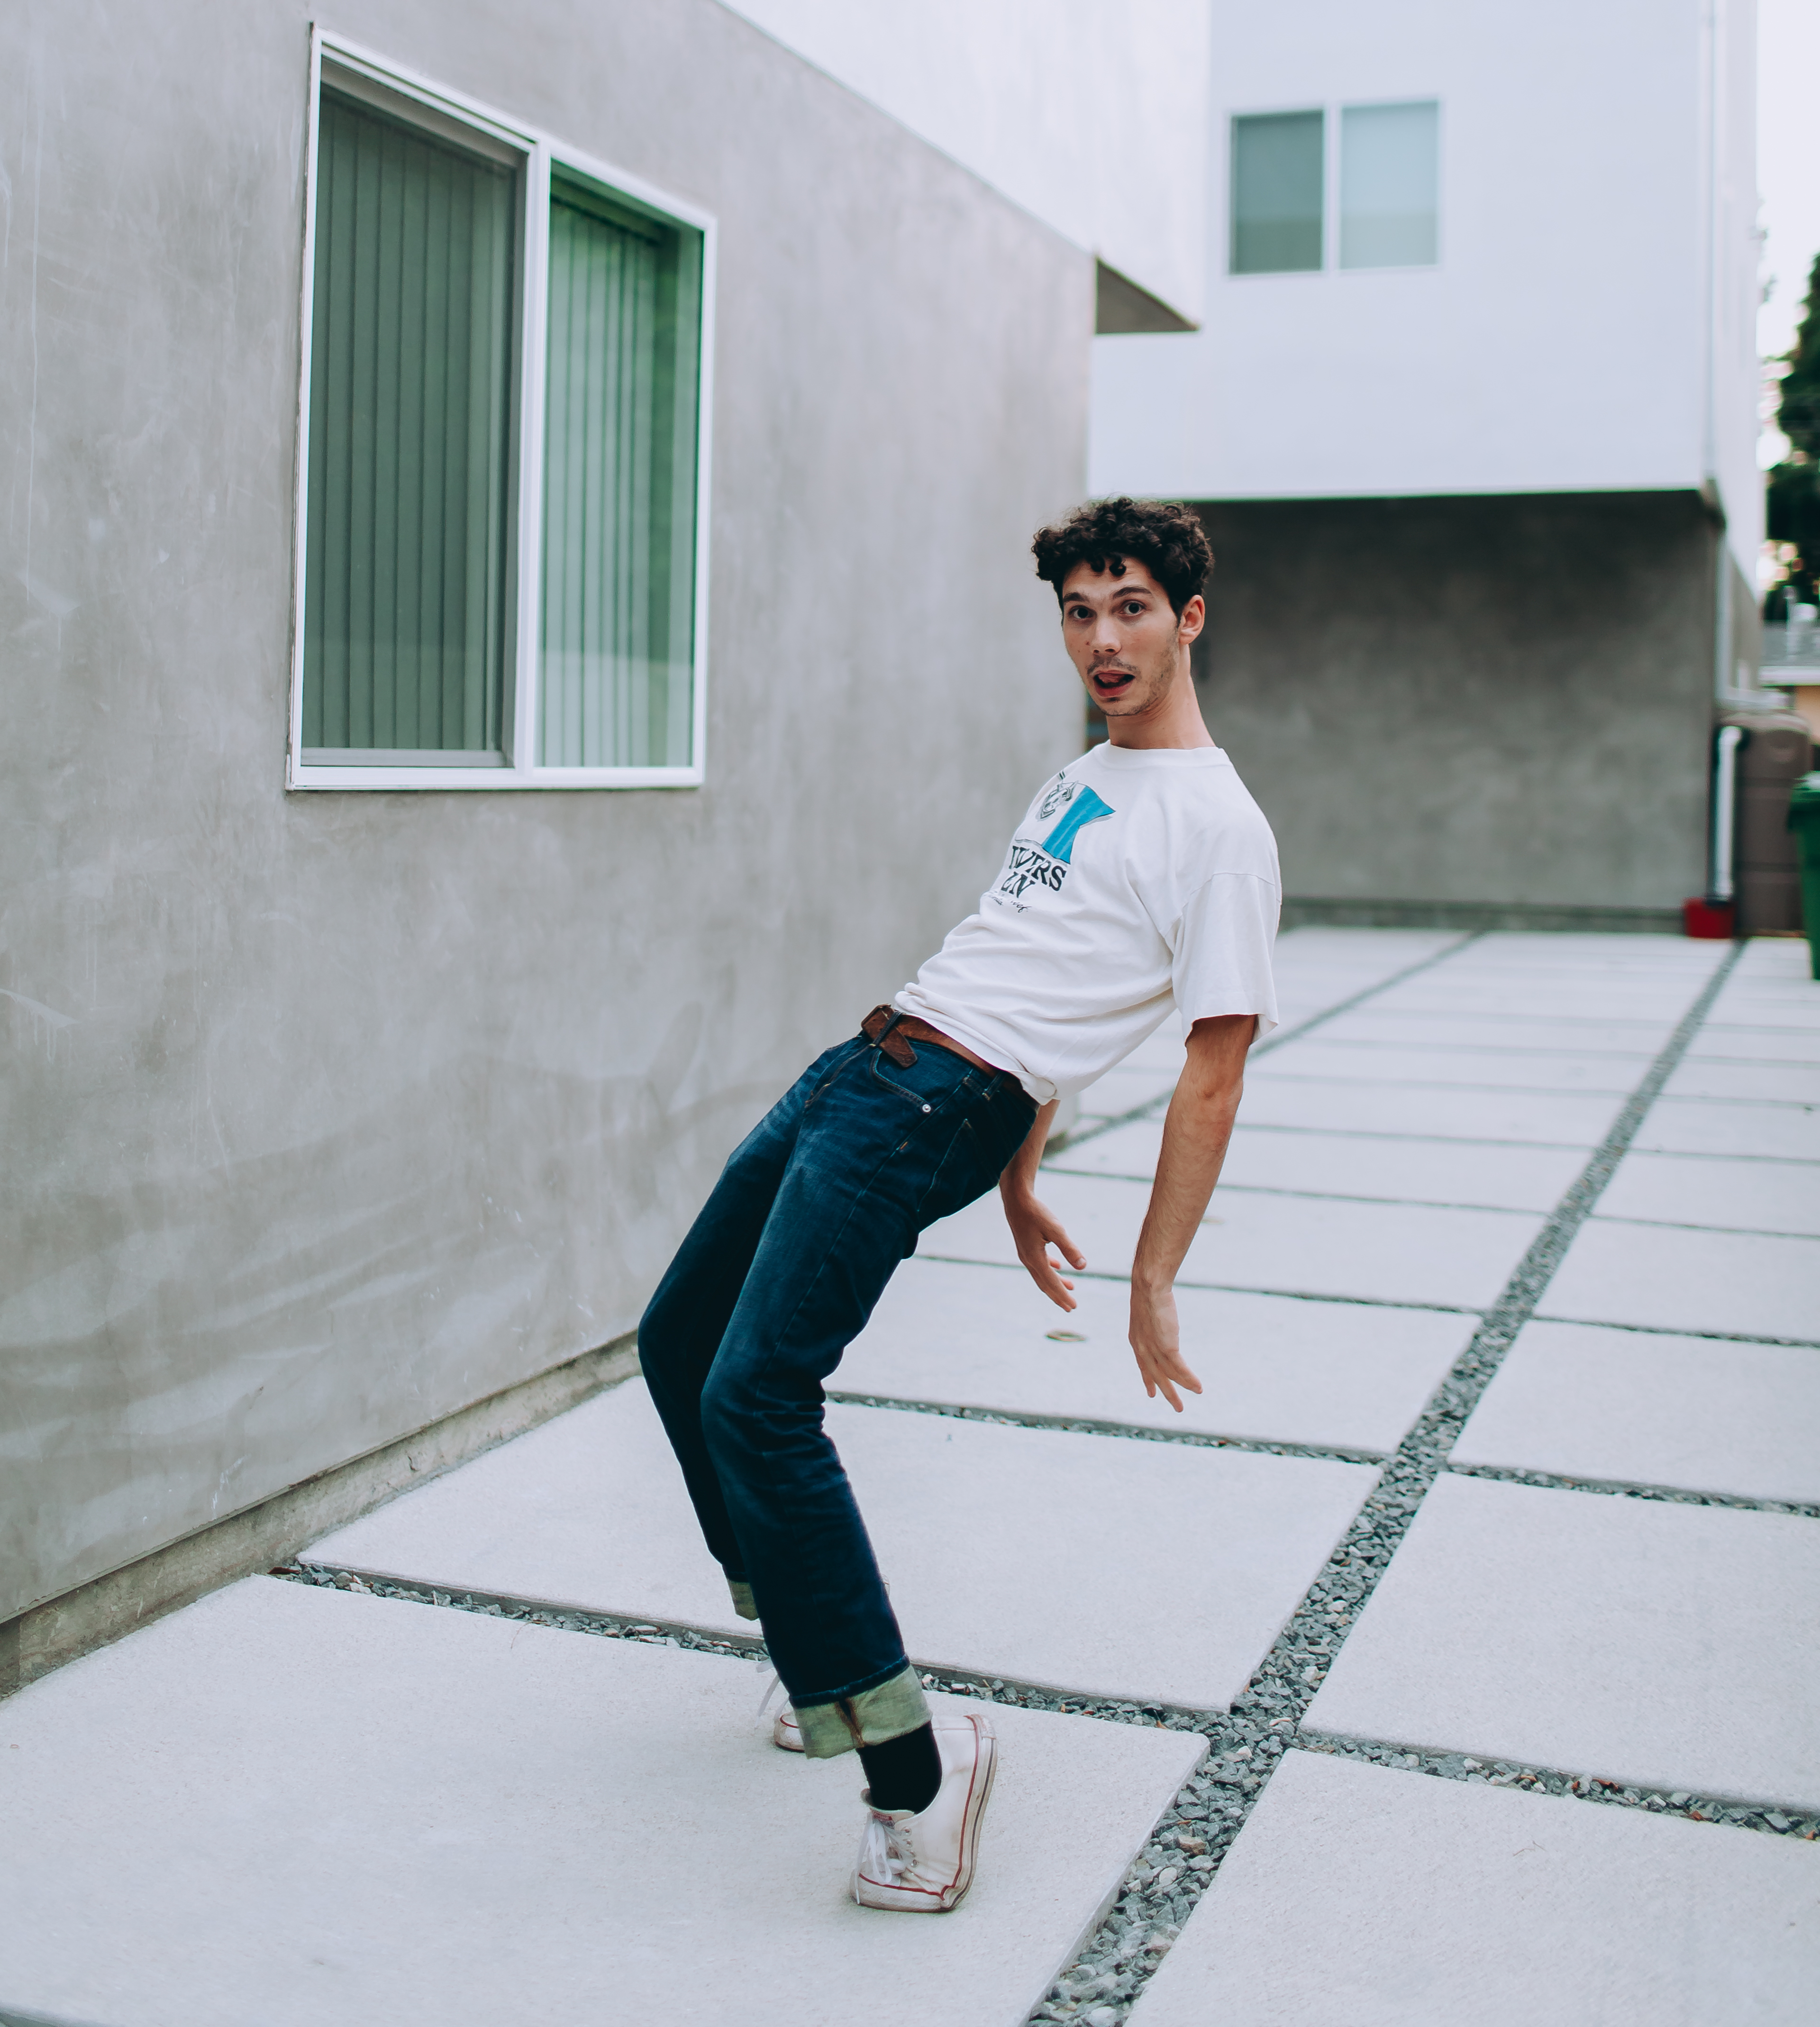

April 3, 2020 (Los Angeles, CA) – Today, buzzing singer, songwriter, multi-instrumentalist, producer, and all-around nice guy MyKey shares a brand-new song “Please Don’t Go” alongside a D.I.Y. video. Watch the video HERE and listen HERE.

The accompanying music video was self-directed by MyKey on an iPhone in the streets of Los Angeles. He strapped on his roller blades, grabbed an acoustic guitar, and cruised the mostly empty streets, breezily strumming to the beat of the song (while still skating) before ending up in a public park as four friends flank him clapping along from atop the picnic tables. Illustrative of his creative process, he co-produced and played every instrument on the track, integrating acoustic guitar, glitchy beats, and phone samples. Residing in the same musical multiverse, “Please Don’t Go” doubles as something of a spiritual successor to his buzzing 2019 single “Was It Something I Said”—which just got its own black-and-white acoustic video. While the latter attempted to make sense of an unraveling relationship, the former accepts the split and encourages him to start moving – or rollerblading – on. “Please Don’t Go” marks his very first official release for Warner Records.

A next-level indie pop auteur, the 22-year-old Maryland-born and Los Angeles-based artist has as many idiosyncrasies as your favorite Wes Anderson character. His music might be just as nuanced too. He’s already posted up over 15 million total worldwide streams. Meanwhile, “Was It Something I Said” just eclipsed 5.1 million Spotify streams, and it remains a mainstay on favorite playlists such as Late Night Vibes (653K followers) and Bedroom Pop (548K followers). When he’s not masterminding off-kilter alternative gems, he might be making late-night Lego orders on Amazon or driving around with chopsticks in his glove compartment.

You definitely want to give him a listen for the surprise factor alone…Get ready for more music from MyKey very soon.

###

Follow MyKey:
INSTAGRAM | FACEBOOK | YOUTUBE

For further information, contact:
Ceri Roberts, Warner Records
Ceri.Roberts@warnerrecords.com

