NESSA BARRETT & jxdn REUNITE FOR BRAND NEW SONG “I’M DEAD” FEATURED IN SCRIPTED PODCAST PROM IN HELL – LISTEN HERE

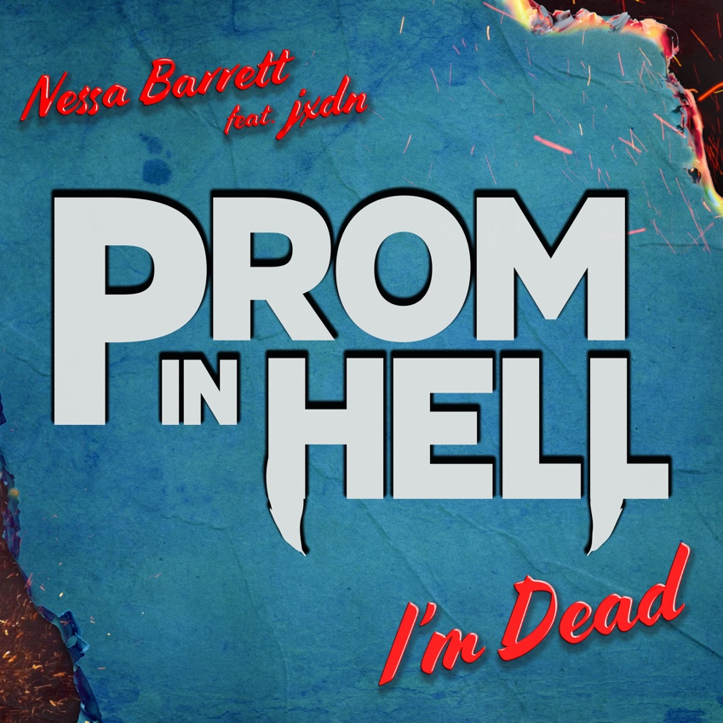

May 28th, 2021 (Los Angeles, CA) – Arriving with more heat just in time for summer, rising singer-songwriter Nessa Barrett unleashes a new song entitled “I’m Dead” [feat. jxdn] as part of the Official Soundtrack for the new scripted podcast Prom In Hell. Listen to “I’m Dead” (Warner Records) HERE and watch the visualizer HERE.

On the track, fuzzed-out shoegaze-style guitars buzz up against the dreamy duet between these two fast-rising stars. jxdn’s anesthetized and anthemic delivery gives way to intimate intonation from Nessa as she assures, “Guess, I’ll be okay. This time you won’t know me.”

Featured in the recent #1 Apple Music Podcast Prom In Hell, a new podcast produced by Audio Up Media, the four part horror-musical-comedy series premiered earlier this week across all streaming platforms, check it out HERE. Nessa and jxdn also notably appear in the series. Nessa recently shared a behind-the-scenes vignette of Prom In Hell on her IGTV series “Life’s A Ness.” Watch it HERE. Nessa and jxdn will perform “I’m Dead” during a special live episode of Prom In Hell produced by NoCap Live on June 8th.

The series will also feature original music produced by Audio Up Media CEO and series creator Jared Gutstadt, rapper Sueco, as well as artists on the rise like QVE, 44Phantom and Yoza.

“I’m Dead” notably marks the second collaboration by Nessa and jxdn following “la di die,” produced by the legendary Travis Barker. The latter has already amassed over 100 million streams and cracked the Top 15 at alternative radio and top 30 at top 40 radio and rising. Listen to “la di die” HERE and watch the music video HERE. The duo made their late-night television debut performance with “la di die” on Jimmy Kimmel Live! (watch HERE) and proceeded to perform the song on The Ellen Degeneres Show (watch HERE) as well.

Nessa has quickly transformed into one of the year’s fastest rising talents. Beyond scoring 125 million-plus streams since her 2020 breakthrough single “Pain,” she continues to attract unanimous tastemaker praise. Nylon declared, “As the last line of ‘La Di Die’ says: She’s gonna be a superstar.” In The Know raved, “Nessa’s delivery is raw and powerful from start-to-finish, and the songwriting style feels genuine and refreshingly relatable and personal, like a true singer-songwriter bursting at the seams to tell her own genuine story should.” Meanwhile, Elite Daily proclaimed, “Barrett’s singing career has been a long time coming.”

Get ready for more from Nessa Barrett soon!

About Nessa Barrett:
Nessa Barrett took control of her own destiny at just 17-years-old and left her hometown in New Jersey to chase her dream in Los Angeles. By sharing every side of herself, she quietly built a major following online, attracting an audience of 20 million-plus fans across platforms. Sitting alone behind a piano, unlocking her truth, and projecting it without filter, she didn’t hold back on her 2020 breakthrough single “Pain.” Not only did it introduce her intriguing and inimitable brand of alternative pop, but it also eclipsed 20 million streams right out of the gate. Meanwhile, Variety raved, “The piano-based ballad puts Barrett’s haunting vocals and lyricism on full display.” On its heels, “if u love me” drew praise from Idolator, In The Know., Elite Daily, and many others. Writing from the heart, she inspires perseverance through life’s trials and tribulations and fearlessly opens up about her own mental health struggles to be the person she always wished she had been growing up. Nessa’s fearless first single of 2021 “la di die” (feat. jxdn) has received over 100 million streams and climbing the Alternative and Top 40 radio charts. Nessa is currently in the studio recording her first EP.

About jxdn:
Born in Dallas as Jaden Hossler, jxdn (pronounced jay-den) initially gained prominence on TikTok, parlaying his massive following into a breakout music career. In January 2020, he independently released “Comatose”, which landed on more than 40 global charts. His explosive success quickly garnered the attention of Travis Barker, who signed him as the first artist on his imprint, DTA Records, a worldwide joint venture with Elektra Music Group. He released his label debut single “Angels & Demons” in May followed by “So What!” in July, both of which landed in the Top 10 of Billboard’s Hot Rock & Alternative Song’s Chart; with “So What!” notably peaking at #20 on Alternative Radio. In October, he teamed up with fellow breakout artist iann dior for “Tonight.” The track combines their signature genre-blurring style of rock, pop and rap. He capped off the year with the release of “Better Off Dead” in December. Cementing his rising rockstar status, jxdn debuted at No. 9 on Rolling Stone’s Breakthrough 25 chart, was featured as Billboard’s August 2020 Chartbreaker, and was included in Billboard’s 2020 annual 21 Under 21 list. Additionally, jxdn has garnered critical acclaim from Entertainment Weekly, MTV, Alternative Press, VMAN, Consequence of Sound, PEOPLE and Forbes, among others. He has performed on Jimmy Kimmel Live! and The Ellen DeGeneres Show. jxdn has surpassed 300 million worldwide streams to date and reaches more than 16.5 million followers across social platforms. He is currently at work on his highly anticipated debut album Tell Me About Tomorrow, due out later this year.

# # #

Nessa Barrett contact:
Darren Baber | Warner Records
Darren.Baber@warnerrecords.com

jxdn contacts:
Natasha Desai | Full Coverage Communications
natasha@fullcov.com
Lauren Morris | Full Coverage Communications
Lauren.Morris@fullcov.com

Follow Nessa Barrett:
Official | Instagram | Twitter | Facebook | YouTube | Press Materials

Follow jxdn
Official | Instagram | Twitter | Facebook | YouTube

