NESSA BARRETT & jxdn TEAM UP FOR NEW SINGLE
“la di die” PRODUCED BY TRAVIS BARKER

WATCH THE VIDEO HERE

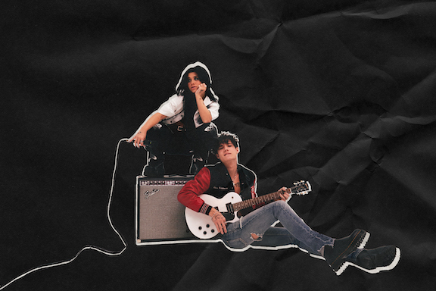
(Photo Credit: Kristen Jan Wong)

February 19th, 2021 (Los Angeles, CA) – Continuing a rapid ascent to the forefront of popular culture on her own terms, New Jersey-born and Los Angeles-based singer-songwriter Nessa Barrett joins forces with fellow alt-pop disruptor jxdn for latest single “la di die,” produced by the legendary Travis Barker. Listen to “la di die” (Warner Records) HERE and watch the music video HERE.

The track unites two of 2021’s hottest new artists for a scorching collaboration. Fusing warm acoustic guitar and icy 808s, it builds towards Nessa’s hypnotic promise “la da di oh la di da, gonna be a superstar.” jxdn pulls up with an instantly unforgettable melody as their voices seamlessly entwine. The equally memorable music video debuted on YouTube and made its broadcast premiere on MTV Live and mtvU.

About the single, Nessa shared, “‘la di die’ touches on how fame is dramatized and something most people wish for, when in reality, it's a dark and evil place. It was cool working with jxdn, not only is he my friend but a dope artist. He really helped make this song come to life!”

“For me, this song represents that sometimes the hardest situation is the one that seems perfect,” added jxdn. “Don’t ever be afraid to let people know you aren’t where you wanna be. Set a goal, find a dream and make those reality. Live for others while being yourself; don’t live for yourself while being like others.This song has had a lot of work put into it. I’m so proud of Nessa and her diligence. I know it’s gonna pay off!”

Nessa has quickly transformed into one of the year’s fastest rising talents. Beyond scoring 50 million-plus streams since her breakthrough single “Pain” was released last July, she continues to attract unanimous tastemaker praise. In The Know raved, “Nessa’s delivery is raw and powerful from start-to-finish, and the songwriting style feels genuine and refreshingly relatable and personal, like a true singer-songwriter bursting at the seams to tell her own genuine story should.” Meanwhile, Elite Daily proclaimed, “Barrett’s singing career has been a long time coming.”

About Nessa Barrett:
Nessa Barrett took control of her own destiny at just 17-years-old and left her hometown in New Jersey to chase her dream in Los Angeles. By sharing every side of herself, she quietly built a major following online, attracting an audience of 20 million-plus fans across platforms. Sitting alone behind a piano, unlocking her truth, and projecting it without filter, she didn’t hold back on her 2020 breakthrough single “Pain.” Not only did it introduce her intriguing and inimitable brand of alternative pop, but it also eclipsed 20 million streams right out of the gate. Meanwhile, Variety raved, “The piano-based ballad puts Barrett’s haunting vocals and lyricism on full display.” On its heels, “if u love me” drew praise from Idolator, In The Know., Elite Daily, and many others. Writing from the heart, she inspires perseverance through life’s trials and tribulations and fearlessly opens up about her own mental health struggles to be the person she always wished she had growing up. Now, Nessa’s fearlessness drives a series of singles in 2021 led by the Travis Barker produced banger “la di die” with jxdn and much more to come.

About jxdn:
Born in Dallas as Jaden Hossler, jxdn (pronounced jay-den) initially gained prominence on TikTok, parlaying his massive following into a breakout music career. In January 2020, he independently released “Comatose”, which landed on more than 40 global charts. His explosive success quickly garnered the attention of Travis Barker, who signed him as the first artist on his imprint, DTA Records, a worldwide joint venture with Elektra Music Group. He released his label debut single “Angels & Demons” in May followed by “So What!” in July, both of which landed in the Top 10 of Billboard’s Hot Rock & Alternative Song’s Chart; with “So What!” notably peaking at #20 on Alternative Radio. Cementing his rising rockstar status, jxdn debuted at No. 9 on Rolling Stone’s Breakthrough 25 chart, was featured as Billboard’s August 2020 Chartbreaker, and was included in Billboard’s 2020 annual 21 Under 21 list. Additionally, he is the #4 Top New Rock Artist on Billboard’s year-end 2020 chart. jxdn has garnered critical acclaim from Entertainment Weekly, Variety, MTV, Alternative Press, V Magazine, Consequence of Sound and Forbes, among others. jxdn reaches over 16.5 million followers across social platforms and has surpassed 200 million total global streams. His debut album Tell Me About Tomorrow will arrive early 2021.

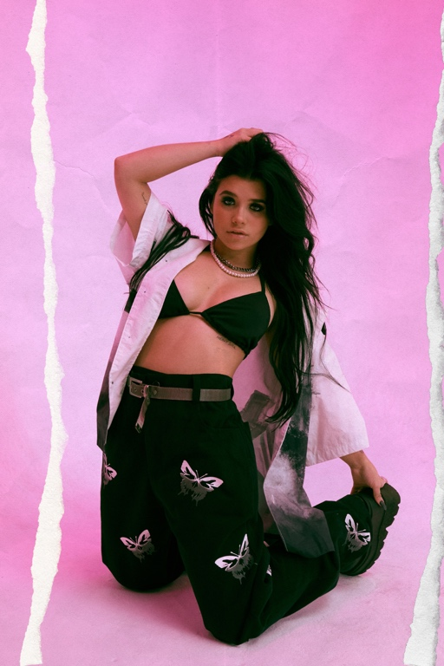
(Photo Credit: Kristen Jan Wong)

# # #

Nessa Barrett contact:
Darren Baber | Warner Records
Darren.Baber@warnerrecords.com

jxdn contacts:
Natasha Desai | Full Coverage Communications
natasha@fullcov.com
Lauren Morris | Full Coverage Communications
Lauren.Morris@fullcov.com

Glenn Fukushima | Elektra Records
GlennFukushima@elektra.com

Follow Nessa Barrett:
Official | Instagram | Twitter | Facebook | YouTube | Press Materials

Follow jxdn
Official | Instagram | Twitter | Facebook | YouTube

