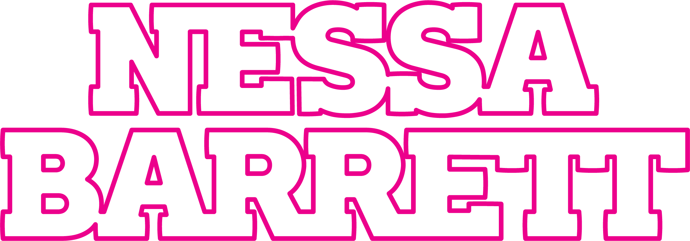

NESSA BARRETT HAUNTS POP WITH NEW SINGLE & MUSIC VIDEO “i hope ur miserable until ur dead” - WATCH HERE

DEBUT PRETTY POISON EP ARRIVES ON SEPTEMBER 10
DELIVERS INTERNET-BREAKING SURPRISE PERFORMANCE AT LOLLAPALOOZA

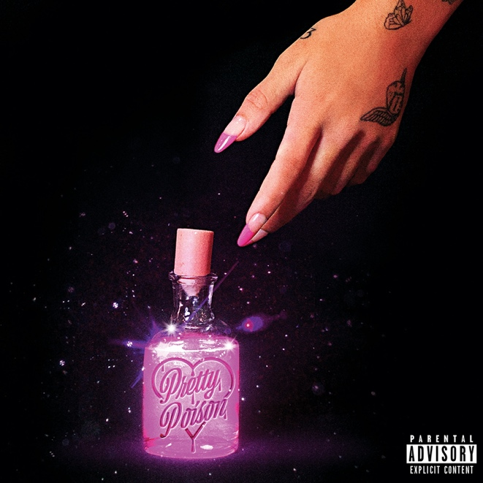

August 5, 2021 (Los Angeles, CA) – Ready to make a major mark after gathering millions of streams and receiving widespread critical acclaim, rising singer-songwriter Nessa Barrett uncovers a new single and music video entitled “i hope ur miserable until ur dead” today. Listen to “i hope ur miserable until ur dead” HERE and watch the music video HERE.

Nessa delivers a Gen-Z grunge bop underlined by caustic guitars and a hypnotically spectral hook. Her voice teems with raw emotion as she lets everyone know exactly how she feels! In the accompanying video directed by the incomparable Hannah Lux Davis [Ariana Grande, Halsey], Nessa emerges from a television set Poltergeist-style in order to haunt a deserving ex with her undeniable presence (and totally stealable nineties prom goth looks).

Regarding the song, she said, “‘i hope ur miserable until ur dead’ is the anger you hold inside when people betray you—when people hurt you so bad and you unapologetically hope they get what they deserve.”

Most importantly, the song heralds the arrival of her debut pretty poison EP out September 10 on Warner Records. Pre-order pretty poison HERE. Illuminating the scope of her signature style, she leans into a lullaby melody on the darkly catchy “grave,” while “i wanna die” feels tailormade for the closing credits of a classic nineties slasher flick. Her jazzy intonation adds raw emotion to “scare myself” as she admits, “Sometimes I even scare myself.” Over wobbling distortion on the title track “pretty poison,” she urges, “Say my name, say my name like you know it’s holy.”

Check out the full tracklisting below.

Nessa broke the internet last weekend when she joined jxdn for a surprise duet of “la di die” on the Main Stage at Lollapalooza. It immediately trended across social media, generating millions of impressions. Meanwhile, she continues to attract critical acclaim. Of her latest release “counting crimes,” Clash Music wrote, “The single itself showcases Barrett’s vocal power alongside a backdrop of guitar and piano overlaid with glitchy production.” In addition to plugs from the likes of UPSET Magazine and more, The Line of Best Fit hailed her as “On The Rise,” going on to rave, “She is the architect of her own, grunge-indebted netherworld, leaning into the pop-punk revival close enough to brush shoulders with it, and yet retaining an extraordinary sense of self that belies her eighteen years.”

Earlier this year, Nessa linked up with jxdn on “I’m Dead” as part of the Official Soundtrack for the new scripted podcast Prom In Hell, the four part horror-musical-comedy series which debuted as the #1 Apple Music Podcast in April. “I’m Dead” notably marks the second collaboration by Nessa and jxdn following their breakout hit “la di die,” produced by the legendary Travis Barker. The latter has already amassed over 200 million streams, cracked the Top 15 at alternative radio and reached #27 at top 40 radio. The duo made their late-night television debut performance with “la di die” on Jimmy Kimmel Live! and also performed on The Ellen Degeneres Show. The song has received widespread acclaim from MTV, Elite Daily, Buzzfeed Radio.com and Nylon declared, “As the last line of ‘la di die’ says: She’s gonna be a superstar.”

pretty poison TRACKLISTING

- pretty poison
- keep me afraid
- i hope ur miserable until ur dead
- grave
- scare myself
- i wanna die
- sincerely

# # #

Follow Nessa Barrett:
Official | Instagram | Twitter | Facebook | YouTube | Press Materials

Nessa Barrett contact:
Darren Baber | Warner Records
Darren.Baber@warnerrecords.com

