**PRETTYMUCH READY TO “TRUST” ON NEW SONG & MUSIC VIDEO**

**WATCH** [**HERE**](https://Prettymuch.lnk.to/trustvideo) **| LISTEN** [**HERE**](https://Prettymuch.lnk.to/trust)

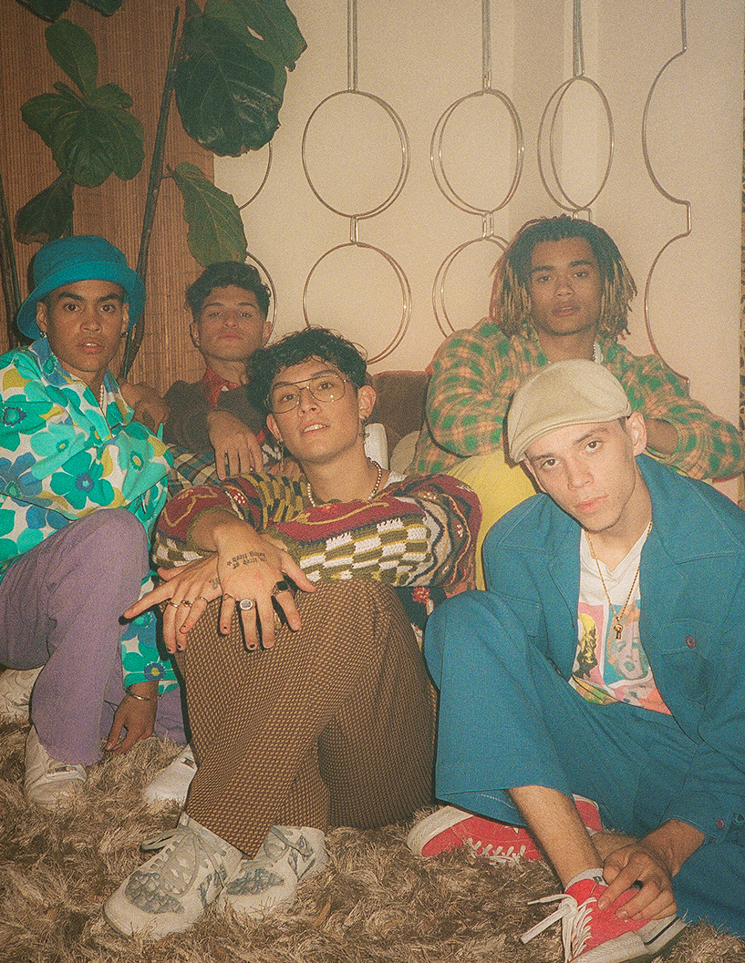

*“The boy band PRETTYMUCH is back, recalibrated and deconstructed.”* ***– The New York Times***

*“[PRETTYMUCH]…is embracing maturity with their new music.”* ***– GQ***

*“This is exemplary boy band trap music.”* ***– Stereogum***

*“a fresh, R&B and mature vibe that sets the boys apart from other groups.”****– People***

**July 30, 2021 (Los Angeles, CA) –** Posting up more than a billion streams streams and receiving praise from the likes of *New York Times*, *People*, and more, pop powerhouse **PRETTYMUCH** continue their hot streak with a new song and music video entitled **“Trust”** today via **Warner Records**. Listen to **“Trust”**—[HERE](https://prettymuch.lnk.to/trust). Watch the music video for **“Trust”**—[HERE](https://prettymuch.lnk.to/trustvideo).

PRETTYMUCH teamed up with frequent collaborator **Ian Eastwood** [Justin Bieber, Chance the Rapper] to create the video together, which was personally edited by member Brandon Arreaga. Integrating show-stopping dance moves and explosive performances, the visual is a fun story of learning how to implicitly trust the one you love. As the guys break it down, the female protagonist gets ready for a girls’ night out. The on-screen action moves in tandem with the high-energy production punctuated by fiery falsetto based around playful lyrics such as *“Even if you’re coming home at three, you’re coming home to me”* and *“Nothing but these sheets come between us, ‘cause I know I’m the only one*.*”*

Earlier this year, the guys returned with their critically-acclaimed EP [*Smackables (Deluxe)*](https://prettymuch.lnk.to/smackablesdeluxeEP) and took the stage at *Good Morning America* to perform “Stars.” Watch it [HERE](https://www.yahoo.com/gma/prettymuch-performs-stars-gma-084731451.html).

You can *“trust”* they’ll keep delivering in 2021 and beyond! Stay tuned for more music coming soon from **PRETTYMUCH**.

**More about PRETTYMUCH:**

PRETTYMUCH—comprised of Brandon Arreaga, Edwin Honoret, Zion Kuwonu, Nick Mara, and Austin Porter—have been hustling since their inception. Early singles like “Would You Mind” and “Summer On You” got them noticed by popheads and critics; later projects, like last year’s Phases and INTL:EP, helped them achieve liftoff, building on their strong musical roots as they worked their way to the top. To date, the band have accumulated more than 1 billion audio and video streams, with a combined social following of 6.3 million. They have sold out two headline tours and opened for Khalid, and were named Artists to Watch by Rolling Stone, MTV, Los Angeles Times, with Billboard honoring them in their “21 Under 21” list three years in a row. They were nominated as Best Boy Band at the 2018 iHeartRadio Music Awards, Best PUSH Artist of the Year at the 2018 MTV’s Video Music Awards and Best Group at the 2019 MTV’s Video Music Awards, and most recently, Choice Music Group at the Teen Choice Awards 2019. Their television performances include The Late Late Show with James Corden, Good Morning America, Fox’s A Christmas Story special, the 2017 Teen Choice Awards, and the 2018 MTV VMAs, and they have partnered with A-list brands such as Puma, Kellogg’s Frosted Flakes, Moncler, FujiFilm, Hollister, and more.

###

**For more information, contact Warner Records Publicity:**

Darren Baber, [Darren.Baber@warnerrecords.com](mailto:Darren.Baber@warnerrecords.com)

Ceri Roberts, [Ceri.Roberts@warnerrecords.com](mailto:Ceri.Roberts@warnerrecords.com)

**Press Materials:**

[press.warnerrecords.com/prettymuch](https://nam04.safelinks.protection.outlook.com/?url=https%3A%2F%2Fpress.warnerrecords.com%2Fprettymuch%2F&data=04%7C01%7CPatrice.Compere%40warnerrecords.com%7C3bb790edfdcf46f7cf9708d8bca49182%7C8367939002ec4ba1ad3d69da3fdd637e%7C0%7C0%7C637466762296843758%7CUnknown%7CTWFpbGZsb3d8eyJWIjoiMC4wLjAwMDAiLCJQIjoiV2luMzIiLCJBTiI6Ik1haWwiLCJXVCI6Mn0%3D%7C1000&sdata=iTcdcoABl%2BdPL%2FWvBr1GJrDwXs39czCONxOMwN0twY0%3D&reserved=0)

**Follow PRETTYMUCH:**

[Official Site](https://nam04.safelinks.protection.outlook.com/?url=https%3A%2F%2Fwww.prettymuch.com%2F&data=04%7C01%7CPatrice.Compere%40warnerrecords.com%7C3bb790edfdcf46f7cf9708d8bca49182%7C8367939002ec4ba1ad3d69da3fdd637e%7C0%7C0%7C637466762296853748%7CUnknown%7CTWFpbGZsb3d8eyJWIjoiMC4wLjAwMDAiLCJQIjoiV2luMzIiLCJBTiI6Ik1haWwiLCJXVCI6Mn0%3D%7C1000&sdata=2t89jF2bM%2Bq0riottcC74w8Nrnc%2FpQKAnrqOCP6h2ss%3D&reserved=0) | [Instagram](https://nam04.safelinks.protection.outlook.com/?url=https%3A%2F%2Fwww.instagram.com%2Fprettymuch%2F%3Fhl%3Den&data=04%7C01%7CPatrice.Compere%40warnerrecords.com%7C3bb790edfdcf46f7cf9708d8bca49182%7C8367939002ec4ba1ad3d69da3fdd637e%7C0%7C0%7C637466762296853748%7CUnknown%7CTWFpbGZsb3d8eyJWIjoiMC4wLjAwMDAiLCJQIjoiV2luMzIiLCJBTiI6Ik1haWwiLCJXVCI6Mn0%3D%7C1000&sdata=gz8AeEXgRiD1CI%2FR7MGw1lvtfTm8ULebP3CPoLy%2BhQ8%3D&reserved=0) | [Facebook](https://nam04.safelinks.protection.outlook.com/?url=https%3A%2F%2Fwww.facebook.com%2FPRETTYMUCH%2F&data=04%7C01%7CPatrice.Compere%40warnerrecords.com%7C3bb790edfdcf46f7cf9708d8bca49182%7C8367939002ec4ba1ad3d69da3fdd637e%7C0%7C0%7C637466762296863748%7CUnknown%7CTWFpbGZsb3d8eyJWIjoiMC4wLjAwMDAiLCJQIjoiV2luMzIiLCJBTiI6Ik1haWwiLCJXVCI6Mn0%3D%7C1000&sdata=MindvUMliLpPk9e8p%2Fbbze74sWxJ1%2Be3359LwFyOktQ%3D&reserved=0) | [Twitter](https://nam04.safelinks.protection.outlook.com/?url=http%3A%2F%2Fwww.twitter.com%2Fprettymuch&data=04%7C01%7CPatrice.Compere%40warnerrecords.com%7C3bb790edfdcf46f7cf9708d8bca49182%7C8367939002ec4ba1ad3d69da3fdd637e%7C0%7C0%7C637466762296873744%7CUnknown%7CTWFpbGZsb3d8eyJWIjoiMC4wLjAwMDAiLCJQIjoiV2luMzIiLCJBTiI6Ik1haWwiLCJXVCI6Mn0%3D%7C1000&sdata=sBCzMsNNdoDfhwQo491rVlh57jisaxnSlGykEOGvmD4%3D&reserved=0) | [YouTube](https://nam04.safelinks.protection.outlook.com/?url=https%3A%2F%2Fwww.youtube.com%2FPRETTYMUCH&data=04%7C01%7CPatrice.Compere%40warnerrecords.com%7C3bb790edfdcf46f7cf9708d8bca49182%7C8367939002ec4ba1ad3d69da3fdd637e%7C0%7C0%7C637466762296873744%7CUnknown%7CTWFpbGZsb3d8eyJWIjoiMC4wLjAwMDAiLCJQIjoiV2luMzIiLCJBTiI6Ik1haWwiLCJXVCI6Mn0%3D%7C1000&sdata=vnJBmrSOp4CXF1wAl2s3pmn7p6uXCBoQyOq67j3r%2BoM%3D&reserved=0)

