RÜFÜS DU SOL RELEASE NEW SINGLE “NEXT TO ME” – LISTEN HERE

LAUNCH A.I. MUSIC VIDEO
DIRECTED BY OSK – WATCH HERE

2021 FALL TOUR TOUCHING DOWN IN LAS VEGAS, PHOENIX, HOUSTON, AND DALLAS THIS NOVEMBER, ON THE BACK OF 70,000 TICKETS SOLD FOR CALIFORNIA SHOWS – TICKETS AVAILABLE HERE

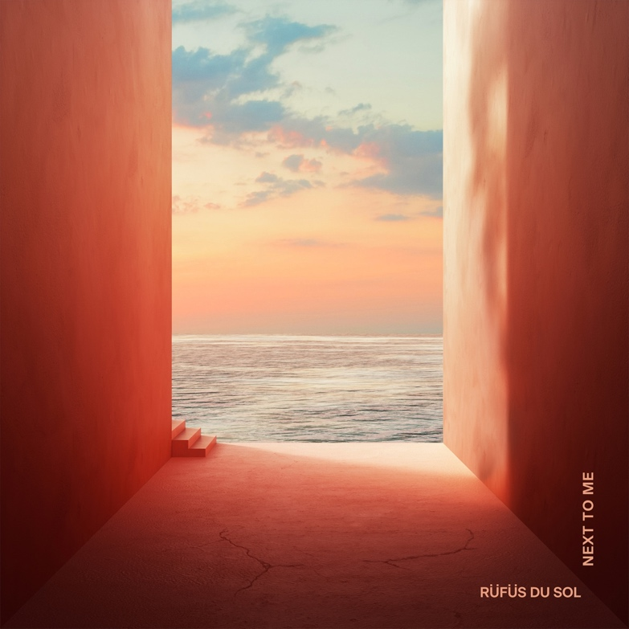

August 12, 2021 (Los Angeles, CA) – Grammy-nominated live-electronic trio RÜFÜS DU SOL have released their latest single on Rose Avenue/Reprise/Warner Records, “Next To Me,” accompanied by an artificially intelligent official music video directed by Osk. The track adds a new chapter to the band’s career-long straddling of the dualities of light and dark, loss and love. Listen to “Next To Me” HERE and watch the video HERE.

“Next To Me” portrays a sense of maturity and adoration on a level not felt before from the band. At its core it is a song of devotion, of caring compassion, an affair of the heart not undercut by the pressures of stardom or toils of young love. It's a point of departure from the haunting emotive roller coaster of recent single “Alive,” and a more positive lyrical take on the foundation set by the similarly anthemic “Treat You Better” off the 2018 Grammy-nominated ‘SOLACE’ LP.

Tyrone sings in the chorus, “…and when time runs out, I want to feel you standing next to me”.

In Jon George’s words, “there were a lot more yearning lyrics being put down when we were writing the track, but we felt it didn’t need any of the darkness that you hear on a lot of our other records. We wanted to create something more positive and happy, a kind of homage to the feel-good soul of classic house music. I am sure there is part of this that reflects a feeling in our lives and relationships. We wanted to share that with this track.”

Tyrone echoes, “We decided we wanted this to be a simple love song, which is rare of us to do, to create something purely sweet without juxtaposing that with the raw, dark emotions on the other side”

“Next To Me” was spawned from a pandemic recording trip in Joshua Tree and refined six months later in RÜFÜS DU SOL’s Los Angeles studio. A true tale of the songwriting process and the value of simplicity, the vocal melody and piano lead originally captured in the desert remain the beating heart of the record. The track offers a clear hook fused with progressive electronic sonics, a furthering of the band’s ability to produce with one foot in mass appeal and the other in the dance music underground.

James Hunt adds, “We tried adding things to make it ‘better’ and kept returning to the feeling we experienced when we first wrote the song that day in the desert. It's a good example of the thing that came out on the day we wrote it being the most pure and authentic version of what we were trying to create.”

The band has tapped futuristic directors Osk to create a self-initiated, artificially intelligent visual work to accompany “Next To Me.” Known for collaborations with Kanye West, NASA, John Coltrane (estate), and Google, Osk has combined the power of A.I. with RÜFÜS DU SOL’s obsession with audio-visual world-building to immerse viewers into new complex landscapes. The official video sees A.I.-generated topographies unfurl and unfold into morphing images that defy reality, seamlessly flowing from mountain tops and valleys to city scapes and highways. This technological connection between the natural and manmade worlds reflects the sonic palette this band has spent the last decade refining.

Osk comments, "We don’t see A.I. as a tool but as a collaborator - one we are in a constant conversation with as we develop new possibilities for its expression and our own. New perspectives are always valuable, and although much of the way A.I. operates is modeled on or inspired by us, it has a fundamentally different way of understanding that can reveal new approaches or perspectives we may not have seen. Merging artificial intelligence with the existing languages of film, art, music and human expression expands our notions of them all."

This single follows the reveal of the band’s North American Fall Tour, touching down at Las Vegas’ Downtown Las Vegas Events Center, Phoenix’s Arizona Federal Theatre, Dallas’ The Pavilion at Toyota Music Factory and a to-be-announced venue in Houston.

RÜFÜS have already experienced an immense demand for their live return, selling 70,000 tickets in three days for their largest headlining shows to date at Los Angeles Banc of California Stadium. The onsale was a true barometer for just how deeply fans crave the sonic escapism RÜFÜS work to deliver at every show. This banner moment joins two sold out nights at Red Rocks Amphitheatre in August, and a bevy of headlining festival appearances already announced including Governors Ball, Austin City Limits, III Points and more.

RÜFÜS DU SOL 2021 Summer / Fall Festival Dates:
Weds, Aug 11 - Morrison, CO - Red Rocks Amphitheatre
Thurs, Aug 12 - Morrison, CO - Red Rocks Amphitheatre
Sun Sep 5 - Manchester, TN - Bonnaroo
Fri Sep 24 - New York, NY - Gov Ball Festival
Sat. Oct. 2 - Austin, TX - Austin City Limits Weekend 1
Sat. Oct. 9 - Austin, TX - Austin City Limits Weekend 2
Sat. Oct. 23 - Miami, FL - III Points Festival
Sun. Oct. 31 - San Francisco, CA - Outside Lands Festival

RÜFÜS DU SOL 2021 North American Fall Tour Dates:
Thu Nov 04 - Phoenix, AZ - Arizona Federal Theatre
Sat Nov 06 - Las Vegas, NV - Downtown Las Vegas Events Center
Fri, Nov 12 - Los Angeles, CA - LA Banc of California Stadium
Sat, Nov 13 - Los Angeles, CA - LA Banc of California Stadium
Sun, Nov 14 -Los Angeles, CA - LA Banc of California Stadium
Thu Nov 18 - Houston, TX - 401 Franklin St
Sat Nov 20 - Irving, TX - The Pavilion at Toyota Music Factory

FOLLOW RÜFÜS DU SOL
Official | Twitter | Instagram |Facebook | Spotify | YouTube
For more information, please contact:
Darren Baber | Warner Records | Darren.Baber@warnerrecords.com
Max Frieser | Infamous PR | mfrieser@infamouspr.com
