RÜFÜS DU SOL ANNOUNCE FOURTH STUDIO ALBUM SURRENDER
OUT OCTOBER 21 – PRE-ORDER HERE

WATCH THE VIDEO FOR “ON MY KNEES” CAPTURED AT RED ROCKS AMPHITHEATRE HERE

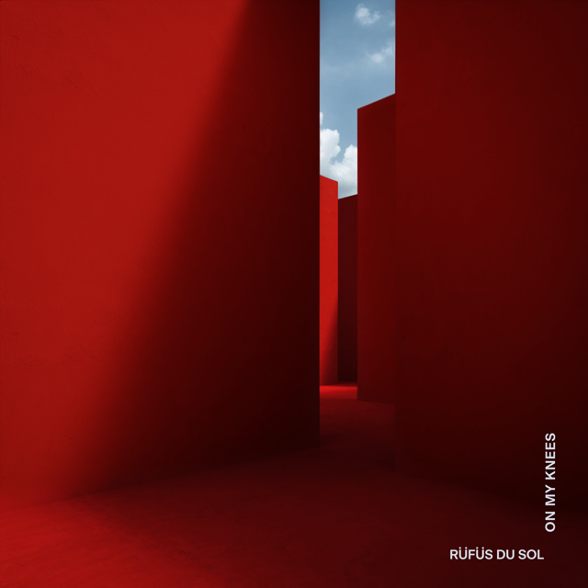

September 23, 2021 (Los Angeles, CA) – Today, Grammy-nominated live-electronic trio RÜFÜS DU SOL announce their fourth full length album Surrender and release their third single, “On My Knees” on Rose Avenue/Reprise/Warner Records. Listen to “On My Knees” HERE and watch the video HERE. Pre-order Surrender HERE.

Surrender sees RÜFÜS stridently building their own world; an album written on their own terms. The band’s electronic roots offer a proud point of separation from other stadium selling live artists, even as they write songs and play to crowds that break the traditional glass ceiling for dance acts.

“On My Knees” is a brooding insight into RÜFÜS DU SOL’s darker tendencies, toying with honest emotions and aching lyricism, demonstrating what makes them so unique in the electronic space. While previous single “Alive” gave a glimmer of hope, and “Next To Me” a yearning for love and romance, “On My Knees” has an anguished sense about it, playing into the powerful title of Surrender. The band reference the industrial sounds and sonics of Trent Reznor and Nine Inch Nails, coupled with the lyrical intensity on which their career has been built.

Tyrone Linqvist hauntingly sings, “If you could see me now, I’d probably let you down… Looks like I’m on my knees again, feels like the walls are closing in.”

James Hunt comments, “For this song we had a lot of fun writing something that was darker, driving and a little more edgy. It’s definitely one of the most banging tracks on the record - we referenced some of our favorite club music for the drum programming and had fun envisioning the time when we could finally play this live. It had an amazing reaction at our Red Rocks shows last month which was really special for us.”

RÜFÜS DU SOL is a band synonymous with tension, they came together through the push and pull of the dancefloor, have a live act whose passion lies on the dancefloor, and lyricists who spill their personal pain for thousands to dance to. From the opening keys of “Next to Me,” through the propulsive chug of “On My Knees,” the record inhabits a world that is deep, lush, organic, yet electronic.

This world building has been RÜFÜS DU SOL’s focus since its inception, its name meant to evoke an otherworldly destination, a future point the band dreamed of arriving at from their bedrooms in Sydney, and, later, recording studios in Berlin and LA. This vision was vital to Surrender, as the band wrote songs to transcend the intimacy of the world they built together, exiled from their families, in a DIY ground floor Hollywood apartment studio. The result is a record that is bolder, braver, and more far reaching than anything they have done before.

The accompanying music video was filmed in August during a unique Red Rocks Amphitheatre show rehearsal. The band’s creative director, Alex “Katzki” George, collaborated with Ruff Mercy, an animation director and artist based out in the UK to create visuals/animations on top of the video, giving the project a darker 90’s rave vibe. Ruff Mercy has worked with artists such as Thom Yorke, Disclosure, Run The Jewels, and big brands such as Nike, Apple, Adidas, and many more.

Alex “Katzki” George comments, “We had been fans of Ruff Mercy for a while and started talking to him during lockdown last year. At first we were bouncing ideas of what could be possible if we couldn’t leave our rooms. After a lot of back and forth it all came together pretty quickly and we ended up shooting the video during a twenty minute gap at our Red Rocks show rehearsals.

It was the first time the band had played it live as well as the first time we’d seen it and it took on a life of its own. It felt very raw, but like us in our element.

There was a really great energy in the room from all these people who were there working on our live show, and switching tracks in order to shoot this seemed to get the best out of everyone (our lighting and live show team, as well as Leah who managed to capture the kinetic electricity of the song.)

We were all pretty tired from long days in the rehearsal space but once we found a window to shoot in - Jon, James and Ty gave these charged performances in the short time we had.

It was so captivating that what we thought was going to be a full animation clip became mostly a performance clip. It felt really great being able to share this with Ruff and see him do his thing.
It felt like making music. Sharing tracks across the world and getting another artist’s take on it.”

As the band returns to the stage for their North American tour and array of festival performances, they experience once again the immense demand for their live return. Two sold out nights at Red Rocks Amphitheatre; 70,000 fans waiting to see them play across three nights at the Los Angeles Banc of California Stadium; festival appearances slated at Governors Ball, Austin City Limits, III Points; and a host of shows dotted around the south west United States act as a stark reminder to their influence on the global music scene.

RÜFÜS DU SOL 2021 Summer / Fall Festival Dates:

Fri. Sep 24 - New York, NY - Gov Ball Festival
Sat. Oct. 2 - Austin, TX - Austin City Limits Weekend 1
Sat. Oct. 9 - Austin, TX - Austin City Limits Weekend 2
Sat. Oct. 23 - Miami, FL - III Points Festival
Sun. Oct. 31 - San Francisco, CA - Outside Lands Festival

RÜFÜS DU SOL 2021 North American Fall Tour Dates:

Thu. Nov 04 - Phoenix, AZ - Arizona Federal Theatre
Sat. Nov 06 - Las Vegas, NV - Downtown Las Vegas Events Center
Fri. Nov 12 - Los Angeles, CA - Banc of California Stadium
Sat. Nov 13 - Los Angeles, CA - Banc of California Stadium
Sun. Nov 14 - Los Angeles, CA - Banc of California Stadium
Thu. Nov 18 - Houston, TX - 713 Music Hall
Thu. Nov 19 - Houston, TX - 713 Music Hall
Sat. Nov 20 - Irving, TX - The Pavilion at Toyota Music Factory

FOLLOW RÜFÜS DU SOL
Official | Twitter | Instagram |Facebook | Spotify | YouTube | TikTok
For more information, please contact:
Darren Baber | Warner Records | Darren.Baber@warnerrecords.com
Max Frieser | Infamous PR | mfrieser@infamouspr.com

