RÜFÜS DU SOL RETURN WITH NEW SINGLE “ALIVE”
LISTEN HERE

NORTH AMERICAN 2021 FALL TOUR TOUCHING DOWN IN
LAS VEGAS, PHOENIX, HOUSTON AND DALLAS THIS NOVEMBER, ON THE BACK OF 70,000 TICKETS SOLD FOR LA BANC OF CALIFORNIA SHOWS

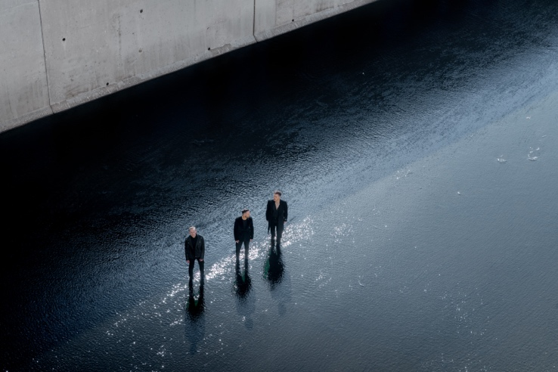

July 13, 2021 (Los Angeles, CA) – RÜFÜS DU SOL have been quiet. Quietly looking inwards, quietly crafting a new world to explore with their fans, quietly relearning what it means to be Alive...

Today the band continues its legacy as global leaders of the live-electronic movement, releasing the first new music since their Grammy nominated 2018 ‘SOLACE’ album. “Alive,” out now on Rose Avenue and Reprise / Warner Records, is a transcendent take from a group that have built a career on defying expectations – listen HERE.

Premiered today on The Zane Lowe Show, “Alive” is adorned with haunting lyricism and inventive broken beat percussion, encapsulating the highs and lows of a lost but not forgotten year. RÜFÜS’ lead singer Tyrone calls out with a sense of urgent and naked emotion, these are intensely personal lyrics for him, yet they encapsulate the feelings many of us have endured the past year:

There’s a pain in my chest that I can’t describe
It takes me down and leaves me there
When I talk to the night I can feel it’s stare
It creeps inside and meets me there…..

At least I'm alive...

“Alive” is the initial taste of what the band’s reemergence sounds like; a retention of the darkness they have consistently explored, notably on ‘SOLACE,’ paired with a glistening energy aimed to uplift and uphold their dedication to wowing larger than life dancefloors.

“Alive” begins to sculpt the first look into a new world for the band and their fans to cohabitate, a continuation of the exploration of place that defines the way they write and perform music. From their debut album recorded on the coast of Australia, onwards to the brooding ‘BLOOM’ written in the streets of techno mecca Berlin, to ‘SOLACE’s glimpse of the darker side of Los Angeles, the trio now push outwards, less bound by Geographical location, to the wider reaches of space and time.

In Tyrone Lindqvist of the band’s own words, “It’s a heavier song in some ways, but at its core it's hopeful. We are - all of us - living in this transitional moment right now and we wanted to focus on the hope that the future holds for us all. To focus on the light at the end of this tunnel."

This announcement comes alongside the reveal of the band’s North American Fall Tour, touching down at Las Vegas’ Downtown Las Vegas Events Center, Phoenix’s Arizona Federal Theatre, Dallas’ The Pavilion at Toyota Music Factory and a to-be-announced venue in Houston.

RÜFÜS have already experienced an immense demand for their live return, selling 70,000 tickets in three days for their largest headlining shows to date at Los Angeles Banc of California Stadium. The onsale was a true barometer for just how deeply fans crave the sonic escapism RÜFÜS work to deliver at every show. This banner moment joins two sold out nights at Red Rocks Amphitheater in August, and a bevy of headlining festival appearances already announced including Governors Ball, Austin City Limits, III Points and more. General tickets go on sale July 16th at 10am local time in each market – purchase tickets HERE.

General On Sale Begins July 16 at 10am Local Time in Each Market
http://www.rufusdusol.com/

RÜFÜS DU SOL 2021 Summer / Fall Festival Dates:
Sun July 25 Las Vegas, NV Art of the Wild – (DJ SET)
Sun Sep 5 Manchester, TN Bonnaroo
Fri Sep 24 New York, NY Gov Ball Festival
Sat Oct 2 Austin, TX Austin City Limits Weekend 1
Sat Oct 9 Austin, TX Austin City Limits Weekend 2
Sat Oct 23 Miami, FL III Points Festival
Sun Oct 31 San Francisco, CA Outside Lands Festival

RÜFÜS DU SOL 2021 North American Fall Tour Dates:
Thu Nov 04 Phoenix, AZ Arizona Federal Theatre
Sat Nov 06 Las Vegas, NV Downtown Las Vegas Events Center
Fri Nov 12 Los Angeles, CA Banc of California Stadium
Sat Nov 13 Los Angeles, CA Banc of California Stadium
Sun Nov 14 Los Angeles, CA Banc of California Stadium
Thu Nov 18 Houston, TX 401 Franklin Street
Sat Nov 20 Irving, TX The Pavilion at Toyota Music Factory

# # #
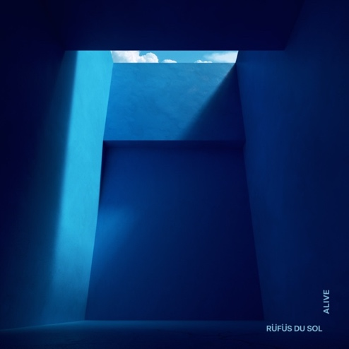
FOLLOW RÜFÜS DU SOL
Official | Twitter | Instagram |Facebook | Spotify | YouTube
For more information, please contact:
Darren Baber | Warner Records | Darren.Baber@warnerrecords.com
Max Frieser | Infamous PR | mfrieser@infamouspr.com
