RICKY MONTGOMERY UNVEILS EMOTIONALLY CHARGED
NEW SINGLE & MUSIC VIDEO “SORRY FOR ME”
LISTEN HERE – WATCH HERE

NORTH AMERICAN HEADLINE TOUR KICKS OFF NEXT MONTH

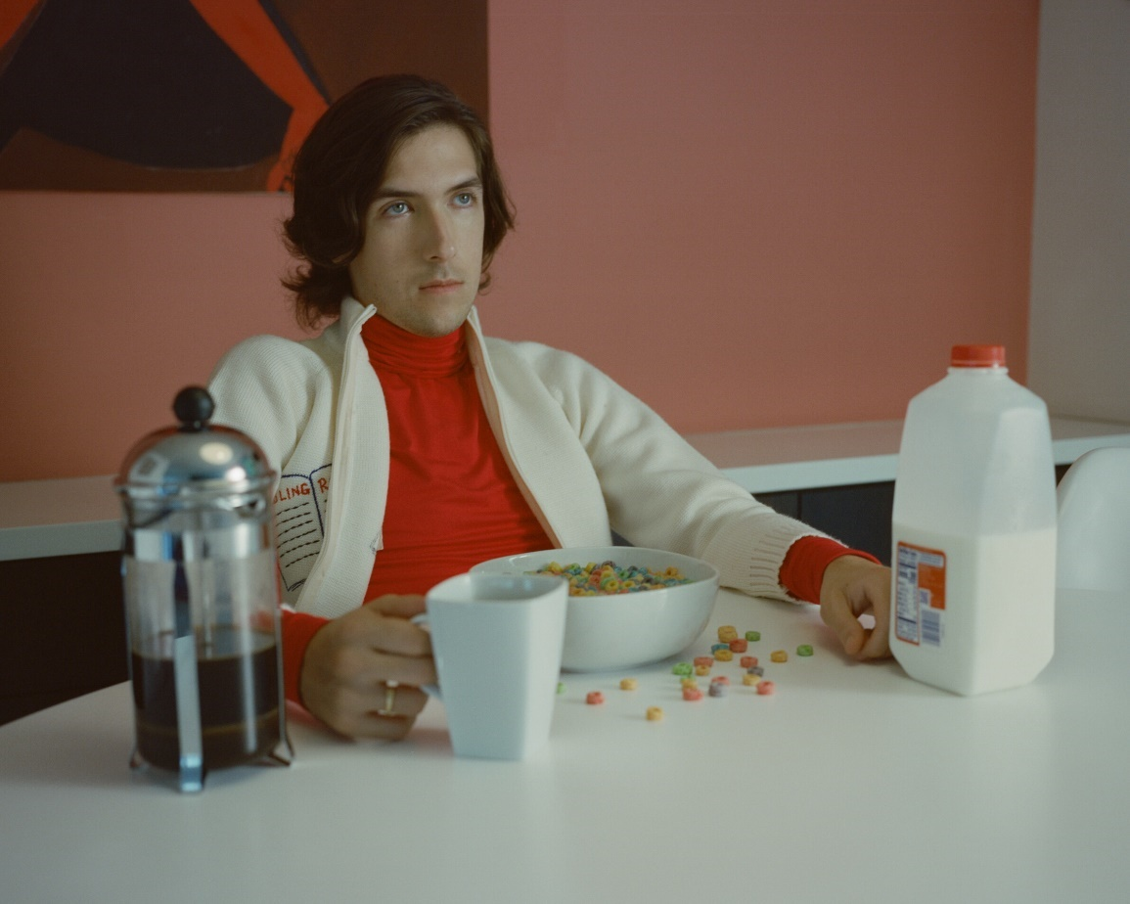

October 15, 2021 (Los Angeles, CA) – Opening up once again, rising indie-pop singer/songwriter Ricky Montgomery reveals his most personal release to date, “Sorry For Me,” out today on Warner Records. The emotionally charged track arrives just a few short weeks before he embarks on his completely sold-out headline tour with Laufey and Peter McPoland, kicking off November 18th. See full list of dates below.

On “Sorry For Me,” acoustic guitar creaks beneath his soft delivery as a bright melody underscores a harsher reality. With the unshakable calm of a documentarian, Ricky details the day of his (now) ex-stepfather’s arrest without imploring listeners to cry for him. Rather, the story unspools as he eventually picks up and leaves for California where he promises himself, “I won’t have to deal.” The accompanying video reimagines these real-life events and explores the emotional spiral his family endured, as Ricky pleads with his mother to divorce this abusive parent and altogether rejects the pity of the listener—while finally acknowledging he never actually got to feel bad for himself.

“Sorry For Me” comes on the heels of his most recent single “Talk To You,” the follow-up to his viral breakthrough hits “Mr Loverman” (feat Chloe Moriondo) and “Line Without A Hook” (feat. Mxmtoon), which have generated just shy of half-a-billion streams to date.

Stay tuned for more from Ricky Montgomery very soon.

More about Ricky Montgomery:
Ricky Montgomery’s music was ahead of its time—literally. The two once-obscure, yet universal singles – “Line Without A Hook” and “Mr. Loverman” – were suddenly reinvigorated four years after their original release on his 2016 debut album Montgomery Ricky. Ironically, it came just when he was ready to call it quits on a music career entirely after years of nominal wins. The seemingly impossible—yet somehow inevitable— happened: suddenly people were finding solace in his songs. Now, among all the hip-hop hits, the Los Angeles native’s indie-pop has been a balm in the midst of a heavy time, comforting listeners with warm melodies and relatable lyrics. He balances melancholy with a touch of sweet humor and loads of humanity. With a newly-inked deal on Warner Records, Ricky’s using that momentum to prepare for the release of much more music to come in 2021 and beyond. “I just want to create something that can feel as special for other people as it is to me,” he says.

TOUR DATES
11/18 San Francisco, CA Rickshaw Stop
11/20 Santa Ana, CA Constellation Room
11/23 Denver, CO Larimer Lounge
11/27 Minneapolis, MN 7th Street Entry
11/28 Chicago, IL Lincoln Hall
11/30 Washington, DC Songbyrd
12/2 New York, NY Gramercy Theatre
12/4 Atlanta, GA Vinyl
12/6 Dallas, TX TOB Cambridge Room
12/9 Los Angeles, CA Troubadour

###
For more information, contact:
National: Jaime Rosenberg, Jaime.Rosenberg@warnerrecords.com
National: Ceri Roberts, Ceri.Roberts@warnerrecords.com
Tour: Patrice Compere, Patrice.Compere@warnerrecords.com

Press Materials:
press.warnerrecords.com/rickymontgomery

Follow Ricky Montgomery:
INSTAGRAM | TWITTER | YOUTUBE | TIKTOK

