RICKY MONTGOMERY RETURNS WITH HEARTFELT NEW SINGLE + VIDEO “TALK TO YOU”
LISTEN HERE | WATCH HERE

FALL 2021 U.S. HEADLINE TOUR ANNOUNCED
GET TICKETS HERE

June 25, 2021 (Los Angeles, CA) – After racking up nearly half-a-billion streams with his viral breakthrough hits “Mr Loverman” (feat Chloe Moriondo) and “Line Without A Hook” (feat. Mxmtoon), rising indie-pop singer/songwriter Ricky Montgomery starts a different kind of conversation altogether on his new single “Talk To You,” out today on Warner Records. It also stands out as his first proper new release for Warner and kicks off this next chapter! Listen to “Talk To You” HERE and watch the accompanying music video HERE.

As usual, Ricky slips a much deeper meaning into a handcrafted bop. About “Talk To You,” he shared, “The lyrics of the song present it as a relatively general "I miss you" type of track, which is easily interpreted as a breakup song. It’s actually inspired by the 10-year anniversary of my dad's death and also my own self-sabotaging behavior isolating me from old friends in my life. The lyrics are meant to be general so that I can speak on multiple instances in my life of "wishing I could talk to" people from my past -- but tell them all simultaneously.“

Embodying a truly personal vision, Ricky co-wrote, co-produced, penned the lyrics, and played guitar on the track, while his sister Mary Montgomery contributed background vocals. What better tribute to his dad? The song sways between a head-nodding guitar riff and bright piano as he confesses, “I wish I could talk to you, pull my chair right up there next to you…you’re in my head more than I want.” It culminates on a melodic solo before his vocals take hold again. Meanwhile, the visual brings these themes to life with a twist (of course!).

Next up, he hits the road this fall for a U.S. headline tour with support from Laufey and Peter McPoland. It kicks off November 18 at Rickshaw Stop in San Francisco, CA, visits major markets across the country, and concludes December 9 at The Troubadour in Los Angeles, CA. Check out the full confirmed itinerary below. Starting today, tickets are available HERE.

Stay tuned for more from Ricky Montgomery very soon.

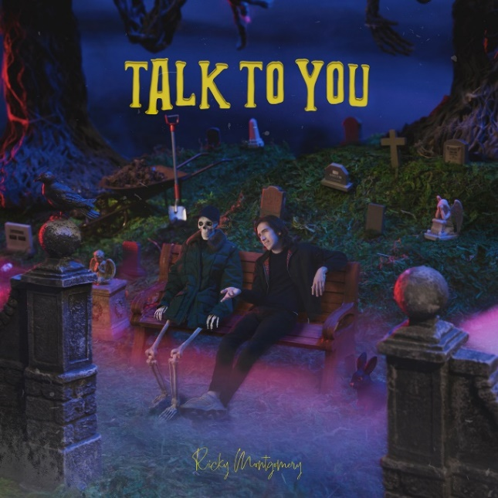
High-res artwork + photos available here

More about Ricky Montgomery:
Ricky Montgomery’s music was ahead of its time—literally. The two once-obscure, yet universal singles – “Line Without A Hook” and “Mr. Loverman” – were suddenly reinvigorated four years after their original release on his 2016 debut album Montgomery Ricky. Ironically, it came just when he was ready to call it quits on a music career entirely after years of nominal wins. The seemingly impossible—yet somehow inevitable— happened: suddenly people were finding solace in his songs. Now, among all the hip-hop hits, the Los Angeles native’s indie-pop has been a balm in the midst of a heavy time, comforting listeners with warm melodies and relatable lyrics. He balances melancholy with a touch of sweet humor and loads of humanity. With a newly-inked deal on Warner Records, Ricky’s using that momentum to prepare for the release of much more music to come in 2021 and beyond. “I just want to create something that can feel as special for other people as it is to me,” he says.

TOUR DATES
11/18 San Francisco, CA Rickshaw Stop
11/20 Santa Ana, CA Constellation Room
11/23 Denver, CO Larimer Lounge
11/27 Minneapolis, MN 7th Street Entry
11/28 Chicago, IL Lincoln Hall
11/30 Washington, DC Songbyrd
12/2 New York, NY Gramercy Theatre
12/4 Atlanta, GA Vinyl
12/6 Dallas, TX TOB Cambridge Room
12/9 Los Angeles, CA Troubadour

###
For more information, contact:
Ceri Roberts, Ceri.Roberts@warnerrecords.com
Patrice Compere, Patrice.Compere@warnerrecords.com

Press Materials:
press.warnerrecords.com/rickymontgomery

Follow Ricky Montgomery:
INSTAGRAM | TWITTER | YOUTUBE | TIKTOK

