ELECTRONIC PRODUCER & ARTIST SAM GELLAITRY IS ON A “NEW WAVE” WITH SINGLE – LISTEN HERE

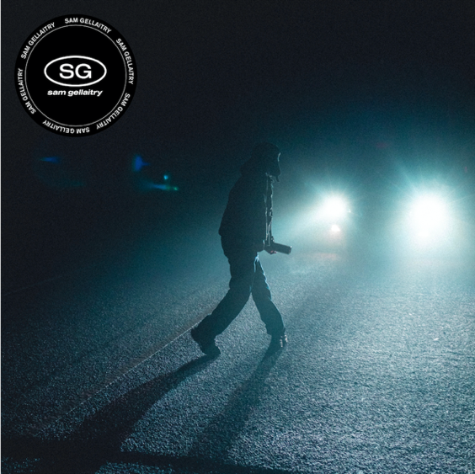

March 11, 2022 (Los Angeles, CA) – Today, Scottish electronic producer and singer/songwriter Sam Gellaitry shares a brand new track, “New Wave.” Listen to “New Wave” HERE via FFRR/Parlophone Records. With Sam’s own high-octane vocals and his captivating signature production, “New Wave” is a bouncy, uplifting track that immediately hooks you with its opening beat.

“New Wave” marks Sam’s first release since 2021’s “Gullible” and critically acclaimed EP IV and is the first song in a series of monthly releases. Earlier this year, Sam remixed PinkPantheress’ viral hit “Passion,” which was a highlight on her debut mixtape To Hell With It.

About “New Wave,” Sam commented, “New Wave to me is a coming of age, 80’s inspired track I wrote which dives into the pressures that are faced when transitioning from innocence into a party filled adulthood. It also brings to light the tug of war that substances and alcohol create from within and how eventually one side must win. In this instance, I end the track with a cry for help begging to be taken back into the lifestyle I thrived in as a child before this spiritual warfare began.”

Sam’s 2021 EP IV introduced a new phase of Sam’s career as he embraced both his Scottish heritage and his unparalleled and unadulterated passion for creativity. The EP received critical acclaim from the likes of i-D, Vice, Clash, Fader, and more. IV was a testament to why Sam’s career comes back to why he does it all in the first place. He loves creating and playing around with different colors. It’s like a form of magic: a source of respite, release, and happiness.

Sam’s music is a journey through experience, circumstance, and surroundings told through his impressive, synesthesia-informed knowledge of different musical tones. For him, songwriting and producing has always connected to a process of pairing and contrasting different tones – “using the notes to create different sensations – like tension or relief in your head.” In practice, this technique has seen him experiment with high-definition club music, crisp hip hop production, dabs of orchestral instrumentation and more. It signals a new phase of Sam’s career, and an embrace of his unparalleled and unadulterated passion for creativity. With more music to come this year, Sam Gellaitry is set to take the scene by storm.

For more information, contact:
Darren Baber | Warner Records
Darren.Baber@warnerrecords.com

Follow Sam Gellaitry:
Website | Twitter | Facebook | Instagram | Soundcloud | Press Materials

