SAWEETIE X LONDON ON DA TRACK UNVEIL MUSIC VIDEO FOR NEW SINGLE “UP NOW” FEATURING G-EAZY & RICH THE KID
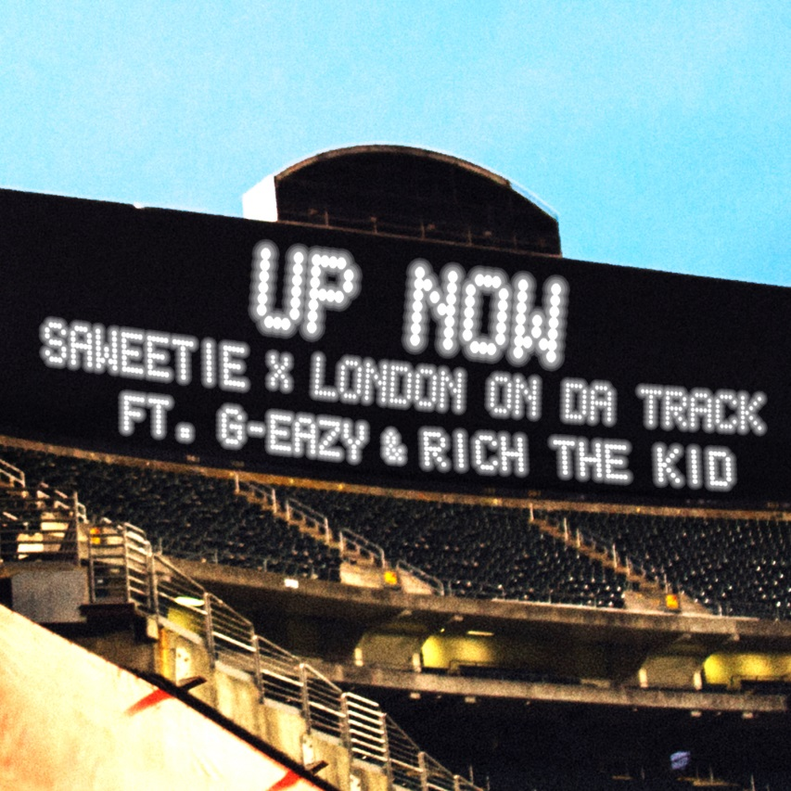

August 30, 2018 (Los Angeles, CA) – After drumming up critical acclaim and widespread fan excitement around the world, SAWEETIE X London On Da Track share the music video for their joint single “Up Now” [feat. G-Eazy & Rich The Kid], today. Watch it HERE. Get it HERE via ICY/Artistry Worldwide/Warner Bros. Records.

These four hip-hop stars unite for a blockbuster visual befitting of the hype surrounding this once-in-a-lifetime collaboration. The cinematic clip plays out as a fast-paced rollercoaster that barely relents with foreign whips taking hairpin turns at high speed and this quartet taking over and stunting at The Coliseum in Oakland—home of The Oakland Athletics. It’s a slick, sexy, and seismic video most definitely worthy of the talent behind it. You’ll be rocking to “Up Now” for a long time to come. Check out behind the scenes from the collaboration HERE.

Earlier this month, Zane Lowe personally premiered the single as a “World Record” on Apple Music Beats 1, impacting over 100 countries simultaneously. Touted among “Bangers This Week,” XXL described it as “a momentous track, with a bounce that sounds like it’ll touch the club and stay there” before appropriately adding, “This song bangs.”

“Up Now” notably marks the first collaboration between Saweetie x London. The Atlanta producer is responsible for numerous multiplatinum chart-topping hits for everyone from Post Malone and Drake to Rich Gang and 50 Cent. On Wednesday night, August 29th, Saweetie x London gave fans an exclusive look at the “Up Now” video at Neuehouse in Hollywood.

Following her EP High Maintenance, the single sets the stage for the release of her highly anticipated next release, coming soon. 2018 is the year of Saweetie.

ABOUT SAWEETIE:
Flaunting nineties rhyme reverence, fashion-forward fire, and endless charisma, SAWEETIE—born Diamonté Harper—can go bar-for-bar with the best of ‘em, and fans and critics immediately recognized and responded to that. Within six months, she cracked 100 million cumulative streams, garnered a gold plaque, and earned the praise of Billboard, Fader, and Noisey. as Los Angeles times pegged her as “one to watch this year.” Drawing on a passion for poetry and numerous years of rapping in the car, she turned her love for words into vivid verses during 2018 on the High Maintenance EP.

Born in Santa Clara of African-American and Chinese-Filipino descent and raised in Sacramento, the California native went from MVP status as a high school volleyball champ to becoming a shining student at USC. Initially, she deferred her rap dreams to achieve a degree in Communications before being discovered at a Downtown Los Angeles Puma event by current manager Max Gousse [Beyoncé, YG, Ty Dolla $ign]. At Artistry Studios, they produced her 2017 knockout viral smash “ICY GRL.” Driven by a bulletproof flow and one clever line after another, it racked up 50 million YouTube views in a few months and over 31 million Spotify streams between the original and Kehlani remix, achieved a gold certification from the RIAA, and soared to #1 on Musical.ly. She also earned the early endorsement of gatekeepers such as Vibe, XXL, HipHopDX, and MTV. Touting a new partnership with Warner Bros. Records and Artistry Records for her label Icy, she’s rewriting the rule book and breaking the stereotype of the female emcee. Armed with tracks like “B.A.N.” and “Good Good,” High Maintenance features production courtesy of Zaytoven, Hassan, Saweetie, Cash Money AP, and Gousse.

As a businesswoman, she teamed with Sprayground, Reebok, and Honeybum for high-profile partnerships. Meanwhile, everyone from David Guetta to Dua Lipa has enlisted her for guest spots. As a fashionista, Next Models signed her for modeling, and she graced the cover of Wonderland in addition to appearing in C.R. Fashion Book, Notion, and VFiles. Represented by CAA, she launches a full-scale headline tour this fall and readies her full-length debut for release soon.

About London On Da Track
London On Da Track is one of the most sought after producers in hip-hop, creating an in-demand sound made up of his signature bounce, a singular mood, and moving keys. His resume includes Drake’s (“Sneakin’” ft. 21 Savage), Tyga’s (“Hookah”), Richgang’s (“Lifestyle”), Young Thug’s (“Check”, “Killed Before”), T.I.’s (“All About The Money”) and many more. Most recently he produced Roddy Rich’s “Die Young,” Post Malone’s “92 Explorer,” Derez Deshon’s “Hardaway” and Kodak Black’s “Roll In Peace” ft. XXXtentatcion, which is RIAA certified double platinum.

In August 2017, London penned a deal with RCA Records in a transition to a forward facing artist. Since signing, London adds to his accomplishments the release of his debut single, “No Flag” featuring Nicki Minaj, 21 Savage, and Offset, which streamed over 60 million times worldwide and was featured on Spotify’s New Music Friday and Rap Caviar upon release. London followed up with the release his second track: “Whatever You On” ft. Young Thug, Jeremih, YG and Ty Dolla $ign, which has been streamed nearly 20 million times worldwide.
London also produced and is featured on A$AP Rocky x 21 Savage x Gucci Mane’s “Cocky.” Featured in the trailer and throughout the film, “Cocky” was the lead single from the motion picture, Uncle Drew. Raved about by Pitchfork, Noisey, FADER, Complex, Rolling Stone and more, “Cocky” has been streamed over 20 million times worldwide.

London has also performed at major festivals across the country including Electric Daisy Carnival in Las Vegas, Ultra in Miami, Lollapalooza in Chicago. He will also play Bumbershoot in a few weeks before embarking on his European tour.

