RELEASE VIDEO FOR
“VIRGINIA (WIND IN THE NIGHT)”

<VIDEO EMBED: https://youtu.be/6LS4oKobHp0>

ANNOUNCE PERFORMANCE ON THE TONIGHT SHOW STARRING JIMMY FALLON TOMORROW, MARCH 4

NEW ALBUM EVERY SHADE OF BLUE OUT APRIL 29, 2022 & NORTH AMERICAN TOUR ON SALE NOW

March 3, 2022 – (Los Angeles, CA) – The Head And The Heart have revealed the Jacqueline Justice directed video for their latest track “Virginia (Wind In The Night).” The song is the second released track from their forthcoming fifth studio album Every Shade of Blue out April 29th on Reprise/Warner Records. Listen to “Virginia (Wind In The Night)” HERE.

The band has also announced they will perform “Virginia (Wind In The Night)” tomorrow, March 4 on The Tonight Show Starring Jimmy Fallon.

Acclaim for “Virginia (Wind In The Night)”:

"This bittersweet track showcases the band playing to their strengths: a sturdy piano sound garnished with strings and perfectly paired with Jonathan Russell’s evocative lyrics." - SPIN

"An anthemic celebration with a catchy chorus." - Consequence

"A gut-wrenching offering, and certainly an emotional one, another stellar example of what to expect from the full record." - Variance Magazine

At AAA radio, the song was the #1 Greatest Gainer and moved up the chart from #28 to #15 - following #1 most added impact last week. Also, at Alternative Radio, Virginia (Wind In The Night) jumped from #42 to #36 in its first week after impact following a most added debut.

Jonathan Russell spoke about the inspiration behind the song, saying “Being from Virginia, for me this song represents a long and winding relationship to place - a place that is grounding. I’m often drawing on my life through symbolism as a way into someone else’s psyche. It’s part of my search for a deeper connection without having to compare our experiences directly. There is a reason this song has two titles. One is literal and one is symbolic. Not everyone is from Virginia, I know that. But I bet you have walked home and heard the wind in the night.”

Every Shade of Blue was produced by GRAMMY-award winning songwriter, producer and engineer Jesse Shatkin (Sia, Pink, The Shins, Tegan and Sara) except for album tracks “Shadows”, “Don’t Show Your Weakness” and “Love We Make” which were produced by Andrew Sarlo (Big Thief, Wet), and “Paradigm”, produced by John Hill and Sammy Witte (Florence + The Machine, Portugal The Man, Cage The Elephant), and mastered by Emily Lazar and Chris Allgood at The Lodge, NY.

Last month, The Head And The Heart announced the Every Shade of Blue 2022 North American Tour which kicks off May 20th. Special guests joining the band in select cities include Shakey Graves, Dawes and Jade Bird. Tickets for most shows are on sale now, with the 8/8 Salt Lake City, UT show going on sale at a later date.

The band previously released the album’s title track and a music video directed by Jacqueline Justice. Rolling Stone described it saying, “the band swim, dive around and tread water as they ride the lyric’s emotional waves of wanting to know all the facets of a significant other." Listen to “Every Shade of Blue” HERE and watch the video HERE.

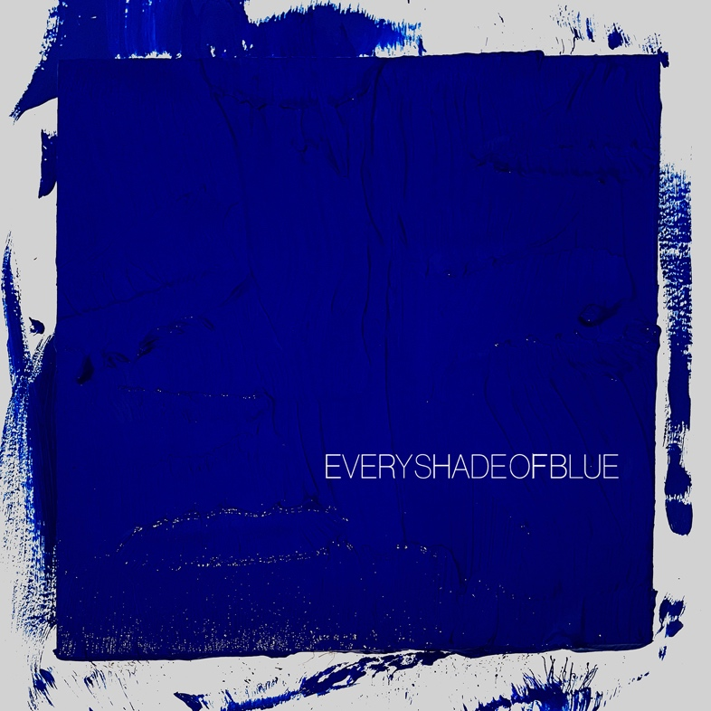
Download high-res album art here

Every Shade of Blue Tracklist:
- Every Shade of Blue
- Tiebreaker
- Paradigm
- Virginia (Wind In The Night)
- Same Hurt
- Hurts (But It Goes Away)
- Don’t Show Your Weakness
- Love We Make
- Starstruck
- Love Me Still
- Shut Up
- Family Man
- Taking My Time (Wrong Woman)
- Enemy Lines
- Shadows
- GTFU

Every Shade Of Blue Tour 2022
5/20/22 - St. Petersburg, FL - Jannus Live *
5/22/22 - Gulf Shores, AL - Hangout Music Festival
5/24/22 - Kansas City, MO - Uptown Theater *
5/25/22 - Milwaukee, WI - Riverside Theater *
5/27/22 - Pittsburgh, PA - STAGE AE *
5/28/22 - Lewiston, NY - Artpark Amphitheater *
5/29/22 - Cleveland, OH - Agora Theatre *
5/31/22 - LaFayette, NY - Beak & Skiff Apple Orchards *
6/1/22 - Northampton, MA - The Pines Theater at Look Park *
6/3/22 - Shelburne, VT - Ben & Jerry's Concerts on the Green at Shelburne Museum * SOLD OUT
6/4/22 - Portland, ME - Thompson's Point *
6/6/22 - New York, NY - Pier 17 - The Rooftop * SOLD OUT
6/7/22 - New York, NY - Pier 17 - The Rooftop * JUST ADDED!
6/9/22 - Vienna, VA - Wolf Trap *
6/10/22 - Boston, MA - Leader Bank Pavilion *
8/1/22 - Austin, TX - ACL Live at The Moody Theater ^ JUST ADDED!
8/2/22 - Austin, TX - ACL Live at The Moody Theater ^ SOLD OUT
8/4/22 - Houston, TX - Lawn at White Oak ^
8/5/22 - Dallas, TX - The Pavilion at Toyota Music Factory ^
8/6/22 - Oklahoma City, OK - The Criterion ^
8/8/22 - Salt Lake City, UT - Venue to be announced at a later date ^
8/9/22 - Boise, ID - Outlaw Field at the Idaho Botanical Garden ^
8/11/22 - Missoula, MT - KettleHouse Amphitheater ^
8/12/22 - Seattle, WA - Marymoor Park ^ SOLD OUT
8/13/22 - Seattle, WA - Marymoor Park ^ JUST ADDED!
8/16/22 - Portland, OR - McMenamins Edgefield ^
8/18/22 - Santa Barbara, CA - Santa Barbara Bowl ^
8/19/22 - Berkeley, CA - Greek Theatre ^
8/20/22 - Los Angeles, CA - Greek Theatre ^
8/22/22 - San Diego, CA - Humphreys Concerts By The Bay ^ SOLD OUT
8/23/22 - San Diego, CA - Humphreys Concerts By The Bay ^ JUST ADDED!
9/14/22 - Denver, CO - Mission Ballroom
9/15/22 - Morrison, CO - Red Rocks Amphitheatre - SOLD OUT
9/17/22 - Richmond, VA - Altria Theater #
9/20/22 - Charlotte, NC - Charlotte Metro Credit Union Amphitheatre #
9/21/22 - Wilmington, NC - Live Oak Bank Pavilion at Riverfront Park #
9/22 - 9/25 - Dover, DE - Firefly Festival
9/23/22 - Columbus, OH - KEMBA Live! #
9/27/22 - Toronto, ON - RBC Echo Beach
9/29/22 - Detroit, MI - Oakland University - Meadow Brook Amphitheatre #
9/30/22 - Indianapolis, IN - TCU Amphitheater at White River State Park #
10/1/22 - Chicago, IL - Huntington Bank Pavilion at Northerly Island #
10/3/22 - Madison, WI - The Sylvee #
10/4/22 - Madison, WI - The Sylvee #
10/7/22 - Minneapolis, MN - Armory #
10/8/22 - St. Louis, MO - Saint Louis Music Park #
10/10/22 Birmingham, AL - Avondale Brewing Company #
10/13/22 - St Augustine, FL - The Saint Augustine Amphitheatre #
10/14/22 - Atlanta, GA - Cadence Bank Amphitheatre at Chastain Park #
10/15/22 - Nashville, TN - Ascend Amphitheater #

* Jade Bird
^ Dawes
# Shakey Graves

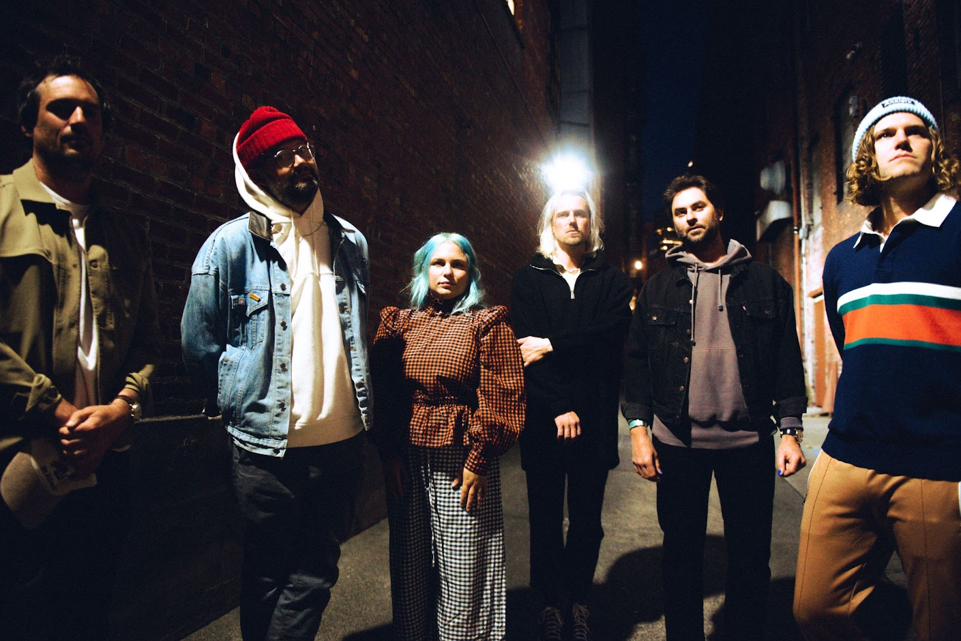
Photo credit: Jacqueline Justice | high-res here

More about The Head And The Heart
Initially self-released in 2011, The Head and The Heart’s self-titled breakout debut produced instant classics including “Rivers and Roads,” “Down In The Valley” and “Lost In My Mind” (#1 at AAA) and is now Certified Gold. 2013’s Let’s Be Still and 2016’s Signs of Light, settled into Billboard’s Top 10 albums chart, with Signs of Light securing the #1 position on Rock Album Charts, securing the band’s first #1 at Alternative position with “All We Ever Knew” and also held the #1 spot at AAA for nine straight weeks. The band’s fourth full-length album, Living Mirage, was released to critical praise in 2019. “Missed Connection” which secured the #1 position on the Alternative Chart and #1 at Mediabase and BDS alternative charts, already having achieved #1 on the AAA chart. The album’s breakout track, “Honeybee”, became a fan favorite with 153M+ total global streams and 1M+ global weekly streams. They have appeared in Cameron Crowe’s Roadies, with music featured in countless other commercials, films and TV, among them Corona, Silver Linings Playbook and more. The band has established their status as a touring powerhouse, having landed prime time mainstage slots at Coachella, Lollapalooza and Austin City Limits. In total, the band has performed 15 times on national television including appearances on Ellen, The Tonight Show Starring Jimmy Fallon, The Late Show With Stephen Colbert, Austin City Limits and more. Every Shade of Blue is the band’s fifth studio album.

Contacts:

Grandstand Media
Kate Jackson katej@grandstandhq.com
Katie Nelson katien@grandstandhq.com

Warner Records
Rick Gershon Rick.Gershon@warnerrecords.com
Jenny Huynh Jenny.Huynh@warnerrecords.com

Follow The Head And The Heart:
Website / Instagram / Twitter / TikTok / Facebook

