TEDDY SWIMS RELEASES MOVING NEW SINGLE “PLEASE TURN GREEN” – LISTEN HERE

FROM THE UPCOMING TOUGH LOVE EP OUT JANUARY 21ST

TOUGH LOVE WORLD TOUR KICKS OFF MARCH 24TH

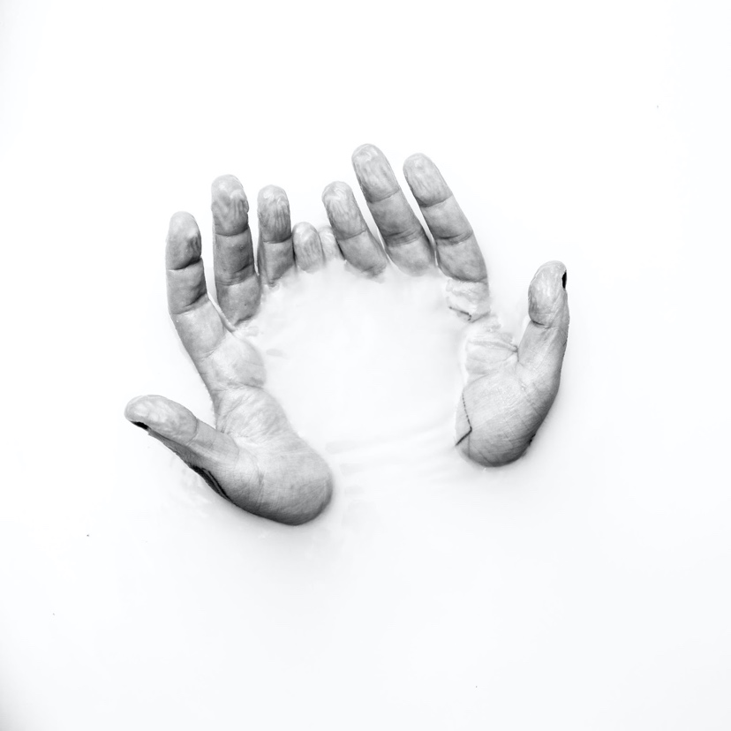

November 12, 2021 (Los Angeles, CA) – Genre-blurring vocal powerhouse Teddy Swims returns today with the emotional ballad “Please Turn Green.” The second cut from the Atlanta native’s forthcoming Tough Love EP out on January 21st, is a soulful breakup anthem with an excruciatingly relatable twist. Get “Please Turn Green” HERE and pre-order Tough Love HERE.

“I wrote this song about running into my ex at a stoplight,” Teddy Swims reveals. “If you are from a small town, you will feel this one."

“Please Turn Green” is a forlorn track about the aftermath of a breakup, as Teddy Swims copes with the loss of someone he hasn’t quite gotten over yet. “I heard you found somebody else, but I hadn’t seen it for myself,” he sings. Things go awry when he pulls up to a traffic light. “Now we’re both stopped at the same place at 11:23, praying that this light would... please turn green.”

“Please Turn Green” caps a breakthrough year for Teddy Swims. The hitmaker born Jaten Dimsdale, who first went viral by posting covers on social media, released his debut Unlearning EP to critical acclaim in May. Rolling Stone praised his “silky voice that slides right into country, hip-hop, and classic soul,” while American Songwriter applauded the rising star’s “arena-worthy anthems.” The project produced the soulful hit “Bed on Fire,” which was recently transformed into a duet with country artist Ingrid Andress.

Instead of resting on his laurels, Teddy Swims got straight back to work. “Simple Things,” a stripped-back guitar anthem about life’s small joys, introduced fans to the Tough Love era in August. The breakout artist’s sophomore EP, due early 2022, will coincide with his Tough Love World Tour. The three-month trek kicks off in Belfast, UK, on February 6, 2022 (buy tickets here). No doubt, “Please Turn Green” will be a heart-rending highlight at nearly every stop.

Teddy will make his morning show debut, performing on NBC’s Today on November 16^{th.} Earlier this year he performed “My Bad” on The Kelly Clarkson Show, “Bed on Fire” on The Late Show With Stephen Colbert, and “Simple Things” on The Late Late Show With James Corden.

He also recently started the holiday season a little early with the release of his A Very Teddy Christmas EP and just debuted a live performance this week for his rendition of “This Christmas,” dressed as Santa.

2022 TOUGH LOVE US TOUR DATES:
March 24 - Fort Lauderdale, FL - Culture Room
March 25 - Tampa, FL - The Orpheum
March 27 - New Orleans, LA - House of Blues
March 29 - Houston, TX - Warehouse Live
March 30 - Dallas, TX - Canton Hall
March 31 - Austin, TX - Scoot Inn
April 2 - Phoenix, AZ - Crescent Ballroom
April 3 - San Diego, CA - Observatory North Park
April 5 - Los Angeles, CA - Fonda Theater
April 6 - San Francisco, CA - The Fillmore
April 8 - Portland, OR - Wonder Ballroom
April 9 - Seattle, WA - Showbox
April 12 - Salt Lake City, UT - The Complex - Grand
April 13 - Englewood, CO - Gothic Theatre
April 15 - Minneapolis, MN - Fine Line Music Café
April 16 - Chicago, IL - Metro
April 17 Indianapolis, IN - Deluxe at Old National Center
April 19 - Columbus, OH Newport Music Hall
April 20 - Pittsburgh, PA - Mr. Smalls Theatre
April 22 - Cleveland, OH - House of Blues
April 23 - Detroit, MI - St. Andrews Hall
April 27 - Boston, MA - Royale
April 29 - New York, NY - Webster Hall
April 30 - Philadelphia, PA - Theatre of Living Arts (TLA)
May 1 - Washington, DC - 9:30 Club
May 3 - Raleigh, NC - Lincoln Theatre
May 4 - Asheville, NC - The Orange Peel
May 6 - Nashville, TN - Basement East
May 7 - Atlanta, GA Buckhead Theatre

ABOUT TEDDY SWIMS:
After dedicating his life to music as a kid, Teddy Swims—a.k.a. Atlanta native Jaten Dimsdale—unassumingly knocked on the door of stardom and claimed the payoff of a decades-long grind in 2019. Broadcasting covers from a bedroom studio, he lit up the Internet with hundreds of millions of views and a following of over 4 million. That was just the first step though. Teddy fashioned a show-stopping signature style out of soaring soul, intimate R&B, rock energy, and hip-hop swagger all uplifted by his earthquaking vocals. Leaving tastemakers such as American Songwriter, Billboard, Flaunt, and Idolator and idols like Shania Twain speechless, Rolling Stone christened him a 2021 "Artist To Watch.” During this time, he went from singing covers of his favorite artists on YouTube to performing his own original music The Kelly Clarkson Show and The Late Show with Stephen Colbert. Teddy continues to spread his wings, unveiling his 2021 debut graphic novel, Teddy Swims: Swimmy and the Valley of the Last Song [Z2 Comics] and hitting the road with GRAMMY® Award-winning Zac Brown Band for a series of stadium gigs. In between, he released his 2021 debut EP Unlearning to critical acclaim. However, he only picks up the pace with the Tough Love EP in 2022 supported by his massive “Tough Love” World Tour.

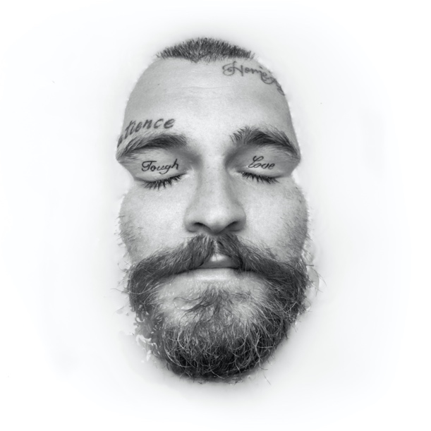
Tough Love Artwork

###

FOLLOW TEDDY SWIMS:
Official | Twitter | Instagram | Facebook | YouTube | Press Materials

For more information, please contact:
Darren Baber | Warner Records
Darren.Baber@warnerrecords.com

Regional: Jenny Huynh | Warner Records
Jenny.Huynh@warnerrecords.com
