VOCAL POWERHOUSE TEDDY SWIMS APPRECIATES THE “SIMPLE THINGS” ON NEW SINGLE – WATCH THE LIVE PERFORMANCE VIDEO HERE

WRAPS UP A STRING OF SUMMER DATES OPENING FOR
ZAC BROWN BAND

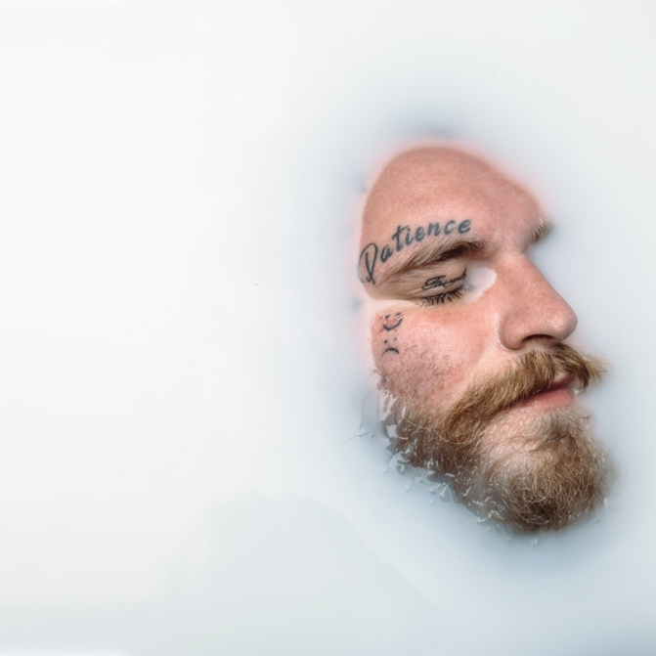

August 27, 2021 (Los Angeles, CA) – After lighting up social media with just a snippet, ace Atlanta singer/songwriter Teddy Swims uncovers his new single “Simple Things” today via Warner Records. Listen to “Simple Things” HERE. Watch a powerful performance video of “Simple Things” HERE.

He initially teased “Simple Things” on TikTok, and it set the platform ablaze with 4 million views and counting and also shared a clip on Instagram. On the track, delicate acoustic guitar entwines with emotive vocals from Teddy as he celebrates, “The sound of the rain coming down when you fall asleep, it’s the call from a friend that you love, but never get to see.” Joined by his full band, he delivers an impassioned performance in front of a lush backdrop.

About the song, Teddy shared, “Growing up, both sides of my family were all in the same town for generations and were always so close-knit. As lucky as I was to have that, I found myself sometimes resenting that as a kid, because everyone seemed so complacent and just okay with a simple life. The older I get, the more people in my life I lose, and the more I travel, the more I start to appreciate the simple things in life. This dream I’m chasing has made me realize real fulfillment comes from being truly present and happy within yourself. Making plans and striving for greatness is good for you but don’t be so focused on the future you forget to be present. It’s true what they say, ‘Sometimes, you’ve gotta stop and smell the roses’.”

Right now, Teddy is enchanting audiences everywhere on a sold-out summer tour opening for GRAMMY® Award-winning country rock leaders Zac Brown Band. Expect to hear “Simple Things” in the set. Check out the remaining dates below. Tickets are on sale HERE.

“Simple Things” arrives on the heels of his debut EP, Unlearning. American Songwriter described the EP as “fluttering between sunny, arena-worthy anthems and introspective examinations of self,” and Atwood Magazine extolled how it “ebbs and flows with the steady rhythm of a tide, easing the listener from one realm to the next” and Rolling Stone applauded his “silky voice that slides right into country, hip-hop, and classic soul.”

Unlearning includes “L.I.F.E.”, which was co-written by mega-songwriters Poo Bear (Justin Bieber, Usher) and John Ryan (Maroon 5, John Legend), “Bed On Fire” and the incendiary music video that stars Leila George from TNT’s Animal Kingdom along with fan favorites “Broke” (feat. Thomas Rhett) and “Til I Change Your Mind.”

Teddy appeared on A Little Later With Lilly Singh (watch HERE) and delivered his late-night television debut performance with “Bed On Fire” on The Late Show With Stephen Colbert (watch HERE). Teddy started out the year by being named a 2021 “Artist To Watch” by Rolling Stone who praise “A boundaryless approach comes through in Dimsdale’s original songs, which blend elements of hip-hop, R&B, country, and classic soul.”

ABOUT TEDDY SWIMS:
After dedicating his life to music as a kid, Teddy Swims—a.k.a. Atlanta native Jaten Dimsdale—unassumingly knocked on the door of stardom and claimed the payoff of a decades-long grind in 2019. Broadcasting covers from a bedroom studio, he lit up YouTube with hundreds of millions of views and a following of nearly 2 million subscribers. That was just the first step though. Teddy fashioned a show-stopping signature style out of soaring soul, intimate R&B, rock energy, and hip-hop swagger all uplifted by his earthquaking vocals. Leaving tastemakers such as American Songwriter, Billboard, Flaunt, and Idolator and idols like Shania Twain speechless, Rolling Stone christened him a 2021 "Artist To Watch.” During this time, he went from singing covers of his favorite artists on YouTube to performing his own original music The Kelly Clarkson Show and The Late Show with Stephen Colbert. Teddy continues to spread his wings, unveiling his 2021 debut graphic novel, Teddy Swims: Swimmy and the Valley of the Last Song [Z2 Comics] and hitting the road with GRAMMY® Award-winning Zac Brown Band for a series of stadium gigs. Ultimately, he took all of the lessons from a life-changing year and distilled them in his 2021 debut EP, Unlearning [Warner Records].

TOUR DATES:
Fri Aug 27 Indianapolis, IN Ruoff Music Center
Sat Aug 28 Tinley Park, IL Hollywood Casino Amphitheatre
Sun Aug 29 Cincinnati, OH Riverbend Music Center
Fri Sep 17 Las Vegas, NV Life Is Beautiful Festival
Sat Sep 18 Atlanta, GA Music Midtown Festival

Photo credit: TheWorkOfJAR

# # #

Follow Teddy Swims
Official | Instagram | Twitter | Facebook | YouTube | Press Materials

Teddy Swims Press Contact:
Darren Baber / Warner Records / Darren.Baber@warnerrecords.com

