VOCAL POWERHOUSE TEDDY SWIMS TO LAUNCH THE TOUGH LOVE WORLD TOUR 2022

TOUGH LOVE EP OUT EARLY 2022

September 21, 2021 (Los Angeles, CA) – Today, ace Atlanta singer/songwriter Teddy Swims reveals the details for his Tough Love World Tour in 2022. The marathon three-month global run kicks off in Belfast, UK at Limelight 1 and takes over the UK and Europe before returning stateside where it rolls through major markets coast-to-coast and concludes with a hometown show at Buckhead Theatre on May 7th. A special fan pre-sale launches September 22 at 10am local time through September 23 at 10pm local time before general on-sale goes live Friday September 24 at 10am local time. Tickets will be available HERE.

It will be the first jaunt in support of his forthcoming EP, Tough Love, arriving at the top of 2022. Tough Love season began with the release of his latest single “Simple Things.” He also just delivered a seismic and show-stopping performance of the song on The Late Late Show with James Corden—watch it HERE.

Receiving critical acclaim, American Songwriter recently noted, “His vocal talents certainly speak for themselves, but he goes much deeper than most,” and Consequence of Sound raved, “Teddy Swims can truly move mountains with his colossal voice.”

Additionally, he shared a remix of his buzzing “Bed On Fire” with GRAMMY® nominated singer-songwriter Ingrid Andress last week. It’s available HERE.

Not to mention, Teddy just enchanted audiences everywhere on a sold-out summer tour opening for GRAMMY® Award-winning country rock leaders Zac Brown Band. He also lit up multiple festival stages this past weekend, including Life Is Beautiful and Music Midtown.

“Simple Things” arrived on the heels of his debut EP, Unlearning. American Songwriter described the EP as “fluttering between sunny, arena-worthy anthems and introspective examinations of self,” and Atwood Magazine extolled how it “ebbs and flows with the steady rhythm of a tide, easing the listener from one realm to the next” and Rolling Stone applauded his “silky voice that slides right into country, hip-hop, and classic soul.”

Unlearning includes “L.I.F.E.”, which was co-written by mega-songwriters Poo Bear (Justin Bieber, Usher) and John Ryan (Maroon 5, John Legend), “Bed On Fire” and the incendiary music video that stars Leila George from TNT’s Animal Kingdom along with fan favorites “Broke” (feat. Thomas Rhett) and “Til I Change Your Mind.”

Earlier this year, Teddy appeared on A Little Later With Lilly Singh (watch HERE) and delivered his late-night television debut performance with “Bed On Fire” on The Late Show With Stephen Colbert (watch HERE). Teddy started out the year by being named a 2021 “Artist To Watch” by Rolling Stone who praise “A boundaryless approach comes through in Dimsdale’s original songs, which blend elements of hip-hop, R&B, country, and classic soul.”

ABOUT TEDDY SWIMS:
After dedicating his life to music as a kid, Teddy Swims—a.k.a. Atlanta native Jaten Dimsdale—unassumingly knocked on the door of stardom and claimed the payoff of a decades-long grind in 2019. Broadcasting covers from a bedroom studio, he lit up the Internet with hundreds of millions of views and a following of over 4 million. That was just the first step though. Teddy fashioned a show-stopping signature style out of soaring soul, intimate R&B, rock energy, and hip-hop swagger all uplifted by his earthquaking vocals. Leaving tastemakers such as American Songwriter, Billboard, Flaunt, and Idolator and idols like Shania Twain speechless, Rolling Stone christened him a 2021 "Artist To Watch.” During this time, he went from singing covers of his favorite artists on YouTube to performing his own original music The Kelly Clarkson Show and The Late Show with Stephen Colbert. Teddy continues to spread his wings, unveiling his 2021 debut graphic novel, Teddy Swims: Swimmy and the Valley of the Last Song [Z2 Comics] and hitting the road with GRAMMY® Award-winning Zac Brown Band for a series of stadium gigs. In between, he released his 2021 debut EP Unlearning to critical acclaim. However, he only picks up the pace with the Tough Love EP in 2022 supported by his massive “Tough Love” World Tour.

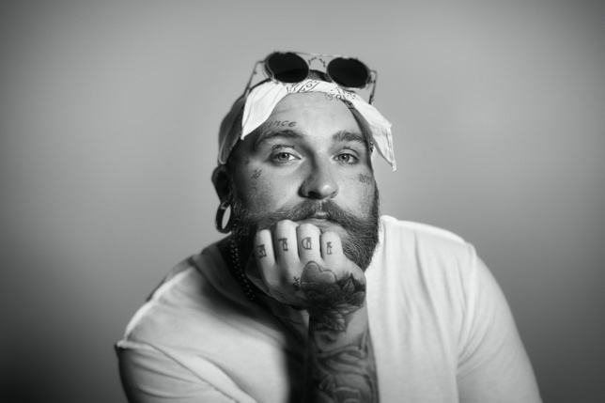
Photo credit: The Work of Jar

Follow Teddy Swims
Official | Instagram | Twitter | Facebook | YouTube | Press Materials

Teddy Swims Press Contacts:
National: Darren Baber / Warner Records / Darren.Baber@warnerrecords.com
Regional: Jenny Huynh / Warner Records / Jenny.Huynh@warnerrecords.com

