**cid:image001.png@01D5204D.CFB194F0**

**NASHVILLE SINGER/SONGWRITER PATRICK DRONEY SIGNS TO WARNER RECORDS, SHARES MUSIC VIDEO FOR “STAND AND DELIVER”**

**PERFORMING AT BONNAROO MUSIC & ARTS FESTIVAL THIS WEEKEND,**

**FOLLOWED BY AUSTIN CITY LIMITS THIS FALL**

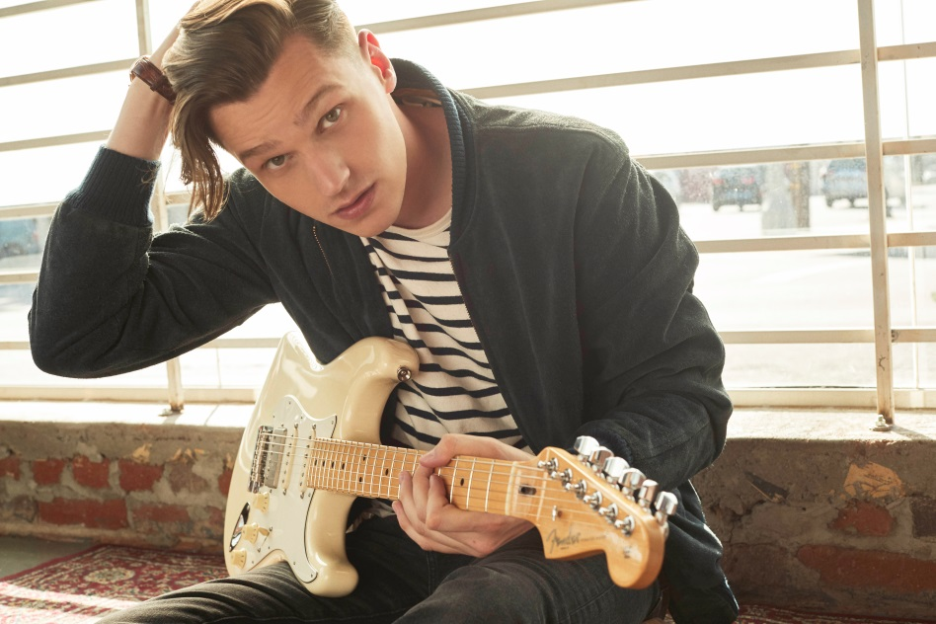

**June 13, 2019 (Los Angeles, CA) –** Nashville-based singer, songwriter, and celebrated guitarist Patrick Droney has released the official video for “Stand and Deliver.” With a cathedral-size chant and searing blues guitar solo, the breakout track garnered upwards of 100K streams in its first week, landed in the Top 10 on Spotify’s U.S. Viral Top 50 chart, and earned Droney a recent performance on [*Late Night with Seth Meyers*](https://www.nbc.com/late-night-with-seth-meyers/video/patrick-droney-stand-and-deliver/3847946). He will perform at Bonnaroo this Sunday, June 16 at 3:45pm on the Who Stage, followed by Austin City Limits this fall alongside Kacey Musgraves, Billie Eilish, Mumford & Sons and more.

**Watch/Share “Stand and Deliver” (Official Video):**

[https://ad.gt/standanddelivermv*](https://ad.gt/standanddelivermv*)

“Stand and Deliver” offers the perfect introduction to Droney, who signed to Warner Records earlier this year. He states, “I could not be more thrilled to join this incredible team with such a rich and iconic history. I’ve always focused on creating music with intent as well as being an additive part of the musical landscape. I am inspired by this partnership already.”

Droney nods back to an era of handmade pop songcraft and musical virtuosity through a 21st century prism of playlist-hopping ambition – what he calls, “New Classic.” He was just five years old when he picked up a guitar for the first time, an obsession that led him to receive the “Next Generation Award” from the Robert Johnson Foundation at age twelve, and catapulted him into a life on the road, performing with the likes of James Brown, B.B. King, Elvis Costello and the Experience Hendrix Tour. After attending the prestigious Clive Davis Institute of Recorded Music at New York University, he signed a publishing deal that brought him to Los Angeles where he also caught the attention of Fender Guitars as one of their go-to artist ambassadors. However, the desire to dig deeper into songwriting led him to Nashville, where he crafted and released his self-titled debut EP in 2018, earning more than 10M cumulative streams, with early critical acclaim from the likes of *Ones To Watch* and *Premier Guitar* who praise Droney’s “bluesy, catchy hooks à la John Mayer”… and his “standout, melodically rich, smooth, passionate, articulate” songwriting.

# # #

**For further information contact Warner Records Publicity**

National: [Jaime.Rosenberg@warnerrecords.com](mailto:Jaime.Rosenberg@warnerrecords.com)

Regional: [Patrice.Compere@warnerrecords.com](mailto:Patrice.Compere@warnerrecords.com)

**Follow Patrick Droney:**

Website: [www.patrickdroneymusic.com](https://www.patrickdroneymusic.com/)

Facebook: [Facebook.com/PatrickDroney](https://www.facebook.com/patrickdroney/)

Twitter: [@PatrickDroney](https://twitter.com/patrickdroney)

Instagram:  [@PatrickDroney](https://www.instagram.com/patrickdroney/?hl=en)

YouTube: [Youtube.com/PatrickDroney](https://www.youtube.com/user/patrickdroney/featured)

**Press materials:**

[press.warnerrecords.com/patrickdroney](http://press.warnerrecords.com/patrickdroney/)