Singer, songwriter, producer and celebrated guitarist Patrick Droney releases “The Wire” today, the first taste of his major label debut due out on Warner Records later this year. Self-produced, and mixed by Spike Stent, the new track is accompanied by a lyric video filmed in the neighborhood where Droney currently resides . Earlier this week, he kicked off a 20+ date North American tour alongside ZZ Ward, which will continue through March. See upcoming dates below!

Watch/Share “The Wire” (Video) HERE
Listen/Share “The Wire” (Audio) HERE

Patrick had a breakout moment with the independent release of his debut EP in 2018, earning more than 15M streams and spawning “Stand and Deliver,” which he performed on Late Night with Seth Meyers and landed in the Top 10 on Spotify’s US Viral Top 50 chart, with Premier Guitar praising his “bluesy, catchy hooks à la John Mayer.” A natural virtuoso, he first picked up a guitar around age 5, starting an obsession that that led him to receive the “Next Generation Award” from the Robert Johnson Foundation at age 12, later attending the prestigious Clive Davis Institute at NYU and earning a spot as one of Fender’s go-to artist ambassadors, and of course, his new deal with Warner Records.

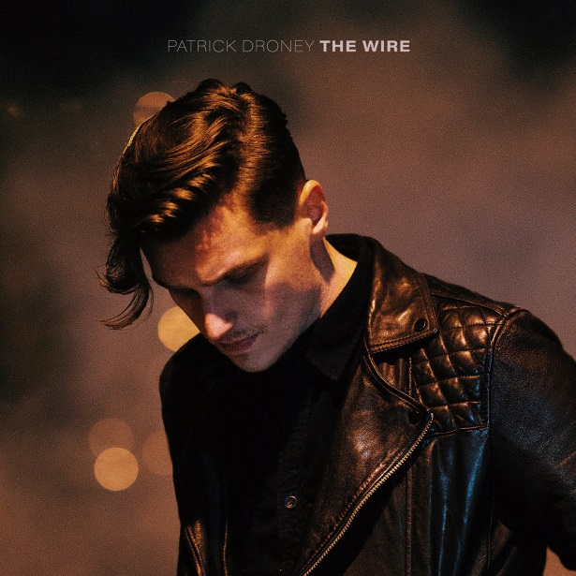

Upcoming Tour Dates
Feb. 21 – Spokane, WA – Knitting Factory
Feb. 22 – Seattle, WA – The Showbox
Feb. 25 – San Francisco, CA – August Hall
Feb. 27 – Los Angeles, CA – Troubadour
Feb. 28 – Solana Beach, CA – Belly Up Tavern
Feb. 29 – Las Vegas, NV – The Bunkhouse Saloon (headline show)
March 2 – Salt Lake City – The Grand at The Complex
March 4 – Aspen, CO – Belly Up Aspen
March 5 – Boulder, CO – Fox Theatre
March 7 – Englewood, CO – Gothic Theatre
March 9 – Omaha, NE – The Waiting Room
March 10 – Des Moines, IA – Wooly’s
March 12 – Chicago, IL – House of Blues
March 13 – Minneapolis, MN – First Avenue
March 14 – Madison, WI – Barrymore Theatre
March 16 – Detroit, MI – St. Andrew’s Hall
March 17 – Pittsburgh, PA – Mr. Smalls
March 18 – Washington, DC – 9:30 Club
March 20 – Philadelphia, PA – TLA
March 21 – Boston, MA – Royale
March 22 – New York, NY – Gramercy Theatre

