RÜFÜS DU SOL RELEASE MUSIC VIDEO FOR ‘TREAT YOU BETTER’

OFF SOLACE LP OUT NOW ON ROSE AVENUE / REPRISE RECORDS

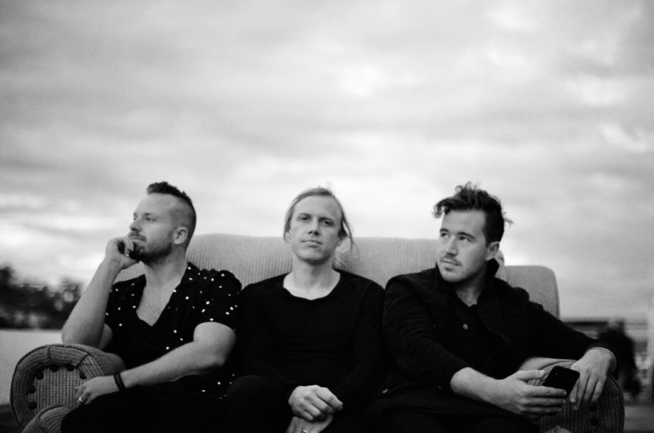
Photo Credit: Isabel Durant

(March 21, 2019 – Los Angeles, CA) – Today globally renowned live-electronic band RÜFÜS DU SOL have released a music video for their break-out track ‘Treat You Better’ off their ‘SOLACE’ LP out now via their own Rose Avenue imprint and Reprise Records.

The video welcomes fans into the emotive world in which the album was written - one defined by honesty and introspection. ‘Treat You Better’ leads the melancholy, yet dance driven LP as a euphoric ode to both the band’s loved-ones and themselves, a calling out for heartfelt self-improvement.

Shot in Mexico City, the new music video features intimate scenes of subjects lost in their own emotions, subsequently reaching within and outwardly to find solace in that which brings them joy. Viewers are left with a sense of yearning for passionate support and self-care that continues to define the band’s personal and sonic development.

The genuity of the record has been felt far and wide in the live space as RÜFÜS have tantalized packed crowds around the globe on their SOLACE World Tour. The album run has already seen them dominate sold out performances at both LA’s Shrine and New York City’s Terminal 5 three nights in a row, and is now headed towards their top billing return at this year’s Coachella Music and Arts Festival.

Watch: https://rufusdusol.lnk.to/TYBOfficialFullVid

SOLACE North American 2019 Tour Dates (with more dates to be announced):
April 12 - Indio, CA - Coachella Music Festival
April 19 - Indio, CA - Coachella Music Festival
April 20 - Santa Barbara, CA - Santa Barbara Bowl
April 24 - Portland, OR - Roseland Theatre
April 25 - Portland, OR - Roseland Theatre
April 26 - Vancouver, BC - PNE Forum
April 27 - Seattle, WA - WaMu Theater
May 8 - Orlando, FL - Hard Rock Live
May 9 - Tampa, FL - Cuban Club
May 10 - Atlanta, GA - Shaky Beats Festival
May 11 - Miami, FL - Bayfront Park
July 18 - Avila Beach, CA - Avila Beach Resort
July 19 - Berkeley, CA - The Greek Theatre
July 20 - Berkeley, CA - The Greek Theatre
July 24 - Dallas, TX - The Bomb Factory
July 25 - Austin, TX - ACL Live at The Moody Theater
July 27 - New Orleans, LA - Joy Theater
August 6 - Philadelphia, PA - Franklin Music Hall
August 8 - Washington, DC - The Anthem
August 9 - Brooklyn, NY - Brooklyn Mirage
August 10 - Brooklyn, NY - Brooklyn Mirage
August 11 - Brooklyn, NY - Brooklyn Mirage
October 2nd - Morrison, CO - Red Rocks Amphitheatre
October 3rd - Morrison, CO - Red Rocks Amphitheatre
###
Press Contacts:
Bobbie Gale / Warner Bros. Records
(818) 953-3692 / Bobbie.Gale@wbr.com

Maxfield Frieser / Infamous PR
mfrieser@infamouspr.com

Press materials:
http://press.wbr.com/rufusdusol/

