https://lh3.googleusercontent.com/4tIKyXxkBqjkdBlcc_EMvNQkfgZoZ-A4Qi0WEH2aglQR40l9BZH6S_7AHm0ul5u65vc1_p7ZyyFWP-6dIzVi9oWRQnhoYCRNo-0fSQ3pIPlwDfjUH0gyCf4wjU5a-vFmuRvxWotC

**RÜFÜS DU SOL RELEASES “SOLACE REMIXES VOL. 3”**

**FEATURING ICARUS** **REMIX OF “LOST IN MY MIND” AND WILL CLARKE REMIX OF “NO PLACE”**

***SOLACE* LP OUT NOW ON ROSE AVENUE AND REPRISE RECORDS**

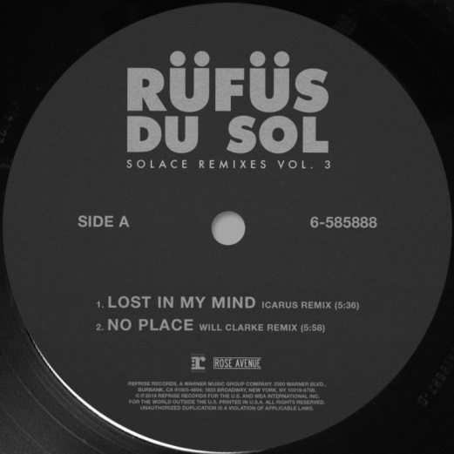

**December 14, 2018 (Los Angeles, CA) -** Globally renowned live-electronic trio RÜFÜS DU SOL have revealed “SOLACE REMIXES VOLUME 3” featuring Icarus’s remix of “Lost In My Mind,” and Will Clarke’s remix of “No Place” off their new LP SOLACE.

UK house duo Icarus lead the package with their rework of “Lost In My Mind,” featuring the pair’s singular melodies and ethereal sound design atop a breakbeat percussive riff. Matching the emotive energy of the original, Icarus breathe a new life into “Lost In My Mind,” completely reinventing the melodic structures and reinvigorating the song into something entirely different. 2018 has been monumental for Icarus, tapped by Pete Tong for their first ever Essential Mix, boasting spins from Annie Mac, releasing two singles “Echoes” and “Man Of The Land” via Parlophone/WBR, and joining RÜFÜS DU SOL for their U.S. record tour.

Will Clarke leaves “No Place” largely intact, while completely reworking the song’s chorus and elevating it to an entirely different sonic echelon. A global favorite by the way of Bristol, Clarke, a known generator of quality house music, won over the hearts of the DIRTYBIRD family by countless releases on the label and becoming a mainstay at their flagship Campout festivals. These steps catapulted him to conquer stages at some of the globe’s most prominent electronic music festivals including Coachella, CRSSD, HARD Summer and more.

As celebrated in the DJ booth as they are headlining festivals, RÜFÜS DU SOL continue to tip their curatorial hat to rising talents and widely respected legends alike. Exemplified through their own Rose Avenue Records imprint, and the handpicking of remixers from across the electronic spectrum, they aim to make their mark as a band by and for global dance music fans. “SOLACE Remixes Vol. 3” see’s Icarus and Will Clarke join an already star-studded assemblage of remix talent for the LP like Adam Port and Lindstrom & Prins Thomas with more on the way.

Listen to “SOLACE Remixes Vol. 3” **[HERE](https://rufusdusol.lnk.to/SolaceRemixesV3)**

Today’s remix pack arrives just two weeks after RÜFÜS DU SOL’s massive BBC 1 Essential Mix, and just two months after their third LP SOLACE which was released via their own imprint Rose Avenue / Reprise Records.

The crux of RÜFÜS DU SOL remains the deep connection felt between the band and their dedicated global fan base in the live space. The band recently embarked on the beginning of a world tour in support of SOLACE with sold-out shows including three nights at Los Angeles’ Shrine Expo Hall, two nights at Denver’s Fillmore, plus single night triumphs at Bill Graham in San Francisco, Valley View Casino Center in San Diego and Aragon Ballroom in Chicago. Following three sold out nights at Terminal 5 in New York, the tour continues through the end of the year with the band’s return to Europe with dates in London, Manchester, Amsterdam, Paris, Berlin, and Cologne.

SOLACE North American Fall Tour Dates (with more dates to be announced):

January 1, 2019 - Sydney, AUS - The Domain

February 14, 2019 - Melbourne, AUS - Sidney Myer Music Bowl

February 15, 2019 - Melbourne, AUS - Sidney Myer Music Bowl

February 16, 2019 - Elwood, AUS - Riva St. Kilda

February 20, 2019 - Adelaide, AUS - Adelaide Entertainment Centre

February 22, 2019 - Fremantle, AUS - Fremantle Arts Centre

February 23, 2019 - Metricup, AUS - 3 Oceans Winery

February 24, 2019 - Fremantle, AUS - Fremantle Arts Centre

March 1, 2019 - Wollongong, AUS - Maccabe Park

March 2, 2019 - Brisbane, AUS - Riverstage

March 3, 2019 - Brisbane, AUS - Riverstage

March 8, 2019 - Auckland, NZ - Logan Campbell Centre

March 13, 2019 - Riviera Maya, MX

###

**Press Contacts:**

**Bobbie Gale** / Warner Bros. Records

(818) 953-3692 / Bobbie.Gale@wbr.com

**Maxfield Frieser** / Infamous PR

mfrieser@infamouspr.com

**Press materials:**

<http://press.wbr.com/rufusdusol/>