RED HOT CHILI PEPPERS RETURN WITH 12TH STUDIO ALBUM UNLIMITED LOVE
ON APRIL 1

REVEAL FIRST SINGLE & MUSIC VIDEO “BLACK SUMMER”

LISTEN TO “BLACK SUMMER” – HERE / WATCH THE VIDEO – HERE

BAND EMBARK ON MASSIVE GLOBAL STADIUM HEADLINE TOUR THIS SUMMER
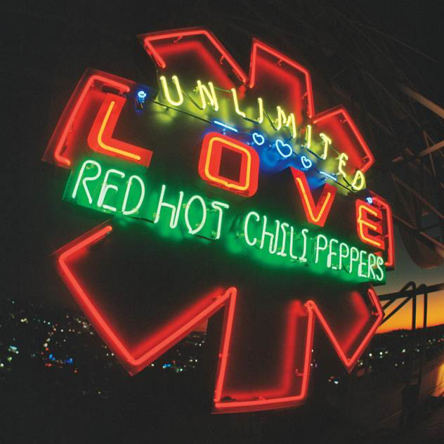

Click here for hi-res image
February 3, 2022 (Los Angeles, CA) — Red Hot Chili Peppers will unveil their new album and twelfth full-length offering, Unlimited Love [Warner Records], on April 1, 2022. It notably marks their first recording with guitarist John Frusciante since 2006 and first with producer and longtime collaborator Rick Rubin since 2011. To herald Unlimited Love, the Los Angeles band just shared the first single and music video “Black Summer.” Listen to “Black Summer”— HERE. Check out the music video HERE. Pre-order/Pre-save Unlimited Love—HERE.

“Our only goal is to get lost in the music. We (John, Anthony, Chad and Flea) spent thousands of hours, collectively and individually, honing our craft and showing up for one another, to make the best album we could. Our antennae attuned to the divine cosmos, we were just so damn grateful for the opportunity to be in a room together, and, once again, try to get better. Days, weeks and months spent listening to each other, composing, jamming freely, and arranging the fruit of those jams with great care and purpose. The sounds, rhythms, vibrations, words and melodies had us enrapt.

We yearn to shine a light in the world, to uplift, connect, and bring people together. Each of the songs on our new album UNLIMITED LOVE, is a facet of us, reflecting our view of the universe. This is our life’s mission. We work, focus, and prepare, so that when the biggest wave comes, we are ready to ride it. The ocean has gifted us a mighty wave and this record is the ride that is the sum of our lives. Thank you for listening, we hope you enjoy it.
ROCK OUT MOTHERFUCKERS!” - Anthony Kiedis, Flea, Chad Smith, John Frusciante

Added Frusciante : “When we got together to start writing material, we began by playing old songs by people like Johnny "Guitar" Watson, The Kinks, The New York Dolls, Richard Barrett and others. Ever so gradually, we started bringing in new ideas, and turning jams into songs, and after a couple of months the new stuff was all we were playing. The feeling of effortless fun we had when we were playing songs by other people, stayed with us the whole time we were writing. For me, this record represents our love for, and faith in each other.”

On lead track “Black Summer,” ethereal guitar underlines introspective lyrics as the rhythm unlocks a hypnotic drum groove highlighted by evocative bass. It quietly inhales only to exhale with a massive refrain, “It’s been a long time since I made a new friend, waiting on another black summer to end,” before a guitar solo echoes to the heavens and back. For the music video, the group teamed up with acclaimed director Deborah Chow [Disney+’s The Mandalorian, Obi-Wan Kenobi]. The result continues a tradition of captivating cinematic visuals—with a twist.

Unlimited Love resumes a three-decade partnership with Rick Rubin [Johnny Cash, Adele]. Their creative collaboration spans legendary albums, including the diamond-selling Blood Sugar Sex Magik [1991], Californication [1999], By The Way [2002], and Stadium Arcadium [2006].

The interplay between the band borders on intergalactic once again—yet elevated to another stratosphere altogether. Unlimited Love represents the united spirit of four individual souls still fearlessly exploring the future of their eternal friendship and musical congregation.

“Here Ever After ”follows a staccato bassline down a rhythmic wormhole as the hook promises, “She’s the kinda girl that make you wanna go faster now.” And whether it be wrangling wild horns and boisterous bass on “Aquatic Mouth Dance” or the poetic dreamscape of confessional ballad “Not The One,” the album twists and turns with gleeful unpredictability On “Poster Child,” a funky riff spiked with wah pedal magic wobbles in tandem with the delivery as a blissful chorus takes hold. “The Great Apes” charges forward towards a primal clarion call. For nearly six minutes, “It’s Only Natural” slips in and out of hypnotic harmonies and magnetic grooves. The slinky funk of “She’s A Lover” bleeds into a chantable gang vocal and dancefloor-ready refrain, while “These Are The Ways” sees a soft melody give way to guitar and vocal catharsis.

“Whatchu Thinkin’” leans on head-nodding percussion as the vocals flutter with the tempo only for guitar to ignite the chorus. An analog synth choir colors the intro of “Bastards of Light,” while a heavenly crescendo elevates “White Braids & Pillow Chair” beyond the clouds. Hitting the highways, “One Way Traffic” revs up funk at an intersection of airy bass and drums. “Veronica” trades the band’s sunny Los Angeles for the South Side of Chicago and a near-cinematic story about the title character. Then, there’s “Let ‘Em Cry” where trumpet punctuates the momentum before peaking on an emotionally charged guitar solo. “The Heavy Wing” takes flight on a climactic burst of distortion and vocal conjurations. The ride culminates on “Tangelo.” Threaded together with delicate guitar and emotionally charged vocals, this otherworldly lullaby leaves off on a vibrant, vulnerable, and vital final note as it slips into the arms of feedback. Check out the full track listing below.

This summer, Red Hot Chili Peppers will launch their first tour in support of Unlimited Love. They’ve invited a dynamic cohort of guests along for the ride at select dates, including Anderson.Paak & The Free Nationals, A$AP Rocky, Beck, HAIM, King Princess, St. Vincent, The Strokes, and Thundercat. Check out the full confirmed itinerary and purchase tickets HERE.

Experience Unlimited Love from Red Hot Chili Peppers in 2022.

TRACKLISTING

1.Black Summer
2.Here Ever After
3.Aquatic Mouth Dance
4.Not The One
5.Poster Child
6.The Great Apes
7.It’s Only Natural
8.She’s A Lover
9.These Are The Ways
10.Whatchu Thinkin’
11.Bastards of Light
12.White Braids & Pillow Chair
13.One Way Traffic
14.Veronica
15.Let ‘Em Cry
16.The Heavy Wing
17.Tangelo

ABOUT RED HOT CHILI PEPPERS:

Red Hot Chili Peppers have sound tracked successive generations as not only one of the bestselling acts in music history, but also one of the biggest streaming rock bands in the world today. Inducted into the Rock and Roll Hall of Fame® in 2012, the award-winning Los Angeles quartet—Anthony Kiedis [vocals], Flea [bass], Chad Smith [drums], and John Frusciante [guitar]—have collected 6 GRAMMY® Awards, sold 80 million albums, generated 5 billion YouTube views, and gathered 22 billion Spotify streams, averaging 21 million monthly listeners on the platform.

Rolling Stone cited Blood Sugar Sex Magik, Californication, and By The Way on its coveted “500 Greatest Albums of All Time,” while “Under the Bridge” landed on the “500 Greatest Songs of All Time” in 2021. In addition to claiming a Star on the Hollywood Walk of Fame, 8 MTV VMAs, 5 EMAs, 4 American Music Awards, and 3 BRIT Awards, they’ve notably notched the most #1 singles of all time at Alternative Radio with 13 #1 hits. They’ve also performed to tens of millions worldwide, headlined Coachella and became the only band ever to sell out three nights at Hyde Park in London—moving over 200,000 tickets. Adorned by anthems such as “Give It Away,” “Under the Bridge,” and “Breaking the Girl,” the diamond-certified Blood Sugar Sex Magik celebrated its 30th anniversary in 2021.

Now the band’s seminal lineup returns with their new studio album, Unlimited Love on April 1st and a record-breaking Global Stadium Tour launching this summer, kicking-off a brand new generation of fans for the legendary group.

# # #

CONNECT WITH RED HOT CHILI PEPPERS
Instagram | Twitter | Facebook | YouTube | Website | Press Site

