RED HOT CHILI PEPPERS REVEAL MORE OF UNLIMITED LOVE WITH NEW SONG & ANIMATED VIDEO “POSTER CHILD”

12TH STUDIO ALBUM UNLIMITED LOVE LANDS APRIL 1

LISTEN TO “POSTER CHILD” – HERE / WATCH THE ANIMATED VIDEO – HERE

MASSIVE GLOBAL STADIUM HEADLINE TOUR LAUNCHES THIS SUMMER
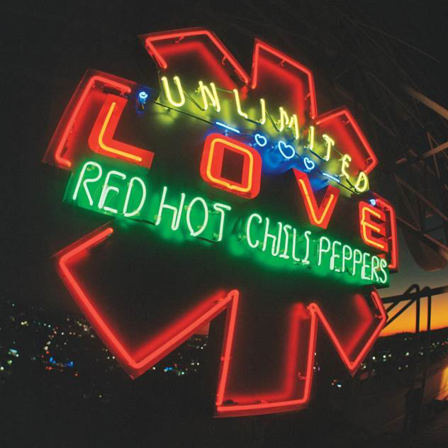
Click here for hi-res image

March 4, 2022 (Los Angeles, CA) — Red Hot Chili Peppers reveal a second song and animated video titled “Poster Child” today. It sets the stage for the arrival of their new album and twelfth full-length offering, Unlimited Love [Warner Records], on April 1st. Listen to “Poster Child”— HERE. Check out the animated video HERE. Pre-order/Pre-save Unlimited Love—HERE.

On “Poster Child,” a steady beat bolts down a bold and buoyant groove as wah pedal-drenched funk guitar shimmies and shakes. The vocals move with this tide of energy only to uplift the hypnotic hook. The accompanying animated visual unspools with one captivating vignette after another at a propulsive pace.

The band launched the build-up to Unlimited Love with the first single and opener “Black Summer.” The single has already amassed over 17 million Spotify streams and more than 20 million YouTube views on the music video. Making a major impact, it marked the band’s best debut on Billboard’s Rock & Alternative Airplay Chart, becoming the first Top 3 entry on the chart since 2019. Within two weeks, “Black Summer” vaulted to #1 and completed the “fastest climb to the top on the chart since 2020,” according to Billboard. Not to mention, it cracked the Billboard Hot 100 and topped the Rock Digital Song Sales Chart at #1—a career first. Plus, it reached the Top 10 on both the Hot Alternative Songs Chart and Hot Rock & Alternative Songs Chart.

Inciting critical applause, Vulture hailed it as “everything you’d want with a Chilis joint,” and Paste praised it as “evocative of the band’s epic 28-track Stadium Arcadium.” Consequence of Sound christened it “Song of the Week” and attested, “They sound renewed and refreshed.” NME summed it up best as “euphoric,” while HYPEBEAST dubbed it “upbeat” and “trippy.”

Unlimited Love notably marks their first recording with guitarist John Frusciante since 2006 and first with producer and longtime collaborator Rick Rubin since 2011. It resumes a three-decade partnership with Rubin [Johnny Cash, Adele]. Their creative collaboration spans legendary albums, including the diamond-selling Blood Sugar Sex Magik [1991], Californication [1999], By The Way [2002], and Stadium Arcadium [2006].

The interplay between the band borders on intergalactic once again—yet elevated to another stratosphere altogether. Unlimited Love represents the united spirit of four individual souls still fearlessly exploring the future of their eternal friendship and musical congregation.

This summer, Red Hot Chili Peppers will launch their first tour in support of Unlimited Love. They’ve invited a dynamic cohort of guests along for the ride at select dates, including Anderson.Paak & The Free Nationals, A$AP Rocky, Beck, HAIM, King Princess, St. Vincent, The Strokes, and Thundercat. Check out the full confirmed itinerary and purchase tickets HERE.

Experience Unlimited Love from Red Hot Chili Peppers in 2022.

About the Red Hot Chili Peppers:
Red Hot Chili Peppers have sound tracked successive generations as not only one of the bestselling acts in music history, but also one of the biggest streaming rock bands in the world today. Inducted into the Rock and Roll Hall of Fame® in 2012, the award-winning Los Angeles quartet—Anthony Kiedis [vocals], Flea [bass], Chad Smith [drums], and John Frusciante [guitar]—have collected 6 GRAMMY® Awards, sold 80 million albums, generated 5 billion YouTube views, and gathered 22 billion Spotify streams, averaging 21 million monthly listeners on the platform.

Rolling Stone cited Blood Sugar Sex Magik, Californication, and By The Way on its coveted “500 Greatest Albums of All Time,” while “Under the Bridge” landed on the “500 Greatest Songs of All Time” in 2021. In addition to claiming a Star on the Hollywood Walk of Fame, 8 MTV VMAs, 5 EMAs, 4 American Music Awards, and 3 BRIT Awards, they’ve notably notched the most #1 singles of all time at Alternative Radio with 13 #1 hits. They’ve also performed to tens of millions worldwide, headlined Coachella and became the only band ever to sell out three nights at Hyde Park in London—moving over 200,000 tickets. Adorned by anthems such as “Give It Away,” “Under the Bridge,” and “Breaking the Girl,” the diamond-certified Blood Sugar Sex Magikcelebrated its 30th anniversary in 2021.

Now the band’s seminal lineup returns with their new studio album, Unlimited Love on April 1st and a record-breaking Global Stadium Tour launching this summer, kicking-off a brand new generation of fans for the legendary group.

# # #

CONNECT WITH RED HOT CHILI PEPPERS
Instagram | Twitter | Facebook | YouTube | Website | Press Site

For more information, please contact:
Laura Swanson | Warner Records
laura.swanson@warnerrecords.com

