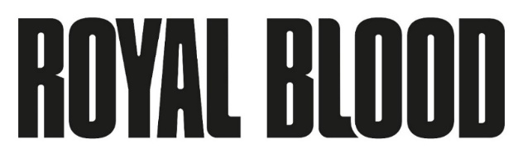
NEW ALBUM TYPHOONS TO BE RELEASED ON APRIL 30TH VIA WARNER RECORDS
AVAILABLE TO PRE-ORDER HERE

FEATURING THE NEW SINGLE AND TITLE TRACK AVAILABLE NOW
LISTEN HERE
WATCH HERE

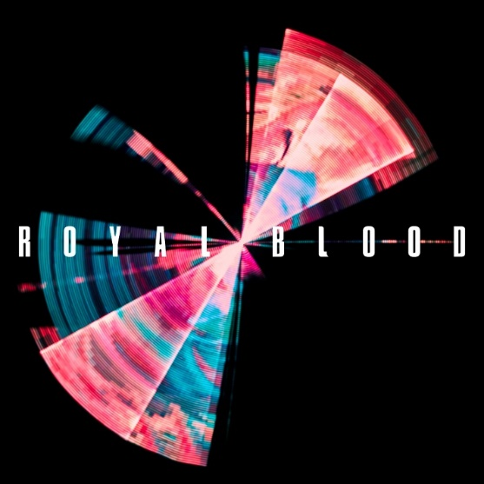
(Click here for hi-res artwork)

January 21, 2021 (Los Angeles, CA) – After two UK #1 albums, over 2 million album sales and an array of international acclaim, you might’ve thought you knew what to expect from British rock duo Royal Blood. Those preconceptions were shattered when they released their hit single “Trouble’s Coming” last summer. Their first new music in three years brewed up a melting pot of fiery rock riffs and danceable beats, they delivered something fresh, unexpected and yet entirely in tune with what they’d forged their reputation on.

The reaction was phenomenal, with highlights including 20 million streams, “Trouble’s Coming” landed on the cover of Spotify’s flagship global rock playlist ROCK THIS and immediately impacted U.S. Rock and Alternative playlists where it remains in the Top 10 today. In the U.K., “Trouble’s Coming” premiered on BBC’s Annie Mac’s Hottest Record, had a nine-week run on BBC Radio 1’s A-list and topped multiple charts across several European territories.
Now, Royal Blood are primed to ascend even greater heights when they release their eagerly anticipated third album Typhoons on April 30th via Warner Records.

Typhoons is now available to pre-order here and will be released on digital, vinyl and CD formats. The official Royal Blood store offers a deluxe vinyl packaged with a bonus 7” single (featuring the extra track “Space”) and an art print, and a picture disc. Amazon and select indie retailers will feature their own exclusive color vinyl editions as well.

Today also sees the digital release of the new single and title track “Typhoons” which underscores Kerr’s spiralling bass riff and casts a thrall as it grows in intensity, while his vocals switch at will between a raw rock roar and a soulful falsetto. It’s underpinned by Thatcher’s thundering beats, his taut rhythms infused with groove-laden hi-hats. “Typhoons,” single will also be released on limited edition black 7” vinyl tomorrow and will be available to order here. Its B-side will feature an etching of a lyric from the song. Stream “Typhoons” here and here to view/share visual.

When Mike Kerr and Ben Thatcher sat down to talk about making a new album, they knew what they wanted to achieve. It involved a conscious return to their roots, back when they had made music that was influenced by Daft Punk, Justice, and Philippe Zdar of Cassius. It also called for a similar back-to-basics approach to what had made their 2014 self-titled debut album so thrilling, visceral and original.

“We sort of stumbled on this sound, and it was immediately fun to play,” recalls Kerr.“That’s what sparked the creativity on the new album, the chasing of that feeling. It’s weird, though - if you think back to ‘Figure it Out,’ (from debut album) it kind of contains the embryo of this album. We realized that we didn’t have to completely destroy what we’d created so far; we just had to shift it, change it. On paper, it’s a small reinvention. But when you hear it, it sounds so fresh.”

After setting the tone with “Trouble’s Coming” and the aforementioned “Typhoons,” the album continues in breathless style with the fierce metallic grooves of “Who Needs Friends” hitting an early visceral peak. Royal Blood further reference their fresh confluence of influences by utilizing a vocoder vocal effect on “Million & One” before dynamically switching between the biggest contrasts of their sound with “Limbo.” Already a fan favorite having been a regular during the duo’s 2019 U.K. shows, “Boilermaker” lives up to its reputation and is more than matched by “Mad Visions,” which evokes a hyper-aggressive Prince influence. The album ends with a final surprise in the shape of the stark piano ballad “All We Have Is Now,” a vulnerable and revealing reminder to live in the moment.

That song’s unguarded sentiments give the album a redemptive finale. Whether directly or allusively, the album explores the flipside of success that they’ve experienced. It comes from the realization that success is much more complicated than it seems and that having the time to regain perspective is a precious commodity which becomes ever more elusive. The situation called for reflection and a change in lifestyle, which Kerr addressed during an end-of-tour trip to Las Vegas. He downed an espresso martini and declared it to be his last drink, and soon discovered that his new-found sobriety would have a positive impact upon his creativity and life as a whole.

That new approach manifested itself in the duo’s decision to produce the majority of Typhoons themselves. “Boilermaker” was produced by Queens of the Stone Age frontman Josh Homme, the two bands having first connected when Royal Blood supported them on their 2017/2018 North American tour. Meanwhile, the multiple Grammy Award-winner Paul Epworth produced “Who Needs Friends” and contributed additional production to “Trouble’s Coming.”

Typhoons Tracklist:
- Trouble’s Coming
- Oblivion
- Typhoons
- Who Needs Friends
- Million & One
- Limbo
- Either You Want It
- Boilermaker
- Mad Visions
- Hold On
- All We Have Is Now

# # #
Royal Blood: Mike Kerr (vocals, bass, keys, piano) and Ben Thatcher (drums)

For more information please contact:
Rick Gershon at Warner Records rick.gershon@warnerrecords.com

Follow Royal Blood:
Website | Facebook | YouTube | Twitter | Instagram | Spotify | Press Materials

