RÜFÜS DU SOL Announce Release of 2019 Coachella Performance
Premiering via YouTube on Friday, April 10

Celebrating the One-Year Anniversary of the Band’s Largest Festival Play

Tune in to RÜFÜS DU SOL’s 2019 Coachella Performance
April 10 at 8PM PST HERE

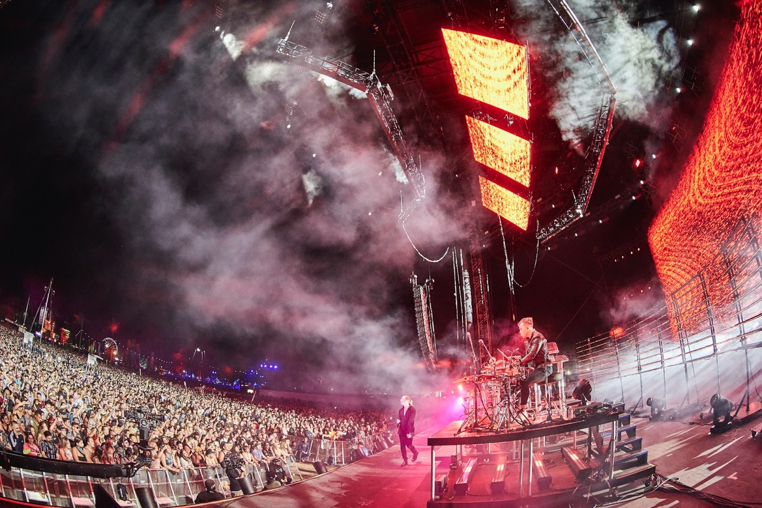

April 9, 2020 (Los Angeles, CA) - On the eve of what would have been Weekend One of Coachella Valley Music and Arts Festival, GRAMMY-nominated trio RÜFÜS DU SOL has announced a special viewing of their unforgettable 2019 performance. Premiering on YouTube this Friday, April 10 at 8:00 PM PST, fans can relive the band’s emotive one-hour set on the Outdoor Theatre stage, from home. Taking place one year to the date, RÜFÜS DU SOL will redeliver their immersive live concert experience featuring fan-favorite tracks across their collection, to viewers worldwide.

Tune in on Friday, April 10 at 8PM PST HERE

During the premiere, the band will join the YouTube live chat and engage with fans, answer questions and recount stories from the festival. Coachella served as the first date on the band’s SOLACE World Tour last year, taking them from 15,000 attendees on the Polo Field, to 21,000 fans on their last stop at Los Angeles State Historic Park. Having made their Coachella debut in 2016 on the Gobi stage, followed by a surprise DJ set in 2017 on the DoLaB stage, the 2019 iteration holds a special place in their hearts as it marked their largest US festival appearance of their careers at the time.

Last month, RÜFÜS DU SOL released their debut film and live album “RÜFÜS DU SOL: Live from Joshua Tree,” a 45-minute audiovisual journey through the band’s biggest songs set against a captivating backdrop of desert terrain. Since the release, the film has collected over one million views and counting, not including the sold-out cinema screenings from Los Angeles to Sydney and Melbourne earlier this year.

Connect with RÜFÜS DU SOL
Facebook | Instagram | Twitter | Spotify | YouTube

