RÜFÜS DU SOL Releases
“Treat You Better (Live)” Video Featuring Footage From SOLACE World Tour
https://rufusdusol.lnk.to/TYBLive

Tickets to RÜFÜS DU SOL’s SOLACE World Tour On Sale Now

http://www.rufusdusol.com/

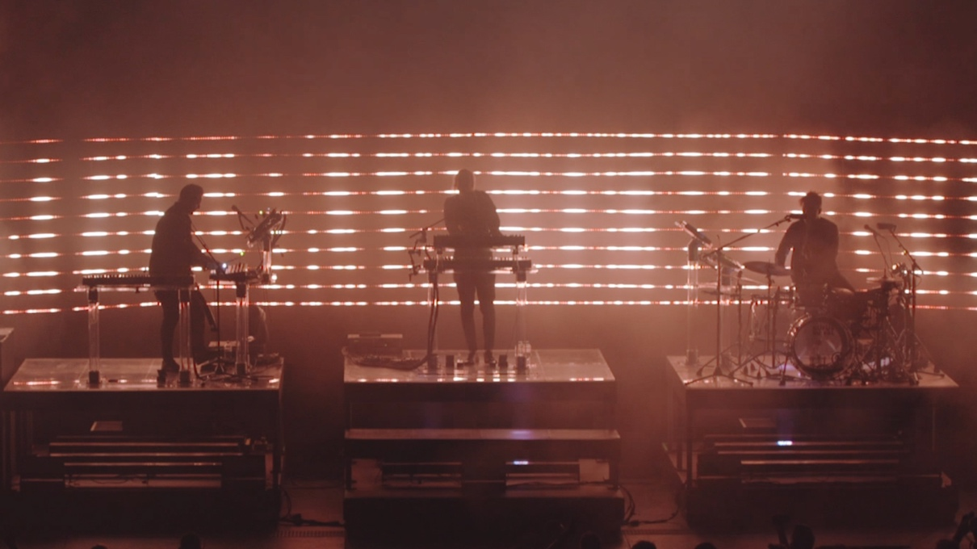

May 7, 2019 (Los Angeles, CA) - Today, RÜFÜS DU SOL have released a breathtaking live performance video of their breakout single, “Treat You Better,” off their recently released album SOLACE. The video was shot across some of their largest shows throughout their world tour, capturing the impressive stage production and buzzing energy from thousands of fans. Relive the stunning performances here.

“Treat You Better,” has received widespread acclaim and collected 26 million streams globally. The track takes listeners to the deeply emotional place from which the band wrote the album, laced with euphoric melodies and introspective lyrics that they claim as both an ode to their loved ones and to themselves. The feeling of melancholic hope that lays at the bedrock of the track is captured by the picturesque aesthetics in this latest live video.

Most recently, the trio performed both weekends at Coachella on The Outdoor Stage to rave reviews from critics like LA Times. At the festival, the band premiered a 360-degree A/V experience at the festival's HP Antarctic Dome which was visually curated by iconic director James Frost, set to their moving track, "Underwater.” Following their desert odyssey, RÜFÜS DU SOL staged a mesmerizing performance of “Treat You Better,” on Jimmy Kimmel Live, view here.

SOLACE North American 2019 Tour Dates (with more dates to be announced):
May 8 - Orlando, FL - Hard Rock Live
May 9 - Tampa, FL - Cuban Club
May 16 - Las Vegas, NV - Encore Beach Club (DJ SET)
May 10 - Atlanta, GA - Shaky Beats Festival
May 11 - Miami, FL - Bayfront Park Amphitheater
July 18 - Avila Beach, CA - Avila Beach Resort
July 19 - Berkeley, CA - The Greek Theatre SOLD OUT
July 20 - Berkeley, CA - The Greek Theatre
July 21 - Las Vegas, NV - XS Nightclub (DJ SET)
July 24 - Dallas, TX - The Bomb Factory
July 25 - Austin, TX - ACL Live at The Moody Theater SOLD OUT
July 26 - Austin, TX - ACL Live at The Moody Theater SOLD OUT
July 27 - New Orleans, LA - Joy Theater SOLD OUT
August 1 - Chicago, IL - Lollapalooza
August 3 - Montreal, QC - Osheaga
August 6 - Philadelphia, PA - Franklin Music Hall
August 8 - Washington, DC - The Anthem
August 9 - Brooklyn, NY - Brooklyn Mirage SOLD OUT
August 10 - Brooklyn, NY - Brooklyn Mirage SOLD OUT
August 11 - Brooklyn, NY - Brooklyn Mirage
August 24 - Las Vegas, NV - Encore Beach Club (DJ SET)
September 20-22 - Las Vegas, NV - Life is Beautiful
September 27 - Ogden, UT - Ogden Amphitheater
October 2 - Morrison, CO - Red Rocks Amphitheatre SOLD OUT
October 3 - Morrison, CO - Red Rocks Amphitheatre SOLD OUT
October 5 - Los Angeles, CA - Los Angeles State Historic Park SOLD OUT

