RÜFÜS DU SOL Teams Up With House Producer & Composer Eelke Kleijn
For Remix of “No Place” Off Their Forthcoming Album, ‘SOLACE REMIXED’

‘SOLACE REMIXED’ Is Available September 6th
18-Track Collection Features Additional Electronic Tastemakers Including
Adam Port, Audiofly, Cassian, Edu Imbernon, Gerd Janson, Hot Since 82, Justin Martin, Made In Paris, Will Clarke, Willaris. K, and More

Stream “No Place (Eelke Kleijn Remix)” HERE

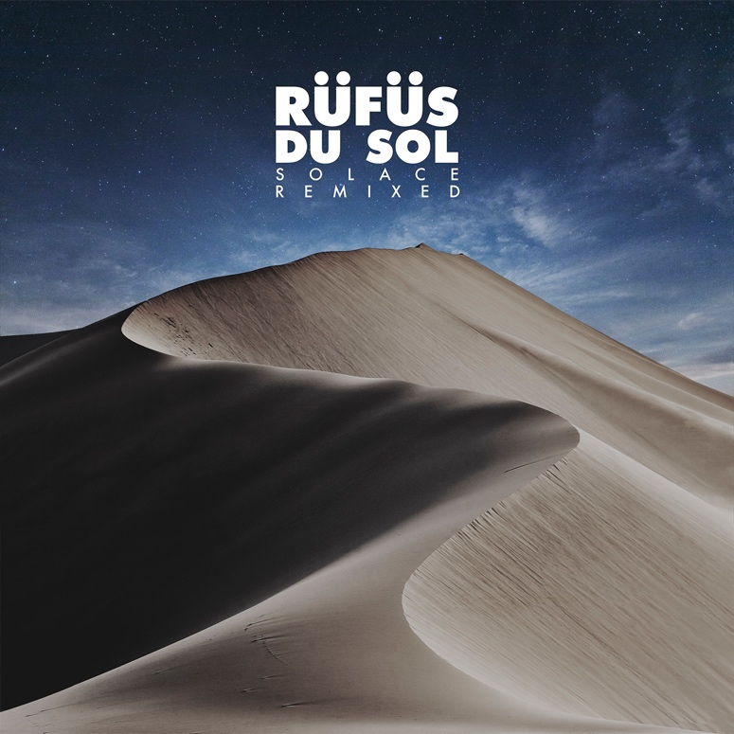

August 30, 2019 (Los Angeles, CA) - One week ahead of RÜFÜS DU SOL's 18-track SOLACE REMIXED album release, the band has shared a rework from Dutch house-favorite, Eelke Kleijn. The producer’s rendition of “No Place” brings a driving melodic progression to the emotive lead single. His use of slow-rolling synths and dramatic instrumentals strips back the original’s heavier brass elements to create more space for the vocals to shine. Stream it HERE.

Last year Eelke released his third studio album “Moments of Clarity,” on his own imprint, Days Like Nights, which beautifully showcased his skills as a classically trained pianist and composer. Just before that, he took to Burning Man’s iconic Mayan Warrior Art Car for an hour-long set as part of a mesmerizing drone art performance in tribute to the gathering’s founder, Larry Harvey. The artistic lens through which he creates his electronic soundscapes are what drew RÜFÜS DU SOL to commission Eelke for a transformative remix on their album.

SOLACE REMIXED arrives via Rose Avenue / Reprise Records on September 6, featuring additional heavyweights such as Audiofly, Adam Port, Edu Imbernon, and more. Last month, Australian indie-electronic duo Lastlings reimagined the title-track “Solace,” bringing velvety vocals and pulsating beats to the original. Listen HERE. The latest unreleased remix came last week from melodic tech duo Mathame, who wove dark celestial layers through RÜFÜS’ hit track “All I’ve Got.” Listen HERE.

SOLACE REMIXED is a testament to the trio's clubland roots, giving fans a look into the record box that shaped the original. From brooding techno to cerebral house, the album showcases the eclectic sonic stylings of RÜFÜS DU SOL as globally-renowned curators.

Pre-order SOLACE REMIXED HERE.
Purchase tickets to see RÜFÜS DU SOL on tour HERE.

SOLACE REMIXED Tracklist
Treat You Better (Cassian Remix)
Eyes (RÜFÜS DU SOL VIP Edit)
New Sky (Audiofly Remix)
Lost In My Mind (Icarus Remix)
No Place (Eelke Kleijn Remix)
All I've Got (Mathame Remix)
Underwater (Adam Port Remix)
Solace (Lastlings Remix)
Another Life (Hot Since 82 Remix)
Treat You Better (Gerd Janson Remix)
Eyes (Durante & Cassian Remix)
New Sky (Edu Imbernon Remix)
Lost In My Mind (Justin Martin Remix)
No Place (Will Clarke Remix)
All I've Got (Gorje Hewek & Izhevski Remix)
Underwater (Willaris. K Remix)
Solace (TERR Remix)
Another Life (Made In Paris Remix)

RÜFÜS DU SOL 2019 US Tour Dates
September 20 - Pomona, CA - Fox Theater
September 21 - Las Vegas, NV - Life Is Beautiful
September 22 - Las Vegas, NV - Wynn Las Vegas Hotel & Casino (DJ SET)
September 25 - Missoula, MT - Wilma Theater
September 26 - Boise, ID - Outlaw Field at the Idaho Botanical Garden
September 27 - Ogden, UT - The Ogden Amphitheater
September 28 - Aspen, CO - Belly Up Aspen SOLD OUT
October 2 - Morrison, CO - Red Rocks Amphitheatre SOLD OUT
October 3 - Morrison, CO - Red Rocks Amphitheatre SOLD OUT
October 5 - Los Angeles, CA - Los Angeles State Historic Park SOLD OUT

Connect with RÜFÜS DU SOL
Facebook | Instagram | Twitter | Spotify

